PRACTICAL BOOK

MSCIT (PART I) SEMESTER - II 2023-24

SUBJECT

MALWARE ANALYSIS

SUBMITTED BY

**Prathamesh Zore**

**Seat No.1312689**

Submitted in partial fulfillment of the requirement for Qualifying

M.Sc. Part I Semester II Examination 2023-24

University of Mumbai Department of Information Technology

Shailendra Degree College

S.V. Road, Dahisar (E), Mumbai-68

# Shailendra Education Society’s

**ARTS, COMMERCE & SCIENCE COLLEGE**

**NAAC Re-accreditated ‘B++’ grade with CGPA score 2.98 Shailendra Nagar, Dahisar (East), Mumbai - 400 068.**



CERTIFICATE

This is to certify that **Mr. Prathamesh Zore** of M.Sc. (I.T.) Part I Semester II has completed the practical work in the subject of **“ Malware Analysis ”** during the academic year 2023- 24 under the guidance of **Asst. Prof. Hemchandra Kumbhar** being the partial requirement for the fulfillment of the curriculum of Master of Science in Information Technology, University of Mumbai.

**Place: Mumbai**

**Date: / /2024**

### Internal Examiner External Examiner

M.Sc. (IT) Coordinator College Seal

**INDEX**

|  |  |  |
| --- | --- | --- |
| **Sr.**  **No.** | **Title** | **Sign** |
| **1** | **a. Files: *Lab01-01.exe* and *Lab01-01.dll*.** |  |
|  | i. Upload the files to [*http://www.VirusTotal.com/*](http://www.virustotal.com/) and view the reports. Does either file match any existing antivirus signatures? |  |
|  | ii. When were these files compiled? |  |
|  | iii. Are there any indications that either of these files is packed or obfuscated? If so, what are these indicators? |  |
|  | iv. Do any imports hint at what this malware does? If so, which imports are they? |  |
|  | v. Are there any other files or host-based indicators that you could look for on infected systems? |  |
|  | vi. What network-based indicators could be used to find thismalware on infected machines? |  |
|  | vii. What would you guess is the purpose of these files? |  |
|  | **b. Analyze the file *Lab01-02.exe*.** |  |
|  | i. Upload the *Lab01-02.exe* file to [*http://www.VirusTotal.com/*.](http://www.virustotal.com/) Does it match any existing antivirus definitions? |  |
|  | ii. Are there any indications that this file is packed or obfuscated? Ifso, what  are these indicators? If the file is packed, unpack it if possible. |  |
|  | iii. Do any imports hint at this program’s functionality? If so, which imports are they and what do they tell you? |  |
|  | iv. What host- or network-based indicators could be used to identify this malware on infected machines? |  |
|  | **c. Analyze the file Lab01-03.exe.** |  |
|  | i. Upload the *Lab01-03.exe* file to [*http://www.VirusTotal.com/*.](http://www.virustotal.com/) Does it match any existing antivirus definitions? |  |
|  | ii. Are there any indications that this file is packed or obfuscated? If so, what are these indicators? If the file is packed, unpack it ifpossible. |  |
|  | iii. Do any imports hint at this program’s functionality? If so, which imports are they and what do they tell you? |  |
|  | iv. What host- or network-based indicators could be used to identify this malware on infected machines? |  |
|  | **d. Analyze the file Lab01-04.exe.** |  |
|  | i. Upload the *Lab01-04.exe* file to [*http://www.VirusTotal.com/*.](http://www.virustotal.com/) Does it match any existing antivirus definitions? |  |
|  | ii. Are there any indications that this file is packed or obfuscated? Ifso, what  are these indicators? If the file is packed, unpack it if possible. |  |

|  |  |  |
| --- | --- | --- |
|  | iii. When was this program compiled? |  |
|  | iv. Do any imports hint at this program’s functionality? If so, which imports are they and what do they tell you? |  |
|  | v. What host- or network-based indicators could be used to identify this malware on infected machines? |  |
|  | vi. This file has one resource in the resource section. Use ResourceHacker to examine that resource, and then use it to extract the resource. What can you learn from the resource? |  |
|  | **e. Analyze the malware found in the file Lab03-01.exe using basic dynamic analysis tools.** |  |
|  | i. What are this malware’s imports and strings? |  |
|  | ii. What are the malware’s host-based indicators? |  |
|  | iii. Are there any useful network-based signatures for this malware? If so, what are they? |  |
|  | **f. Analyze the malware found in the file Lab03-02.dll using basic dynamic analysis tools.** |  |
|  | i. How can you get this malware to install itself? |  |
|  | ii. How would you get this malware to run after installation? |  |
|  | iii. How can you find the process under which this malware is running? |  |
|  | iv. Which filters could you set in order to use procmon to glean information? |  |
|  | v. What are the malware’s host-based indicators? |  |
|  | vi. Are there any useful network-based signatures for this malware? |  |
|  | **g. Execute the malware found in the file Lab03-03.exe while monitoring it**  **using basic dynamic analysis tools in a safeenvironment** |  |
|  | i. What do you notice when monitoring this malware with Process Explorer? |  |
|  | ii. Can you identify any live memory modifications? |  |
|  | iii. What are the malware’s host-based indicators? |  |
|  | iv. What is the purpose of this program? |  |
|  | **h. Analyze the malware found in the file Lab03-04.exe using basic dynamic analysis tools.** |  |
|  | i. What happens when you run this file? |  |
|  | ii. What is causing the roadblock in dynamic analysis? |  |
|  | iii. Are there other ways to run this program? |  |
| 2. | **a. Analyze the malware found in the file Lab05-01.dll using only IDA Pro. The goal of this lab is to give you hands-on experience with IDA Pro. If**  **you’ve already worked with IDA Pro, you may choose to ignore these questions and focus on reverse engineering the malware.** |  |
|  | i. What is the address of DllMain? |  |
|  | ii. Use the Imports window to browse to gethostbyname. Where is the import located? |  |
|  | iii. How many functions call gethostbyname? |  |
|  | iv. Focusing on the call to gethostbynamelocated at 0x10001757, can you fig ure out which DNS request will be made? |  |
|  | v. How many local variables has IDA Pro recognized for the subroutine at  0x10001656? |  |
|  | vi. How many parameters has IDA Pro recognized for the subroutine at |  |

|  |  |  |
| --- | --- | --- |
|  | 0x10001656? |  |
|  | vii. Use the Strings window to locate the string \cmd.exe /cin the disassembly.  Where is it located? |  |
|  | viii. What is happening in the area of code that references \cmd.exe/c? |  |
|  | ix. In the same area, at 0x100101C8, it looks like word_1008E5C4 is a global variable that helps decide which path to take. How does the malware set  dword_1008E5C4? (Hint: Use dword_1008E5C4’s cross-references.) |  |
|  | x. A few hundred lines into the subroutine at 0x1000FF58, a seriesof com parisons use memcmpto compare strings. What happens if the string compar  ison to robotworkis successful (when memcmpreturns 0)? |  |
|  | xi. What does the export PSLISTdo? |  |
|  | xii. Use the graph mode to graph the cross-references from sub_10004E79. Which API functions could be called by entering this function? Based on the API functions alone, what could you rename this function? |  |
|  | xiii. How many Windows API functions does DllMaincall directly? How many at a depth of 2? |  |
|  | xiv. At 0x10001358, there is a call to Sleep (an API function thattakes one parameter containing the number of milliseconds to sleep). Looking backward through the code, how long will the program sleep if this code  executes? |  |
|  | xv. At 0x10001701 is a call to socket. What are the three parameters? |  |
|  | xvi. Using the MSDN page for socketand the named symbolic constants  func tionality in IDA Pro, can you make the parametersmore meaningful? What are the parameters after you apply changes? |  |
|  | xvii. Search for usage of the in instruction (opcode 0xED). This instruction is used with a magic string VMXh to perform VMware detection. Is that in use in this malware? Using the cross-referencesto the function that executes the in instruction, is there further  evidence of VMware detection? |  |
|  | xviii. Jump your cursor to 0x1001D988. What do you find? |  |
|  | xix. If you have the IDA Python plug-in installed (included with the com- mercial version of IDA Pro), run *Lab05-01.py*, an IDA Pro Python script provided with the malware for this book. (Make sure the cursor is at  0x1001D988.) What happens after you run the script? |  |
|  | xx. With the cursor in the same location, how do you turn this data into a single ASCII string? |  |
|  | xxi. Open the script with a text editor. How does it work? |  |
|  | **b. analyze the malware found in the file Lab06-01.exe.** |  |
|  | i. What is the major code construct found in the only subroutine called by main? |  |
|  | ii. What is the subroutine located at 0x40105F? |  |
|  | iii. What is the purpose of this program? |  |
|  | **c. Analyze the malware found in the file Lab06-02.exe.** |  |
|  | i. What operation does the first subroutine called by mainperform? |  |

|  |  |  |
| --- | --- | --- |
|  | ii. What is the subroutine located at 0x40117F? |  |
|  | iii. What does the second subroutine called by maindo? |  |
|  | iv. What type of code construct is used in this subroutine? |  |
|  | v. Are there any network-based indicators for this program? |  |
|  | vi. What is the purpose of this malware? |  |
|  | **d. analyze the malware found in the file Lab06-03.exe.** |  |
|  | i. Compare the calls in main to Lab 6-2’s main method. What is the new function called from main? |  |
|  | ii. What parameters does this new function take? |  |
|  | iii. What major code construct does this function contain? |  |
|  | iv. What can this function do? |  |
|  | v. Are there any host-based indicators for this malware? |  |
|  | vi. What is the purpose of this malware? |  |
|  | **e. analyze the malware found in the file Lab06-04.exe.** |  |
|  | i. What is the difference between the calls made from the main method in Labs 6-3 and 6-4? |  |
|  | ii. What new code construct has been added to main? |  |
|  | iii. What is the difference between this lab’s parse HTML function and those of the previous labs? |  |
|  | iv. How long will this program run? (Assume that it is connected to the Internet.) |  |
|  | v. Are there any new network-based indicators for this malware? |  |
|  | vi. What is the purpose of this malware? |  |
| **3.** | **a. Analyze the malware found in the file Lab07-01.exe.** |  |
|  | i. How does this program ensure that it continues running (achieves per sistence) when the computer is restarted? |  |
|  | ii. Why does this program use a mutex? |  |
|  | iii. What is a good host-based signature to use for detecting this program? |  |
|  | iv. What is a good network-based signature for detecting this malware? |  |
|  | v. What is the purpose of this program? |  |
|  | vi. When will this program finish executing? |  |
|  | **b. Analyze the malware found in the file Lab07-02.exe.** |  |
|  | i. How does this program achieve persistence? |  |
|  | ii. What is the purpose of this program? |  |
|  | iii. When will this program finish executing? |  |
|  | **c. For this lab, we obtained the malicious executable, Lab07- 03.exe, and DLL, Lab07- 03.dll, prior to executing. This is important to note because the mal- ware might change once it runs. Both files were found in the same directory on the victim machine. If you run the program, you should ensure that both files are in the same directory on the analysis machine. A visible IP string beginning with 127 (a loopback address) connects to the local machine. (In the real version of this malware, this address connects**  **to a remote machine, but we’ve set it to connect to localhost to protect you.)** |  |
|  | i. How does this program achieve persistence to ensure that it continues running when the computer is restarted? |  |

|  |  |  |
| --- | --- | --- |
|  | ii. What are two good host-based signatures for this malware? |  |
|  | iii. What is the purpose of this program? |  |
|  | iv. How could you remove this malware once it is installed? |  |
|  | **d. Analyze the malware found in the file Lab09-01.exe using OllyDbg and IDA Pro to answer the following questions. This malware was initially**  **analyzed in the Chapter 3 labs using basic static and dynamic analysis techniques.** |  |
|  | i. How can you get this malware to install itself? |  |
|  | ii. What are the command-line options for this program? What is the pass word requirement? |  |
|  | iii. How can you use OllyDbg to permanently patch this malware, so that it doesn’t require the special command-line password? |  |
|  | iv. What are the host-based indicators of thismalware? |  |
|  | v. What are the different actions this malware can be instructed to take via the network? |  |
|  | vi. Are there any useful network-based signatures for this malware? |  |
|  | **e. Analyze the malware found in the file Lab09-02.exe using OllyDbg to answer the following questions.** |  |
|  | i. What strings do you see statically in the binary? |  |
|  | ii. What happens when you run this binary? |  |
|  | iii. How can you get this sample to run its malicious payload? |  |
|  | iv. What is happening at 0x00401133? |  |
|  | v. What arguments are being passed to subroutine 0x00401089? |  |
|  | vi. What domain name does this malware use? |  |
|  | vii. What encoding routine is being used to obfuscate the domain name? |  |
|  | viii. What is the significance of the CreateProcessAcall at 0x0040106E? |  |
|  | **f. Analyze the malware found in the file Lab09-03.exe using OllyDbg and IDA Pro. This malware loads three included DLLs (DLL1.dll, DLL2.dll, and DLL3.dll ) that are all built to request the same memory load location. Therefore, when viewing these DLLs in OllyDbg versus IDA Pro, code may appear at different memory locations. The purpose of this lab is to make you comfortable with finding the correct location of**  **code within IDA Pro when you are looking at code in OllyDbg** |  |
|  | i. What DLLs are imported by *Lab09-03.exe*? |  |
|  | ii. What is the base address requested by *DLL1.dll*, *DLL2.dll*, and *DLL3.dll*? |  |
|  | iii. When you use OllyDbg to debug *Lab09-03.exe*, what is the assigned based address for: *DLL1.dll*, *DLL2.dll*, and *DLL3.dll*? |  |
|  | iv. When *Lab09-03.exe* calls an import function from *DLL1.dll*, what does this import function do? |  |
|  | v. When *Lab09-03.exe* calls WriteFile, what is the filename it writes to? |  |
|  | vi. When *Lab09-03.exe* creates a job using NetScheduleJobAdd where does it get the data for the second parameter? |  |
|  | vii. While running or debugging the program, you will see that it prints out three pieces of mystery data. What are the following: |  |
|  | DLL 1 mystery data 1, DLL 2 mystery data 2, and DLL 3 mystery data 3? |  |
|  | viii. How can you load *DLL2.dll* into IDA Pro so that it matches the load address used by OllyDbg? |  |

|  |  |  |
| --- | --- | --- |
| **4** | **a. This lab includes both a driver and an executable. You can run the executable from anywhere, but in order for the program to work properly, the driver must be placed in the C:\Windows\ System32**  **directory where it was origi- nally found on the victim computer. The executable is Lab10-01.exe, and the driver is Lab10-01.sys.** |  |
|  | i. Does this program make any direct changes to the registry? (Use procmon to  check.) |  |
|  | ii. The user-space program calls the ControlService function. Canyou set a breakpoint with WinDbg to see what is executed in the kernel as a result of  the call to ControlService? |  |
|  | iii. What does this program do? |  |
|  | **b. The file for this lab is Lab10-02.exe.** |  |
|  | i. Does this program create any files? If so, what are they? |  |
|  | ii. Does this program have a kernel component? |  |
|  | iii. What does this program do? |  |
|  | **c. This lab includes a driver and an executable. You can run the executable from anywhere, but in order for the program to work properly, the driver must be placed in the C:\Windows\System32**  **directory where it was originally found on the victim computer. The executable is Lab10-03.exe, and the driver is Lab10-03.sys.** |  |
|  | i. What does this program do? |  |
|  | ii. Once this program is running, how do you stop it? |  |
|  | iii. What does the kernel component do? |  |
| **5** | **a. Analyze the malware found in Lab11-01.exe** |  |
|  | i. What does the malware drop to disk? |  |
|  | ii. How does the malware achieve persistence? |  |
|  | iii. How does the malware steal user credentials? |  |
|  | iv. What does the malware do with stolen credentials? |  |
|  | v. How can you use this malware to get user credentials from your test environment? |  |
|  | **b. Analyze the malware found in *Lab11-02.dll*. Assume that auspicious**  **file named *Lab11-02.ini* was also found with this malware.** |  |
|  | i. What are the exports for this DLL malware? |  |
|  | ii. What happens after you attempt to install this malware using |  |
|  | iii. *rundll32.exe*? |  |
|  | iv. Where must *Lab11-02.ini* reside in order for the malware to install properly? |  |
|  | v. How is this malware installed for persistence? |  |
|  | vi. What user-space rootkit technique does this malware employ? |  |
|  | vii. What does the hooking code do? |  |
|  | viii. Which process(es) does this malware attack and why? |  |
|  | ix. What is the significance of the .*ini* file? |  |
|  | **c. Analyze the malware found in Lab11-03.exe and Lab11-03.dll. Make**  **sure that both files are in the same directory during analysis** |  |
|  | i. What interesting analysis leads can you discover using basic static analysis? |  |
|  | ii. What happens when you run this malware? |  |

|  |  |  |
| --- | --- | --- |
|  | iii. How does *Lab11-03.exe* persistently install *Lab11-03.dll*? |  |
|  | iv. Which Windows system file does the malware infect? |  |
|  | v. What does *Lab11-03.dll* do? |  |
|  | vi. Where does the malware store the data it collects? |  |
| **6** | **a. Analyze the malware found in the file Lab12-01.exe and Lab12-01.dll. Make sure that these files are in the same directory when performing the**  **analysis** |  |
|  | i. What happens when you run the malware executable? |  |
|  | ii. What process is being injected? |  |
|  | iii. How can you make the malware stop the pop-ups? |  |
|  | iv. How does this malware operate? |  |
|  | **b. Analyze the malware found in the file *Lab12-02.exe*.** |  |
|  | i. What is the purpose of this program? |  |
|  | ii. How does the launcher program hide execution? |  |
|  | iii. Where is the malicious payload stored? |  |
|  | iv. How is the malicious payload protected? |  |
|  | v. How are strings protected? |  |
|  | **c. Analyze the malware extracted during the analysis of Lab 12- 2, or use the file *Lab12-03.exe*.** |  |
|  | i. What is the purpose of this malicious payload? |  |
|  | ii. How does the malicious payload inject itself? |  |
|  | iii. What filesystem residue does this program create? |  |
|  | d. Analyze the malware found in the file *Lab12-04.exe*. |  |
|  | i. What does the code at 0x401000 accomplish? |  |
|  | ii. Which process has code injected? |  |
|  | iii. What DLL is loaded using LoadLibraryA? |  |
|  | iv. What is the fourth argument passed to the CreateRemoteThread call? |  |
|  | v. What malware is dropped by the main executable? |  |
| **7** | **a. Analyze the malware found in the file *Lab13-01.exe*.** |  |
|  | i. Compare the strings in the malware (from the output of the strings command) with the information available via dynamic analysis. Based on this comparison, which elements might be encoded? |  |
|  | ii. Use IDA Pro to look for potential encoding by searching for the string xor. What type of encoding do you find? |  |
|  | iii. What is the key used for encoding and what content does it encode? |  |
|  | iv. Usethestatic toolsFindCrypt2, Krypto ANALyzer(KANAL), and the IDA Entropy Plugin to identify any other encoding mechanisms. What do you find? |  |
|  | v. What type of encoding is used for a portion of the network traffic sent by the malware? |  |
|  | vi. Where is the Base64 function in the disassembly? |  |
|  | vii. What is the maximum length of the Base64-encoded data that is sent? What is encoded? |  |
|  | viii. In this malware, would you ever see the padding characters (=or ==) in the  Base64-encoded data? |  |
|  | ix. What does this malware do? |  |

|  |  |  |
| --- | --- | --- |
|  | **b. Analyze the malware found in the file *Lab13-02.exe*.** |  |
|  | i. Using dynamic analysis, determine what this malware creates. |  |
|  | ii. Use static techniques such as an xor search, FindCrypt2, KANAL, and the IDA Entropy Plugin to look for potentialencoding. What do you find? |  |
|  | iii. Based on your answer to question 1, which imported function would be a good prospect for finding the encoding functions? |  |
|  | iv. Where is the encoding function in the disassembly? |  |
|  | v. Trace from the encoding function to the source of the encoded content. What is the content? |  |
|  | vi. Can you find the algorithm used for encoding? If not, how can you decode the content? |  |
|  | vii. Using instrumentation, can you recover the original source of one of the encoded files? |  |
|  | **c. Analyze the malware found in the file *Lab13-03.exe*.** |  |
|  | i. Compare the output of strings with the information available via dynamic analysis. Based on this comparison, which elements might be encoded? |  |
|  | ii. Use static analysis to look for potential encoding by searching for the string  xor. What type of encoding do you find? |  |
|  | iii. Use static tools like FindCrypt2, KANAL, and the IDA Entropy Plugin to identify any other encoding mechanisms. How do thesefindings com- pare with  the XOR findings? |  |
|  | iv. Which two encoding techniques are used in thismalware? |  |
|  | v. For each encoding technique, what is the key? |  |
|  | vi. For the cryptographic encryption algorithm, is the key sufficient? What else must be known? |  |
|  | vii. What does this malware do? |  |
|  | viii. Create code to decrypt some of the content produced during dynamic analysis. What is this content? |  |
| **8** | **a. Analyze the malware found in file *Lab14-01.exe*. This program is not harmful to your system.** |  |
|  | i. Which networking libraries does the malware use, and what are their  advantages? |  |
|  | ii. What source elements are used to construct the networking beacon, and what conditions would cause the beacon to change? |  |
|  | iii. Why might the information embedded in the networking beacon be of interest to the attacker? |  |
|  | iv. Does the malware use standard Base64 encoding? If not, how is the encoding unusual? |  |
|  | v. What is the overall purpose of this malware? |  |
|  | vi. What elements of the malware’s communication may be effectively detected using a network signature? |  |
|  | vii. What mistakes might analysts make in trying to develop a signature for this malware? |  |
|  | viii. What set of signatures would detect this malware (and future variants)? |  |
|  | **b. Analyze the malware found in file Lab14-02.exe. This malware has been configured to beacon to a hard-coded loopback address in order to prevent**  **it from harming your system, but imagine that it is a hard-coded external address.** |  |

|  |  |  |
| --- | --- | --- |
|  | i. What are the advantages or disadvantages of coding malware to use direct IP addresses? |  |
|  | ii. Which networking libraries does this malware use? What are the advantages or disadvantages of using these libraries? |  |
|  | iii. What is the source of the URL that the malware uses for beaconing? What advantages does this source offer? |  |
|  | iv. Which aspect of the HTTP protocol does the malware leverage to achieve  its objectives? |  |
|  | v. What kind of information is communicated in the malware’s initial beacon? |  |
|  | vi. What are some disadvantages in the design of this malware’s communication channels? |  |
|  | vii. Is the malware’s encoding scheme standard? |  |
|  | viii. How is communication terminated? |  |
|  | ix. What is the purpose of this malware, and what role might it play in the attacker’s arsenal? |  |
|  | **c. This lab builds on Practical 8 a. Imagine that this malware is an attempt**  **by the attacker to improve his techniques. Analyze the malware found in file Lab14-03.exe.** |  |
|  | i. What hard-coded elements are used in the initial beacon? What elements, if any, would make a good signature? |  |
|  | ii. What elements of the initial beacon may not be conducive to a long lasting  signature? |  |
|  | iii. How does the malware obtain commands? What example from the chapter used a similar methodology? What are the advantages of this  technique? |  |
|  | iv. When the malware receives input, what checks are performed onthe input to determine whether it is a valid command? How does the attacker hide the  list of commands the malware is searching for? |  |
|  | v. What type of encoding is used for command arguments? How isit different  from Base64, and what advantages or disadvantages does it offer? |  |
|  | vi. What commands are available to this malware? |  |
|  | vii. What is the purpose of this malware? |  |
|  | viii. This chapter introduced the idea of targeting different areas ofcode with independent signatures (where possible) in order to add resiliency to network indicators. What are some distinct areas of code or configuration data that  can be targeted by network signatures? |  |
|  | ix. What set of signatures should be used for this malware? |  |
|  | **d. Analyze the sample found in the file Lab15-01.exe. This is a command-**  **line program that takes an argument and prints “Good Job!” if the argument matches a secret code.** |  |
|  | i. What anti-disassembly technique is used in this binary? |  |
|  | ii. What rogue opcode is the disassembly tricked into disassembling? |  |
|  | iii. How many times is this technique used? |  |
|  | iv. What command-line argument will cause the program to print “Good Job!”? |  |
|  | **e. Analyze the malware found in the file Lab15-02.exe. Correct all anti- disassembly countermeasures before analyzing the binary in order to** |  |

|  |  |  |
| --- | --- | --- |
|  | **answer the questions.** |  |
|  | i. What URL is initially requested by the program? |  |
|  | ii. How is the User-Agent generated? |  |
|  | iii. What does the program look for in the page it initially requests? |  |
|  | iv. What does the program do with the information it extracts from the page? |  |
|  | **f. Analyze the malware found in the file Lab15-03.exe. At first glance,**  **this binary appears to be a legitimate tool, but it actually contains more functionality than advertised.** |  |
|  | i. How is the malicious code initially called? |  |
|  | ii. What does the malicious code do? |  |
|  | iii. What URL does the malware use? |  |
|  | iv. What filename does the malware use? |  |
| **9** | **a. Analyze the malware found in Lab16-01.exe using a debugger. This is the same malware as Lab09-01.exe, with added anti-debugging**  **techniques.** |  |
|  | i. Which anti-debugging techniques does this malwareemploy? |  |
|  | ii. What happens when each anti-debugging technique succeeds? |  |
|  | iii. How can you get around these anti-debugging techniques? |  |
|  | iv. How do you manually change the structures checked during runtime? |  |
|  | v. Which OllyDbg plug-in will protect you from the anti-debugging tech niques used by this malware? |  |
|  | **b. Analyze the malware found in Lab16-02.exe using a debugger. The goal of this lab is to figure out the correct password. The malware does not drop a malicious payload.** |  |
|  | i. What happens when you run *Lab16-02.exe* from the command line? |  |
|  | ii. What happens when you run *Lab16-02.exe* and guess the command-line parameter? |  |
|  | iii. What is the command-line password? |  |
|  | iv. Load *Lab16-02.exe* into IDA Pro. Where in the mainfunction is strncmp |  |
|  | v. found? |  |
|  | vi. What happens when you load this malware into OllyDbg using the defaultsettings? |  |
|  | vii. What is unique about the PE structure of *Lab16-02.exe*? |  |
|  | viii. Where is the callback located? (Hint: Use CTRL-E in IDA Pro.) |  |
|  | ix. Which anti-debugging technique is the program using toterminate  immediately in the debugger and how can you avoid this check? |  |
|  | x. What is the command-line password you see in the debugger after you disable the anti-debugging technique? |  |
|  | xi. Does the password found in the debugger work on the command line? |  |
|  | **c. Analyze the malware in Lab16-03.exe using a debugger. This**  **malware is similar to Lab09-02.exe, with certain modifications, including the introduction of anti debugging techniques.** |  |
|  | i. Which strings do you see when using static analysis on the binary? |  |
|  | ii. What happens when you run this binary? |  |
|  | iii. How must you rename the sample in order for it to run properly? |  |
|  | iv. Which anti-debugging techniques does this malware employ? |  |
|  | v. For each technique, what does the malware do if it determines it is running |  |

|  |  |  |
| --- | --- | --- |
|  | in a debugger? |  |
|  | vi. Why are the anti-debugging techniques successful in this malware? |  |
|  | vii. What domain name does this malware use? |  |
|  | **d. Analyze the malware found in Lab17-01.exe inside VMware. This is**  **the same malware as Lab07-01.exe, with added anti-VMware techniques.** |  |
|  | i. What anti-VM techniques does this malware use? |  |
|  | ii. If you have the commercial version of IDA Pro, run the IDAPython script from Listing 17-4 in Chapter 17 (provided here as *findAntiVM.py*).  What does it find? |  |
|  | iii. What happens when each anti-VM technique succeeds? |  |
|  | iv. Which of these anti-VM techniques work against your virtual machine? |  |
|  | v. Why does each anti-VM technique work or fail? |  |
|  | vi. How could you disable these anti-VM techniques and get the malware to run? |  |
|  | **e. Analyze the malware found in the file Lab17-02.dll inside VMware. After answering the first question in this lab, try to run the installation**  **exports using rundll32.exe and monitor them with a tool like procmon. The following is an example** |  |
|  | **command line for executing the DLL: rundll32.exe Lab17- 02.dll,InstallRT (or InstallSA/InstallSB)** |  |
|  | i. What are the exports for this DLL? |  |
|  | ii. What happens after the attempted installation using *rundll32.exe*? |  |
|  | iii. Which files are created and what do they contain? |  |
|  | iv. What method of anti-VM is in use? |  |
|  | v. How could you force the malware to install during runtime? |  |
|  | vi. How could you permanently disable the anti-VMtechnique? |  |
|  | vii. How does each installation export function work? |  |
|  | **f. Analyze the malware *Lab17-03.exe* inside VMware.** |  |
|  | i. What happens when you run this malware in a virtual machine? |  |
|  | ii. How could you get this malware to run and drop its keylogger? |  |
|  | iii. Which anti-VM techniques does this malware use? |  |
|  | iv. What system changes could you make to permanently avoid the anti-VM techniques used by this malware? |  |
|  | v. How could you patch the binary in OllyDbg to force the anti-VM techniques  to permanently fail? |  |

# Practical No. 1

## This lab uses the files Lab01–01.exe and Lab01–01.dll.

1. To begin with, we have **Lab01–01.exe** and **Lab01–01.dll**. At first glance, we can might assume these associated. As **.dll**s can’t be run on their own, potentially **Lab01–01.exe** is used to run **Lab01–01.dll**. We can upload these to [http://www.VirusTotal.com](http://www.virustotal.com/) to gain a useful amount of initial information (Figure 1.1).

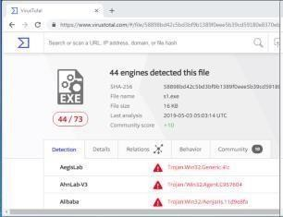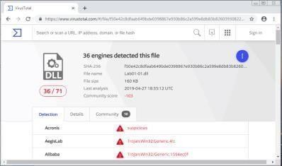

Figure 1.1— VirusTotal.com reports for **Lab01–01.exe** and **Lab01– 01.dll**.

Although the book states that these files are initially unlikely to appear within [VirusTotal](http://www.virustotal.com/), they have become part of the antivirus signatures so have been recognised. We currently see that 44/73 antivirus tools pick up on malicious signatures from **Lab01–01.exe**, whereas 36/71 identify **Lab01–01.dll** as malicious.

1. We can use [VirusTotal](http://www.virustotal.com/) to identify more information, such as when the files were compiled. We see that the two files were compiled almost at the same time (*around 2010–12–19 16:16:19*)

— this strengthens the theory as the two files are associated. Other tools can also be utilised to identify Time Date Stamp, such as [PE Explorer](http://www.pe-explorer.com/) (Figure 2.1).

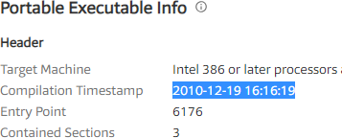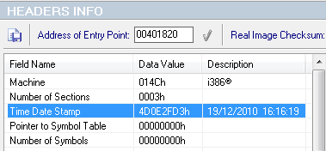

Figure 2.1 — Date Time Stamps from VirusTotal.com and PE Explorer.

1. When a file is **packed**, it is more difficult to analyse as it is typically obfuscated and compressed. Key indicators that a program is packed, is a lack of visible stringsor information,or including certain functions such as LoadLibrary or GetProcAddress — used for additional functions. A packed executable has a **wrapper program** which decompresses and runs the file, and when statically analysing a packed program, only the wrapper program is examined.

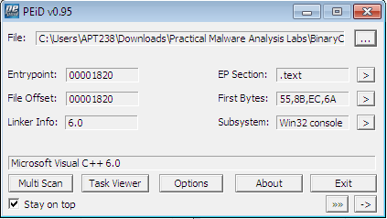

Figure 3.1 — PEiD of **Lab01–01.exe**

[PEiD](https://www.aldeid.com/wiki/PEiD) can be used to identify whether a file is packed, as it shows which packer or compiler was used to build the program. In this case *Microsoft Visual C++ 6.0* is used for both the **Lab01– 01.exe** and **Lab01–01.dll** (figure 3.1), whereas a packed file would be packed with something like [*UPX*.](https://upx.github.io/)

1. Investigating the **imports** is useful in identifying what the malware might do. Imports are functions used by a program, but are actually stored in a different program, such as common libraries.

Any of the previously used tools ([VirusTotal,](http://www.virustotal.com/) [PEiD](https://www.aldeid.com/wiki/PEiD), and [PE Explorer](http://www.pe-explorer.com/)) can be used to identify the imports. These are stored within the **ImportTable** and can be expanded to see which functions have been imported.

**Lab01–01.exe** imports functions from KERNEL32.dll and MSVCRT.dll, with **Lab01–01.dll** also importing functions from KERNEL32.dll, MSVCRT.dll, and WS2_32.dll (figure 4.1)

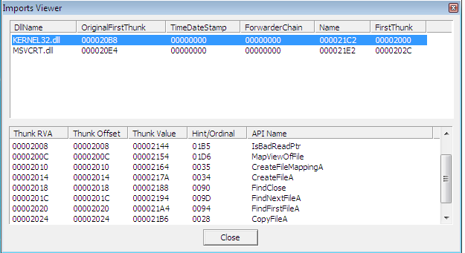

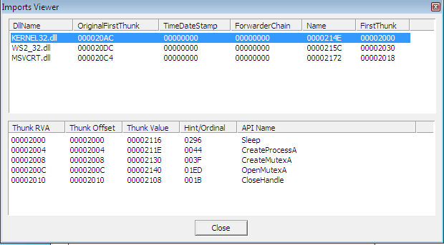

Figure 4.1— Import Tables from **Lab01–01.exe** and **Lab01–01.dll**.

* + KERNEL32.dllis a common DLL which contains core functionality, such as access and manipulation of memory, files, and hardware. The most significant functions to note for **Lab01–01.exe** are are FindFirstFileA and FindNextFileA , which indicates the malware will search through the filesystem, as well as open and modify. On the other hand, **Lab01– 01.dll** most notably uses Sleepand CreateProcessA.
  + WS2_32.dll provides network functionality, however in this case is imported by ordinal rather than name, it is unclear which functions are used.
  + MSVCRT.dllimports are functions that are included in most as part of the compiler wrapper code.

Assessing the combination of imported functions, so far it could be assumed that this malware allows for a network-enabled back door.

1. Along with **Lab01–01.exe** and **Lab01–01.dll**, there are other ways to identify malicious activity on infected systems. Disassembling **Lab01–01.exe** in [PE Explorer](http://www.pe-explorer.com/) shows us a set of strings around kerne132.dll which is supposed to be disguised as the common kernel32.dll— note 1 rather than l (figure 5.1).

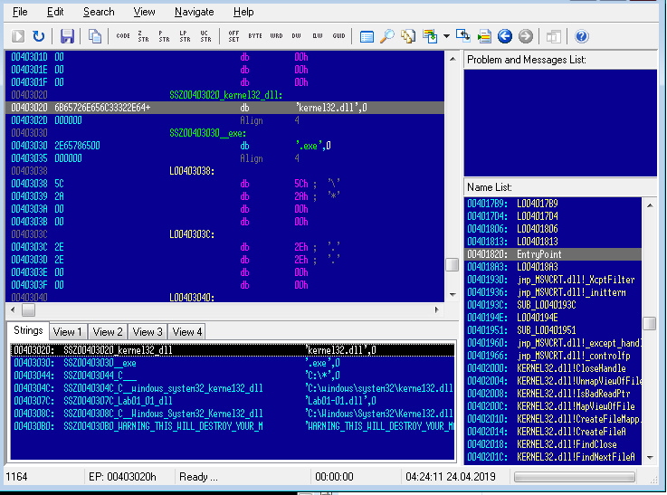

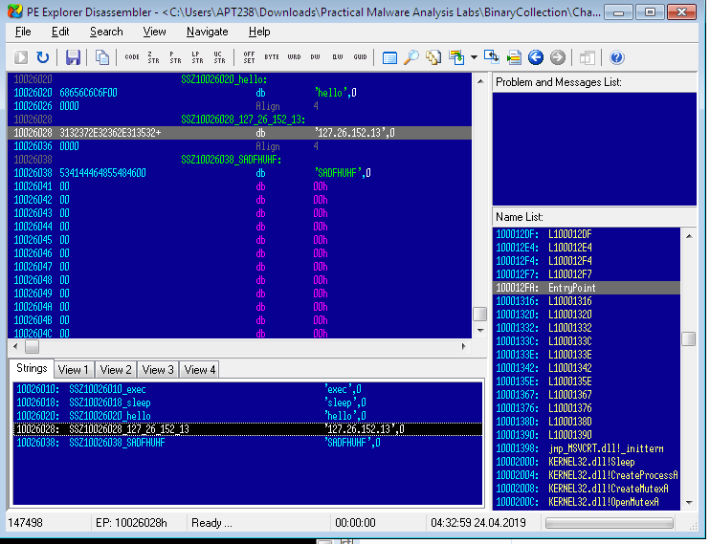

Figure 5.1— Disassembly of **Lab01–01.exe** and **Lab01–01.dll** using PE Explorer

1. Further investigating the strings, however for **Lab01–01.dll**, it is apparent that there is anIP address of 127.26.152.13 , which would act as a network based indicator of malicious activity (figure 5.1).
2. Bringing all the pieces together, there can be an assumption made that **Lab01–01.exe**, and by extension **Lab01–01.dll**, is malware which creates a backdoor. [VirusTotal](http://www.virustotal.com/) provided indication that the files were malicious, and utilising this or [PE Explorer](http://www.pe-explorer.com/) it was established that the two were likely related, with the **.dll** is dependant upon the **.exe**. The files are not packed(as identified by [PEiD](https://www.aldeid.com/wiki/PEiD)), small programs, with no exports, however specific imports which indicate that **Lab01–01.exe** might search through directories and create/manipulate files such as the disguised kernel32.dll, as well possibly searching for executables on the target system, as suggested by the string exec within **Lab01–01.dll**. In addition, there are network based imports, an IP address, as well as the functions imported from kernel32.dll, CreateProcess and sleep, which are commonly used in backdoors.

##### Analyse Lab01–02.exe.

1. 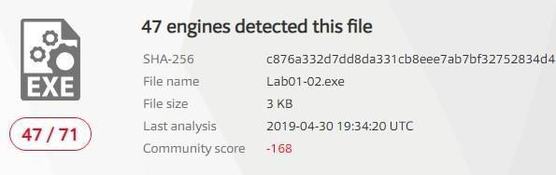As with the previous lab, uploading **Lab01–02.exe** in [VirusTotal.com](http://www.virustotal.com/) shows us that 47/71 antivirus tools recognise this file’s signature as malicious (figure 1.1).

Figure 1.1— VirusTotal.com reports for **Lab01–02.exe.**

1. 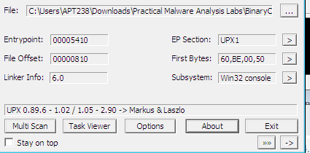We can identify whether the file is packed, either through [VirusTotal.com](http://www.virustotal.com/) or [PEiD.](https://www.aldeid.com/wiki/PEiD) A file which is not packed will indicate the compiler (eg, *Microsoft Visual C++ 6.0*), or the method in which it has been packed. Initially, [PEiD](https://www.aldeid.com/wiki/PEiD) declared there was *Nothing found \**, however after changing from a *normal* to *deep* scan, it has been determined that the file has been packed by [*UPX*](https://upx.github.io/) (figure 2.1).

Figure 2.1 — PEiD Deep scan

* + ***Normal*** *scan is at the Entry Point of the PE File for documented signatures.*
  + ***Deep*** *scan is the containing section of the Entry Point*
  + ***Hardcore*** *scan is a complete scan of the entire file for signatures.*

Another way of identifying whether the file has been packed or not, is via the Entry Point Section (*EP Section*) — these are UPX0, UPX1 and UPX2, section names for UPX packed files. UPX0has a virtual size of 0x4000 but a raw size of 0 (figure 2.2), likely reserved for uninitialized data — the unpacked code.

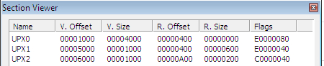

Figure 2.2 — PEiD PE Section Viewer

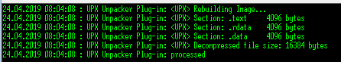We are able to unpack the file directly within [PE Explorer,](http://www.pe-explorer.com/) with the **UPX Unpacker Plug-in**. When enabled, this automatically unpacks the file when loaded (Figure 2.3).

Figure 2.3 — UPX Unpacker Plug-in running in PE Explorer

1. When the file is unpacked, we can investigate stringsand importsto see what the malwaregets up to. From the Import Viewer within [PE Explorer](http://www.pe-explorer.com/), we see there are four imports (figure 3.1).
   * KERNEL32.DLL— imported to most programs and doesn’t tell us much other than suggesting the potential of creating threads/processes.
   * ADVAPI32.dll — specifically CreateServiceA is of note.
   * MSVCRT.dll— imported to most programs and doesn’t tell us much.
   * 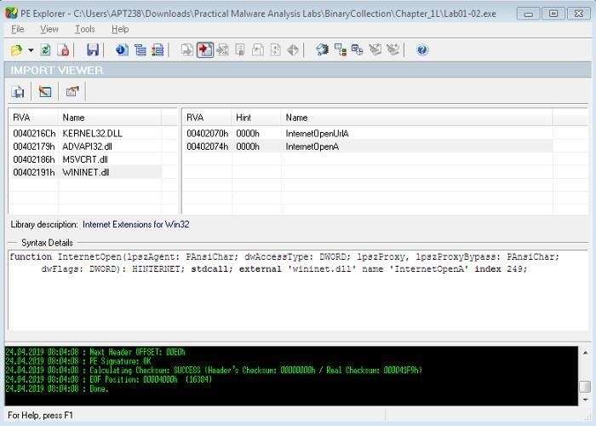WINNET.dll — specifically InternetOpenA and InternetOpenURLA are of note.

Figure 3.1 — Import Viewer within PE Explorer

1. 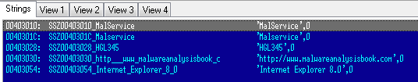So far, this is suggesting that the malware is creating a service and connecting to a URL. Checking out the strings of the file in the Disassembler, we see ‘*Malservice*’, ‘[*http://www.malwareanlysisbook.com*](http://www.malwareanlysisbook.com/)’ and ‘*Internet Explorer 8.0*’ (figure 3.2). These potentially act as host or network based indicators of malicious activity, though the service to run, URL to connect to, and the preferred browser.

Figure 3.2 — Disassembler Strings

##### C. Analyze the file Lab01-03.exe.

i- Once again, uploading to [VirusTotal.com](http://www.virustotal.com/) indicates that **Lab01–03.exe** is malicious due to 58/69 antivirus tools currently recognising signatures.

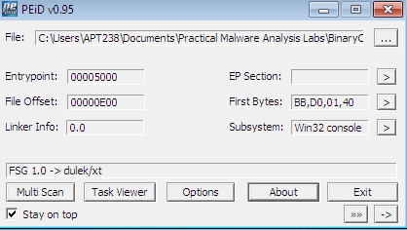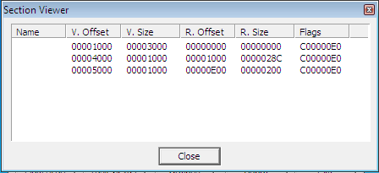ii Scanning this with [PEiD](https://www.aldeid.com/wiki/PEiD) demonstrates that **Lab01–03.exe** is packed with FSG 1.0 (figure 2.1 left). This is much more difficult to unpack than [UPX](https://upx.github.io/) and must be done manually. Currently we are unable to unpack this. Check out **Lab 18–2** (Chapter 18, Packers and Unpacking) to unpack in [OllyDbg.](http://www.ollydbg.de/)

Figure 2.1 —PEiD showing Lab01–03.exe packed with FSG 1.0 (left) and Section VIewer (right)

Other indicators that the file is packed, are the missing names in the EP Section viewer (Figure

2.1 right), as well as the first section having a virtual size of 0x3000 and a raw size of 0 — again most likely reserved for the unpacked code.

1. Although **Lab01–03.exe** is currently unpackable, we can still try to identify any imports to get an idea of what the file might do.

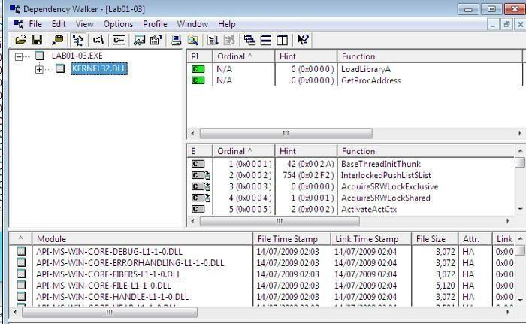

Figure 3.1 — Dependency Walker for **Lab01–03.exe**

Loading the file into [PE Explorer](http://www.pe-explorer.com/) unfortunately shows a blank Import Table, and running it in the Disassembler is also unhelpful. Another useful program is [Dependency Walker](http://www.dependencywalker.com/), which lists the imported and exported functions of a portable executable (PE) file (figure 3.1).

Here, we can see that **Lab01–03.exe** is dependant upon (and therefore imports) KERNEL32.DLL. The particular functions here are LoadLibraryA and GetProcAddress, however this does not tell us much about the functionality other than the fact the file is packed.

1. 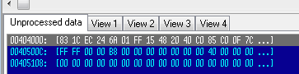We are unable to unpack the file the visible imports are uninformative, and we can’t see anystrings in [PE Explorer](http://www.pe-explorer.com/) (figure 4.1), it is difficult to suggest what the file might do, or identify any host/network based malware-infection indicators.

Figure 4.1 — PE Explorer showing no strings information for packed **Lab01–03.exe**

##### D- Analyze the file Lab01-04.exe.

1. **Lab01–04.exe** is recognised as malicious, with 53/72 engines detecting malicious signatures (Figure 1.1).
2. [PEiD](https://www.aldeid.com/wiki/PEiD) shows us that the file is unpacked (and compiled with *Microsoft Visual C++ 6.0*) (figure 2.1). Likewise, the EP section shows the valid file names as well as actual raw sizes for them all, rather than UPX0-3or blanks, as well as a raw size of 0, typically seen for packed files (figure 2.1). As this is not packed, there is no need to unpack it.

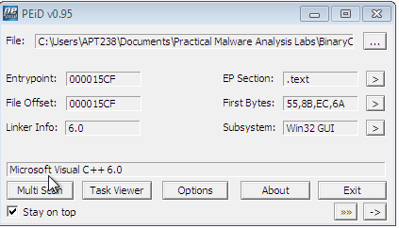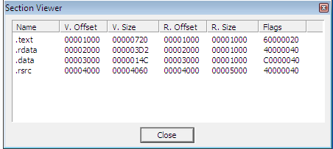

Figure 2.1 — PEiD showing Lab01–04.exe is not packed and Section VIewer

1. Loading **Lab01–04.exe** into [PE Explorer](http://www.pe-explorer.com/), we initially see that the Date Time Stamp is clearly faked (figure 3.1). At the time of writing it looks as though the file was compiled monthsin the future, and it's not immediately clear what the real stamp should be.

Figure 3.1 — Date Time Stamp of **Lab01–04.exe**

1. Switching to the Import Viewer within [PE Explorer](http://www.pe-explorer.com/), we see that there are three of the common .dllimported (figure 4.1).

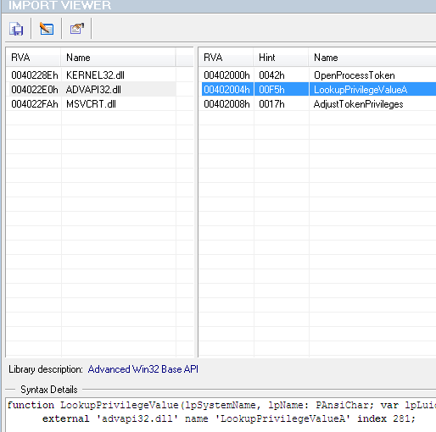

Figure 4.1 — Import Viewer for **Lab01–04.exe**

* + KERNEL32.dll— Core functionality, such as access and manipulation of memory, files, and hardware.
  + ADVAPI32.dll — Access to advanced core Windows components such as the Service Manager and Registry. The functions here look like they’re doing something with privileges.
  + MSVCRT.dll— imports are functions that are included in most as part of the compiler wrapper code.

Assessing the combination of imports, there are a few key ones which can point us in the direction of the program’s functionality.

* + SizeOfResource, FindResource, and LoadResourceindicate that the file is searchingfor data in a specific resource.
  + CreateFile, WriteFileand WinExecsuggests that it might write a file to disk andexecute it.
  + LookupPrivilegeValueA and AdjustTokenPrivilages indicates that it might accessprotected files with special permissions.

1. Looking at the strings is often a good way to identify any host/network based malware- infection indicators. Again, this can be done through the Disassembler in [PE Explorer](http://www.pe-explorer.com/) (Figure 5.1)

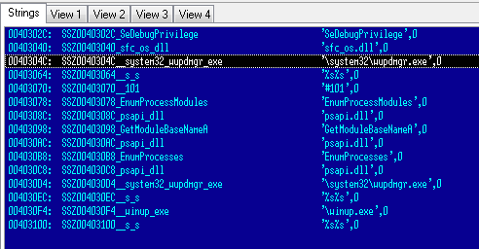

Figure 5.1 — **Lab01–04.exe** strings within PE Explorer Disassembler

The strings of note here look like ‘*\system32\wupdmgr.exe*’, ‘*psapi.dll*’ and ‘*\winup.exe*’ — potentially these are the files which the .dll identified, create, or execute. ‘*\system32\wupdmgr.exe*’ might correlate with KERNEL32.dll GetWindowsDirectoryfunctionto write to system directory and the malware might modify the Windows Update Manager.

This gives us some host-based indicators, however there is nothing apparent regarding network functions.

1. Previously overlooked in [PEiD](https://www.aldeid.com/wiki/PEiD)’s Section Viewer, there is a resources file .rsrc —The Resource Table. This is also seen in [PE Explorer](http://www.pe-explorer.com/)’s Section Headers.

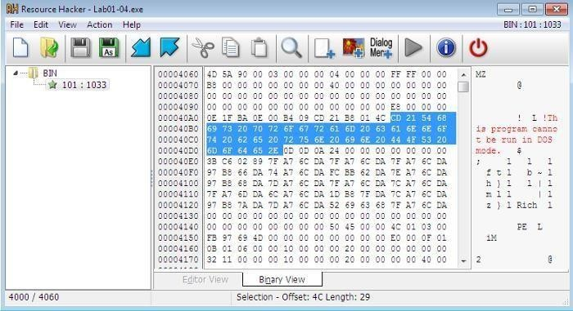

Figure 6.1 — Resource Hacker identifying **Lab01–04.exe**’s **binary resource**

We are able to open this within [Resource Hacker,](http://angusj.com/resourcehacker/) a tool which can be used to manipulate resources within Windows binaries. Loading **Lab01–04.exe** into [Resource Hacker](http://angusj.com/resourcehacker/) identifies that resource as binary and lets us search through it. (figure 6.1)

1. **Analyze the malware found in the file Lab03-01.exe using basic dynamic analysis tools.**
2. This dynamic analysis starts with initial static analysis to hopefully gain a baseline understanding of what might be going on. Straight in with [PEiD](https://www.aldeid.com/wiki/PEiD) and [PE Explorer](http://www.pe-explorer.com/) we see that **Lab03–01.exe** is evidently PEncrypt 3.1 packed, and only visible import of kernel32.dll and function ExitProcess(figure 1.1). Also, there are are no apparent strings visible.

Figure

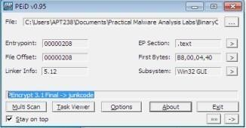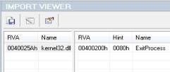

1.1 — File **Lab03–01.exe** is packed, and has minimal imports

It’s difficult to understand this malware’s functionality with this minimal information.

Potentially the file will unpack and expose more information when it is run. One thing we can do is execute [strings](https://docs.microsoft.com/en-us/sysinternals/downloads/strings) to scan the file for UNICODE or ASCII characters not easily located. Doingthis we can identify some useful information.

There is a bit of noise here which have been removed, and the main ones are highlighted in red (table 1.1).

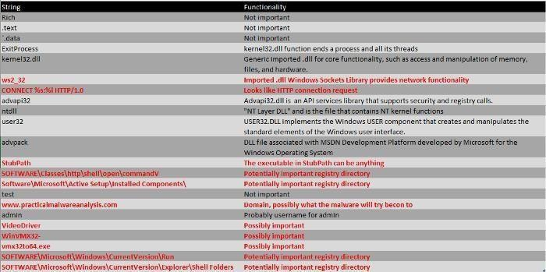

Table 1.1 — Processed output of strings*function on* **Lab03–01.exe**

Looking at these, we can make some rough assumptions that **Lab03–01.exe** is likely to do some network activity and download and hide some sort of file in some of the registry directories, under one of those string names.

1. To identify host-based indicators, we can make assumptions from the previous strings output, such as potentially attaching itself to SOFTWARE\Microsoft\Windows\CurrentVersion\Run\VideoDriver — however, it is more useful to perform **dynamic analysis** and see what it’s doing. Take a snapshot of the VM so you’re able to revert to a pre-execution state!

Set VM networking to Host-only, and manually assign the preferred DNS server as [iNetsim,](http://www.inetsim.org/) or configure the DNS reply IP within [ApateDNS](https://www.fireeye.com/services/freeware/apatedns.html) to loopback, and set up listeners using [Netcat](http://netcat.sourceforge.net/) (ports 80 and 443 are recommended as a starting point as these are common).

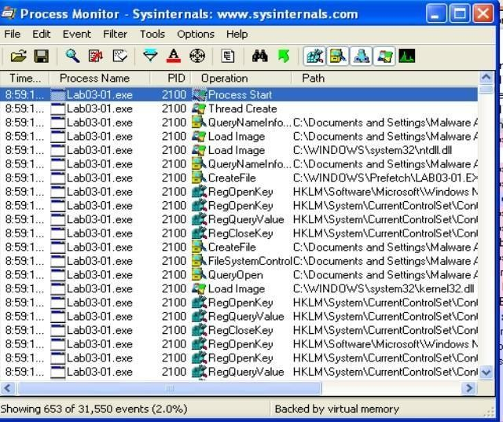Clear all processes within [Procmon,](https://docs.microsoft.com/en-us/sysinternals/downloads/procmon) and apply suitable filters to clear out any noise and find out what the malware is doing. Initially filter to include Process **Lab3–1.exe** so we can see its activity. Likewise, start [Process Explorer](https://docs.microsoft.com/en-us/sysinternals/downloads/process-explorer) for collecting information about processes running on the system.

Figure 2.1 — [Procmon](https://docs.microsoft.com/en-us/sysinternals/downloads/procmon) of **Lab03–01.exe**

The first thing we notice when executing **Lab03–01.exe** is the series of Registry Key operations (Figure 2.1). This doesn’t tell us too much about what the malware is doing specifically however,

it’s always useful to see an overview of the activities. We can filter this further to only show

WriteFileand RegSetValueto see the key operations (figure 2.2)

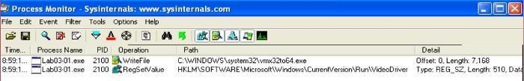

Figure 2.2 — [Procmon](https://docs.microsoft.com/en-us/sysinternals/downloads/procmon) of **Lab03–01.exe**, filtered for WriteFileand RegSetValue

We can investigate these operations further, and we see that they are related. First, a file is written to C:\WINDOWS\system32\**vmx32to64.exe** (*note, this filename is a string we’ve identified as part of the initial static analysis*) however, this appears to be set to the registry of HKLM\SOFTWARE\Microsoft\Windows\CurrentVersion\Run\VideoDriver (*another identified string!*). This is a strong host-based indicator that the malware is up to something (Figure 2.3).

Most likely the malware is intended to be run at startup.

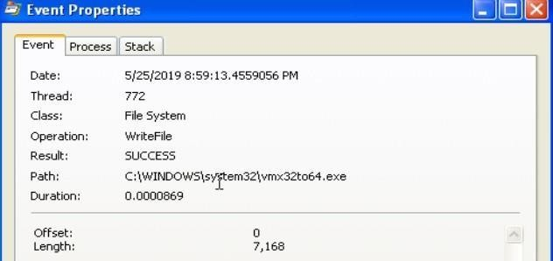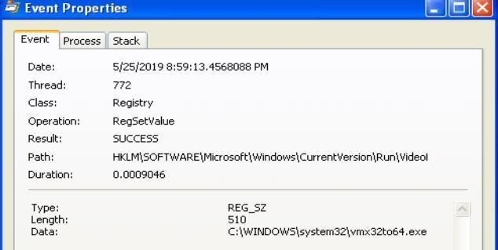

Figure 2.3 — **Lab03–01.exe** hiding under **vmx32to64.exe** *and set to* ***VideoDriver*** *registry.*

Upon further investigation, it appears as though files **vmx32to64.exe** and **Lab03–01.exe** share the same hash (figure 2.4), indicating the malware has established persistence through creating and hiding a copy of itself, as well as to execute at startup via the VideoDriverregistry.

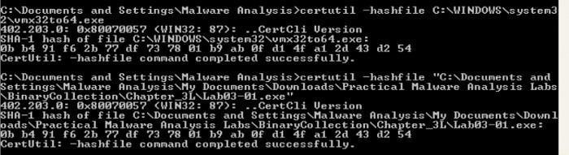

Figure 2.4 — **Lab03–01.exe** sharing the same SHA1 Hash as **vmx32to64.exe***.*

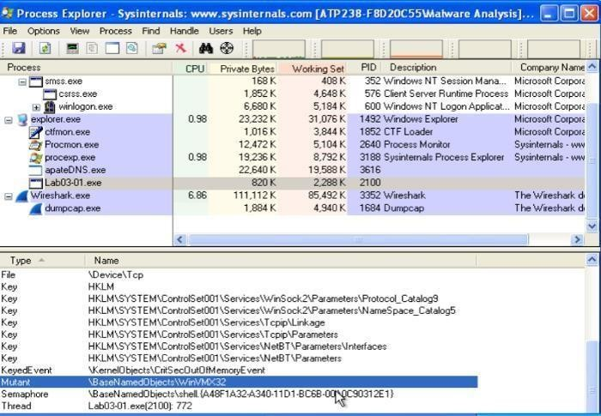Further host-based indicators can be identified through analysis of [Process Explorer](https://docs.microsoft.com/en-us/sysinternals/downloads/process-explorer), to show which handles and DLLs the malware has opened or loaded.

Figure 2.4 — [Process Explorer](https://docs.microsoft.com/en-us/sysinternals/downloads/process-explorer) showing Mutex **WinVMX32**

[Process Explorer](https://docs.microsoft.com/en-us/sysinternals/downloads/process-explorer) shows us that **Lab03–01.exe** has created at mutex of WinVMX32(*again, another identified string*) (Figure 2.4). A mutex (mutual exclusion objects) is used to ensure that only once instance of the malware can run at a time — often assigned a fixed name. We also see **Lab03–01.exe** utilises ws2_32.dlland wshtcpip.dllfor network capabilities.

1. 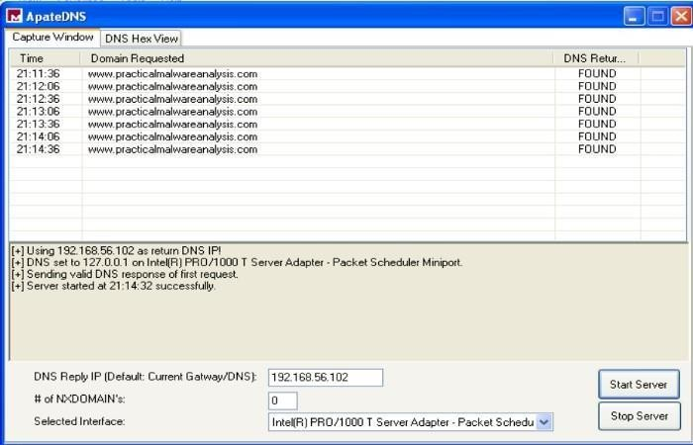We’re able to analyse network activity either locally on the victim, or utilising [iNetSim.](https://www.inetsim.org/) I have demonstrated both, having configured DNS to either the [iNetSim](https://www.inetsim.org/) machine or loopback (for the [netca](https://en.wikipedia.org/wiki/Netcat#%3A~%3Atext%3Dnetcat%20(often%20abbreviated%20to%20nc%2Cby%20other%20programs%20and%20scripts)t listeners). Turning our attention to [ApateDNS](https://www.fireeye.com/services/freeware/apatedns.html) and our [iNetSim](https://www.inetsim.org/) logs, we see some pretty significant network-based indicators of this malware activity. [ApateDNS](https://www.fireeye.com/services/freeware/apatedns.html) show regular DNS requests to [www.practicalmalwareanalysis.com](http://www.practicalmalwareanalysis.com/)every 30 seconds (figure 3.1).

Figure 3.1 — [**ApateDNS**](https://www.fireeye.com/services/freeware/apatedns.html) showing DNS beaconing

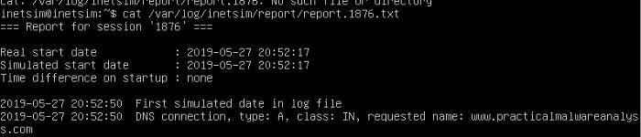The [ApateDNS](https://www.fireeye.com/services/freeware/apatedns.html) capture suggests the malware is beaconing — possibly to either to fetch updates/instructions or to send back stolen information.

Figure 3.2 — [iNetSim](https://www.inetsim.org/) logs

Also, the associated [iNetSim](https://www.inetsim.org/) logs show a recognised DNS request for the malicious website, providing further indication of beaconing intent.

Finally, the [Netcat](http://netcat.sourceforge.net/) listener (with DNS configured for loopback) has picked up a transmission on port 443. This shows a series of illegible characters emitted from the malware (Figure 3.3). On subsequent executions or periodic ticks, the transmission is unique.



Figure 3.3 — Illegible characters transmitted by **Lab03–01.exe.**

The combination of host and network-based indicators provide significant grounding to make assumptions regarding the malware’s activity.

* From **Static Analysis**, not a lot was uncovered other than the output of what might use as hard-coded parameters.
* **Dynamic Analysis** to uncover further host-based indicators show that the malware has replicated and masked under another file name has associated with the registry for execution on startup and has network functionality.
* Network-based activity is identified through capturing periodic DNS requests, as well as intercepting random character transmissions of HTTP & SSL

##### Analyze the malware found in the file Lab03-02.dll using basic dynamic analysis tools.

1. At first glance, we have **Lab03–02.dll.** As this is not a .exe file, we are unable to directly execute it. rundll32.exe is a windows utility which loads and runs 32-bit dynamic-link libraries (.dll).

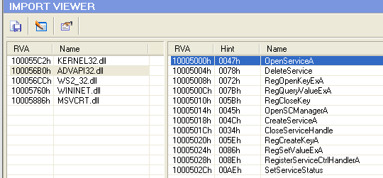First, however, we likely require any exported functions to pass in as an argument. This can be identified through PE analysis, which shows us a set of exported and imported functions. The imported functions (Figure 1.1) give us an idea of the .dll’s capabilities. Speculation into these might suggest there will likely be some networking going on, as well as some file, directory and registry manipulation. Functions included as part of ADVAPI32.dll suggests the malware may need to be run as a service, which is backed up by **Lab03–02.dll**’s exports (Figure 1.1)

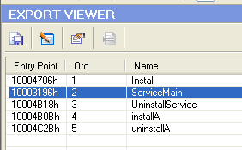

Figure 1.1 — **Lab03–02.dll**’s Imports and Exports showing likely service capabilities

Running [streams](https://docs.microsoft.com/en-us/sysinternals/downloads/strings)also gives us a lot of useful insight into potential actions. Most of which are found as imported functions, however, there are others worth noting that my be useful host/network-based indicators. These include some very distinctive strings, potential registry locations and file or network names, as well as some base64 encoded strings hinting at some functionality (Figure 1.2).

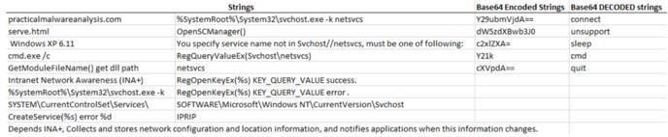

Figure 1.2 — **Lab03–02.dll**’s strings showing potential functionality.

Now we have a starting point to look out for, we can prepare our environment for trying to run the malware — clearing [procmon,](https://docs.microsoft.com/en-us/sysinternals/downloads/procmon) taking a [registry snapshot](https://sourceforge.net/projects/regshot/), and setting up the network.

1. To install the malware, pass one of Installor installA(found from the exports) into

rundll32.

Executing C:\rundll32.exe Lab03-02.dll,install doesn’t give any immediate feedback onthe command line, within [process explorer,](https://docs.microsoft.com/en-us/sysinternals/downloads/process-explorer) or [Wireshark](https://www.wireshark.org/)/[iNetSim,](https://www.inetsim.org/) however taking a 2nd [registrysnapshot](https://sourceforge.net/projects/regshot/) and comparing the two, it’s clear that keys and values have been added — many of these matching up with what we found from [strings](https://docs.microsoft.com/en-us/sysinternals/downloads/strings)(Figure 2.1)

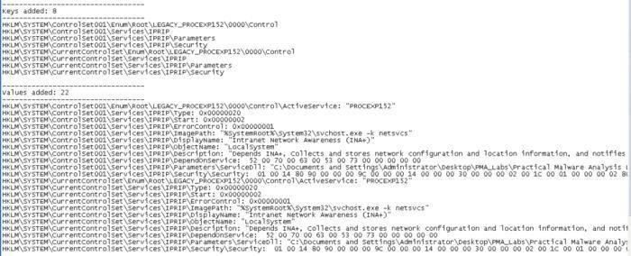

Figure 2.1 — Registry keys and values added as a result of installing **Lab03–02.dll**

We can see within the [regsho](https://sourceforge.net/projects/regshot/)t comparison that something called IPRIP has been added as a service, with some of the more identifiable strings as \DisplayName or \Description. The image path has also been set to %SystemRoot%\System32\svchost.exe -k netsvcs whichshows the malware is likely to be launched within **svchost.exe** with network services as an argument.

1. Since we have installed **lab03–02.dll** as a service, we can now run this and we see the same

\DisplayName+ update found from the added reg values (Figure 3.1).

Figure 3.1 — Starting the IPRIP service

Checking out [ProcessExplorer](https://docs.microsoft.com/en-us/sysinternals/downloads/process-explorer) to see what’s happened, we can search for the **Lab03–02.dll**

which will point us to the **svchost.exe** instance that was created.

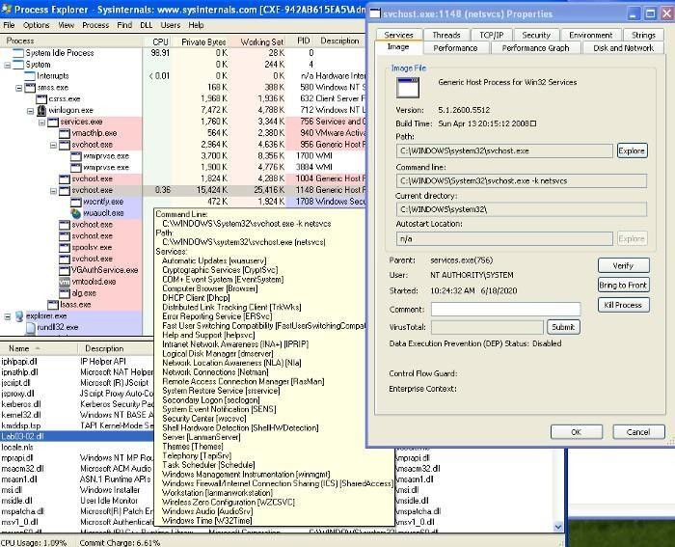

Figure 3.2 — Process Explorer showing **svchost.exe** launched with **Lab03–02.dll**

We can identify various indicators which attribute **Lab03–02.dll** to this instance of **svchost.exe** thorough the inclusion of the .dll, the service display name *“Intranet Network Awareness (INA+)”*, and the command line argument matching what has been found in strings. This helps us to confirm that **Lab03–02.dll** has been loaded — note the *process ID, 1148*. We’ll need this to see what’s going on in [ProcMon](https://docs.microsoft.com/en-us/sysinternals/downloads/procmon)!

1. Checking out [ProcMon,](https://docs.microsoft.com/en-us/sysinternals/downloads/procmon) filtered on *PID 1148*, we see a whole load of registry RegOpenKey

and ReadFiles, however, seems mostly **svchost.exe** related and nothing jumps out as malicious.

1. Turing our attention to look for network-based indicators, we have traffic captured within [Wireshark,](https://www.wireshark.org/) as well as logged within [iNetSim.](https://www.inetsim.org/) To give us an idea of what to look for, we can check out the [iNetSim](https://www.inetsim.org/) logs first (Figure5.1), which show us that we have seen 2 notable types of activity; DNS and HTTP connections. The DNS appears to be periodic requests to practicalmalwareanalysis.com (which we previously saw similar with **Lab03–01.exe**), as well as a HTTP GET request to <http://practicalmalwareanalysis.com/serve.html>which attempts to download a file. Fortunately, as we had [iNetSim](https://www.inetsim.org/) set up to respond, it provides a dummy file to complete the request — /var/lib/inetsim/http/fakefiles/sample.html. If we didn’t have this, we might have downloaded something real nasty.

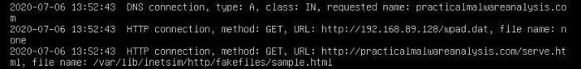

Figure 5.1 — iNetSim logs of **Lab03–02.dll**’s DNS and HTTP request

We’re able to look at these within [Wireshark](https://www.wireshark.org/) and inspect the packets in more detail. Filtering on DNS, we’re able to see the DNS request to practicalmalwareanalysis.com(Figure 5.2).

Finding the conversation between the host and [iNetSim](https://www.inetsim.org/) and following the TCP stream, we’re able to see the content within the HTTP GET request to <http://practicalmalwareanalysis.com/serve.html> (Figure 5.2). This also shows [iNetSim](https://www.inetsim.org/)’s dummy content replacing serve.hmtl.

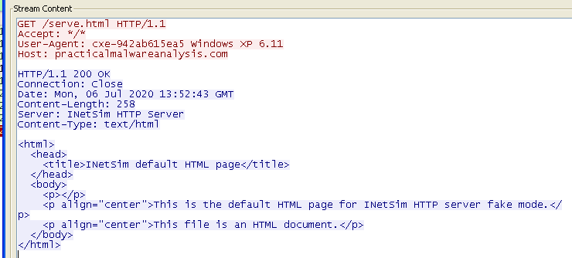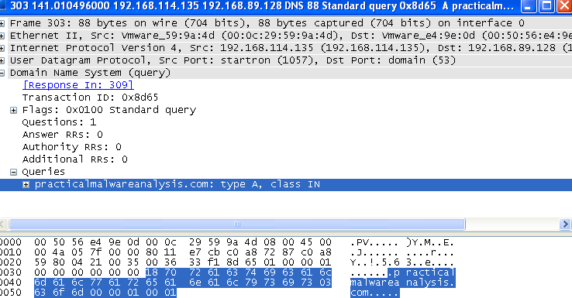

Figure 5.2 — [Wireshark](https://www.wireshark.org/) traffic for **Lab03–02.dll** DNS (left) and HTTP (right)

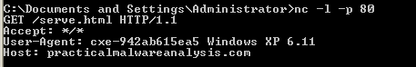

Figure 5.3 — [Netcat](http://netcat.sourceforge.net/) receiving HTTP GETheader

Reverting to snapshot and reinstalling & launching the malicious .dll/service, we can also capture traffic by using [ApateDNS](https://www.fireeye.com/services/freeware/apatedns.html) to redirect to loopback were we have a [Netcat](http://netcat.sourceforge.net/) listener on port 80 (Figure 5.3). Here, we see the same HTTP GETheader as we did within [Wireshark.](https://www.wireshark.org/)

Referring back to the strings output, *“practicalmalwareanalysis.com”*, *“serve.html”*, and *“Windows XP 6.11”* are also evident within the network analysis and can be used as signatures for the malware.

To recap on the main host/network-based indicators we see:

* IPRIPinstalled as a service, including strings such as *“Intranet Network Awareness (INA+)”*
* Network activity to *“practicalmalwareanalysis.com/serve.html”* as well as the User- Agent *%ComputerName% Windows XP 6.11.*

##### Execute the malware found in the file Lab03-03.exe while monitoring it using basic dynamic analysis tools in a safe environment

1. 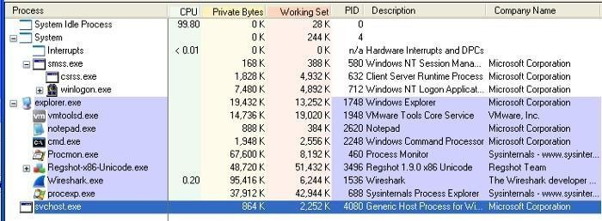After prepping for dynamic analysis, launch **Lab03–03.exe** and you may notice it appear briefly within [Process Explorer](https://docs.microsoft.com/en-us/sysinternals/downloads/process-explorer) with a child process of svchost.exe. After a moment however, it disappears leaving svchost.exeorphaned (Figure 1.1).

Figure 1.1 — Orphaned svchost.exe

An orphaned process is one with no parent listed in the process tree. svchost.exe typically hasa parent process of services.exe, but this one being orphaned is unusual and suspicious.

Investigating this instance of svchost.exe, we see it has a Parent: Lab03-03.exe(904), confirming it’s come from executing **Lab03–03.exe**. Exploring the properties further, we don’t see much anomalous until we get to the strings.

1. Utilizing strings within [Process Explorer](https://docs.microsoft.com/en-us/sysinternals/downloads/process-explorer) is actually a useful trick to analyse malware which is packed or encrypted, because the malware is running and unpacks/decodes itself when it starts.

We’re also able to view strings in both the image on disk and in memory.

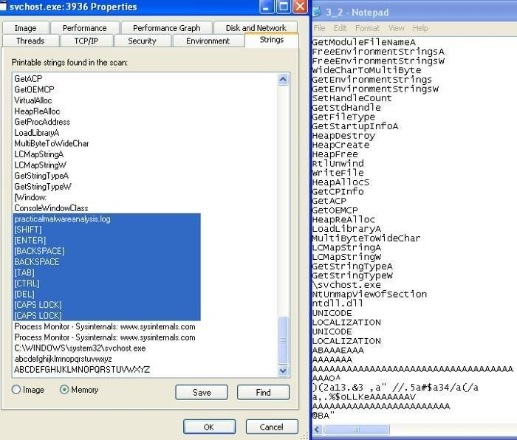

Figure 2.1 — Comparing strings in memory from process explorer and from running strings on

**Lab03–03.exe**

Taking advantage of this, we can inspect the strings in Image and in Memory, as well as compare against what we found from stringsduring quick static analysis.

The strings on image appear pretty consistent with other instances of svchost.exe however, within Memory, these much greater resemble what we discovered earlier, but with a few distinct differences — practicalmalware.log and a set of keyboard commands (Figure 2.1). This is an indicator that the keylogger guess might be accurate.

1. To test the keylogger hypothesis, we can open something and type stuff. To target explicitly on the malware, filter on the suspect svchost.exe(PID, 3936) within Process Monitor, and wesee a whole load of file manipulation for practicalmalwareanalysis.log(Figure 3.1).

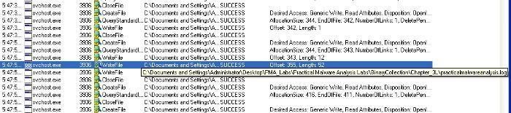

Figure 3.1 — Process Monitor file manipulation from malicious svchost.exe

1. Opening practicalmalwareanalysis.log, we find that the file captures inputted strings and distinctive keyboard commands as seen within the memory strings from [Process Explorer](https://docs.microsoft.com/en-us/sysinternals/downloads/process-explorer) (Figure 4.1). This confirms that **Lab03–03.exe** a keylogger using process replacement on svchost.exe.

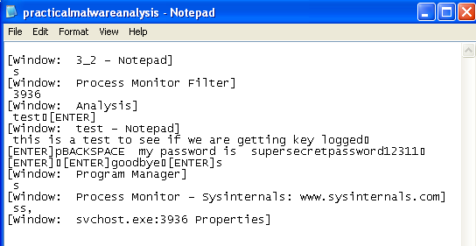

Figure 4.1 — Evidence of **Lab03–03.exe** keylogging

##### Analyze the malware found in the file Lab03-04.exe using basic dynamic analysis tools. i-What happens when you run this file?

When we run the file. Process is created which opens up the CMD and then deleted the original executable after making it execute and hide itself somewhere else.

##### What is causing the roadblock in dynamic analysis?

The executable is evasive and trying to evade itself by checking whether the system is VM or not. AV-Detection etc. Obviously this will make it difficult to observer the file via dynamic analysis.

##### Are there other ways to run this program?

The other ways can be to open this executable using Ollydbg or IDA pro where we can analyze it in a more efficient way.

# Practical No. 2

#### Analyze the malware found in the file Lab05-01.dll using only IDA Pro. The goal of this lab is to give you hands-on experience with IDA Pro. If you’ve already worked with IDA Pro, you may choose to ignore these questions and focus on reverse engineering the malware

[IDA Pro,](https://www.hex-rays.com/products/ida/) an Interactive Disassembler, is a disassembler for computer programs that generates assembly language source code from an executable or a program. IDA Pro enables the disassembly of an entire program and performs tasks such as function discovery, stack analysis, local variable identification, in order to understand (or change) its functionality.

This lab utilises IDA to explore a malicious .dll and demonstrates various techniques for navigation and analysis. Any useful shortcuts will be identified.

##### What is the address of DllMain?

The address off DllMain is 0x1000D02E. This can be found within the graph mode, or within the Functions window (figure 2).

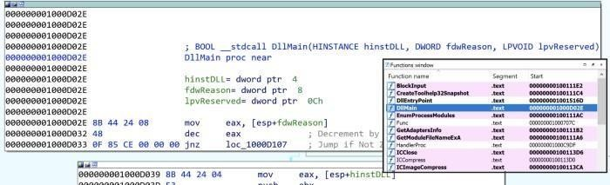

Figure 2: Address of DllMain

##### Where is the import gethostbyname located?

gethostbynameis located at 0x100163CCwithin .idata(figure 3).This is found through the Imports window and double-clicking the function. Here we can also see gethostbyname also takes a single parameter — something like a string.



Figure 3: Location of gethostbyname

##### How many functions call gethostbyname?

Searching the xrefs (ctrl+x) on gethostbynameshows it is referenced 18 times, 9 of which aretype

(p) for the near calll, and the other 9 are read (r) (figure 4). Of these, there are 5 unique calling functions.

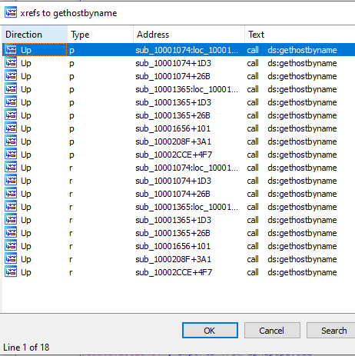

Figure 4: gethostbyname xrefs

##### For gethostbyname at 0x10001757, which DNS request is made?

Pressing G and navigating to 0x10001757, we see a call to thegethostbyname function, which we know takes one parameter; in this case, whatever is in eax— the contents of off_10019040(figure 5)

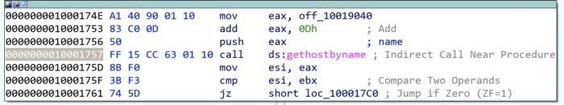

Figure 5: gethostbyname at 0x10001757

The contents of off_10019040points to a variable aThisIsRdoPicsPwhich contains the string

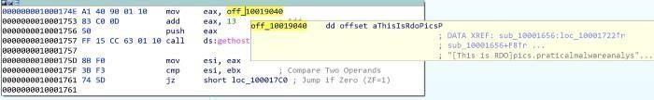[This is RDO]pics.practicalmalwareanalysis.com. This is moved into eax (figure 6).

Figure 6: Contents of off_1001904 (aThisIsRdoPicsP)

Importantly, 0Dhis added to eax, which moves the pointer along the current contents. 0Dhcan be converted in IDA by pressing H, to 13. This means the eax now points to 13 characters inside of its current contents, skipping past the prefix [This is RDO] and resulting in the DNS request being made for pics.practicalmalwareanalysis.com.

##### v & vi. How many parameters and local variables are recognized for the subroutine at 0x10001656?

There are a total of 24 variables and parameters for sub_10001656(figure 7).

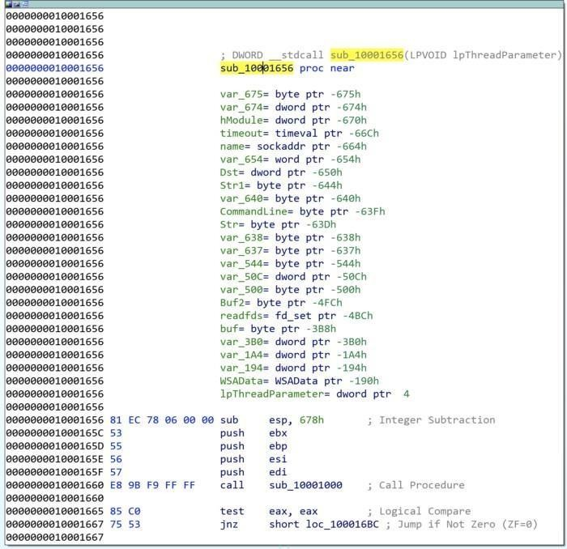

Figure 7: sub_10001656 parameters and varliables

Local variables correspond to negative offsets, where there are **23**. Many are generated by IDA and prepended with var_ however there are some which have been resolved, such as name or commandline. As we work through, we generally rename any of the important ones.

Parameters have positive offsets. Here there is **one**, currently lpThreadParameter. This mayalso be seen as arg_0if not automagically resolved.

##### Where is the string \cmd.exe /c located in the disassembly?

Press Alt+Tto perform a string search for \cmd.exe /c, which is stored as aCmdExeC, foundwithin

sub_1000FF58at offset 0x100101D0(figure 8).

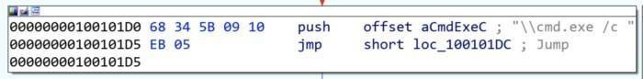

Figure 8: Location of ‘\cmd.exe /c’

##### What happens around the referencing of \cmd.exe /c?

The command cmd.exe /c opens a new instance of cmd.exe and the /c parameter instructs it to execute the command then terminate. This suggests that there is likely a construct of something to execute somewhere nearby.

Taking a cursory look around sub_1000FF58, we see several indications of what might be happening. Look for push offset Xfor quick wins.

Towards the top of the function, we see an address that is quite telling of what is happening. The offset aHiMasterDDDDDD called at 0x1001009Dcontains a long message which includes several strings relating to system time information (actually initialised just before), but more notably reference to a **Remote Shell** (figure 9).

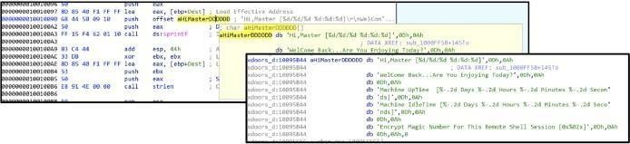

Figure 9: Contents of offset aHiMasterDDDDDD

Further on throughout the function, there are more interesting offset addresses with strings that may provide an indication of activity.

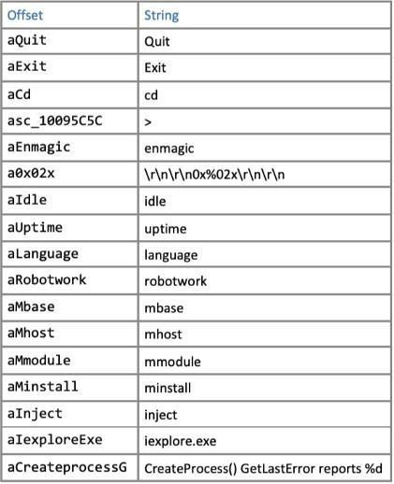

Figure 10: Offset strings within sub_1000FF58

Some of which are likely part of any commandline activity, whereas others may be additional modules. Some of the notable ones might be

aInject, aIexploreExe, and aCreateProcessG, which could be indicative of process injection into

iexplore.exe.

##### At 0x100101C8, dword_1008E5C4 indicates which path to take. How does the malware set dword_1008E5C4?

The comparison of dword_1008E5C4and ebxwill determine whether \cmd.exe /cor

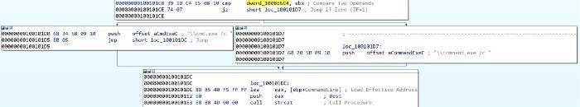\command.exe /c is pushed; likey based upon the Operating System version to utilise the correct command prompt (figure 11).

Figure 11: cmd.exe or command.exe options

Following the xrefs of dword_1008E5C4, we see it written (type w) in sub_10001656, with thevalue of eax. There is a preceding call to sub_10003695, where the function takes a look at thesystem’s Version Information (using API call GetVersionExA) (figure 12).

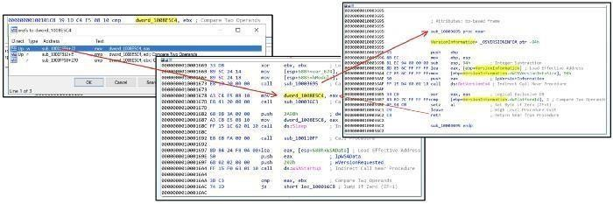

Figure 12:

There is a comparison between the VersionInformation.dwPlatformId and 2, so looking at the [Windows Platform IDs](https://docs.microsoft.com/en-us/dotnet/api/system.platformid?view=net-6.0) we see that it is looking to see if ‘The operating system is WindowsNT or later.’ If it is, then \cmd.exe /cis pushed. If not, then it is \command.exe /c.

##### What happens if the string comparison to robotwork is successful?

The robotworkstring comparison is completed using the function memcmp, which returns **0** if the two strings are identical. The JNZ branch jumps if the result **Is Not Zero**. This means, if the robotwork comparison is successful, returning 0, then the jump does not execute (the red path). If the memcmp was unsuccessful, then some other non-zero value would be returned and the jump (green path) would be followed (figure 13).

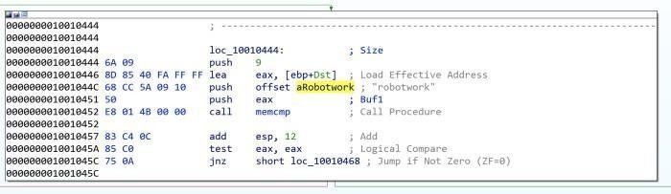

Figure 13: memcmp of robotwork

Not jumping, (and following the red path), leads to a new function sub_100052A2 which includes registry keys SOFTWARE\Microsoft\Windows\CurrentVersion WorkTime and WorkTimes. The function is looking for values within the WorkTime and WorkTimes ( RegQueryValueExA) and if so, are displayed as part of the relevant aRobotWorktimeoffsetaddresses (via %d) (figure 14).

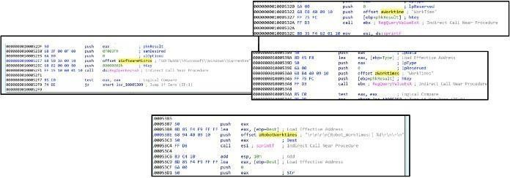

Figure 14: Querying SOFTWARE\Microsoft\Windows\CurrentVersionWorkTimeand WorkTimesregistry keys

The start of the function takes in a parameter for SOCKETas s, which is then passed through to a new function (sub_100038EE) along with the registry values (ebp) (figure 15).

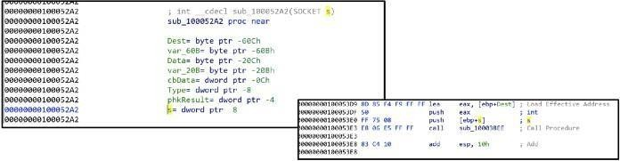

Figure 15: Passing registry values through SOCKET s

Therefore, if the string comparison for robotwork is successful, the registry keys SOFTWARE\Microsoft\Windows\CurrentVersion WorkTime and WorkTimes are queried and the values passed through (likely) the remote shell connection.

##### What does the export PSLIST do?

Figure 16: Exports view

Open the exports list and find the exported function PSLIST. (figure 16).

Navigate here and see there are three subroutines. One of which queries OS version information (similar as seen in Q9, but this time also sees if dwMajorVersion is 5 for more specific OS footprinting ([dwMajorVersions](https://docs.microsoft.com/en-us/windows/win32/api/winnt/ns-winnt-osversioninfoexa#remarks))), and depending on the outcome, will call either sub_10006518or sub_1000664C(figure 17).

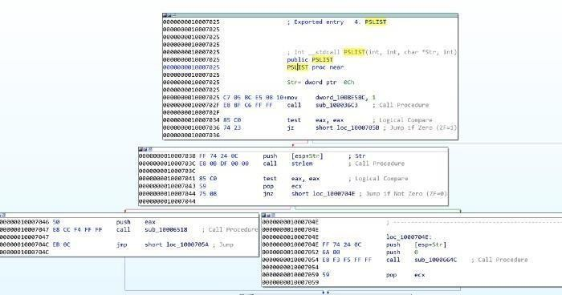

Figure 17: PSLIST exported function paths

Both sub_10006518 and sub_1000664C utilise CreateToolhelp32Snapshot to take a snapshotof the specified processes and associated information, and then execute appropriate commands to query the running processes IDs, names, and the number of threads. sub_1000664Calso includesthe SOCKET

(s) to send the output out to (figure 18).

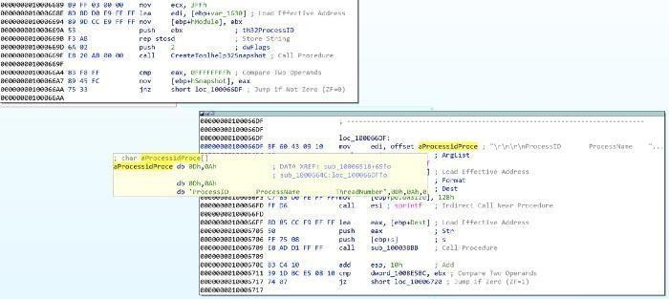

Figure 18: Using CreateToolhelp32Snapshot, quering running processes, and sendingto socket

##### Which API functions could be called by entering sub_10004E79?

A useful way to quickly see what API functions are called by a certain subroutine is through the Proximity Brower view, this transforms the standard Graph or Text views into a much more condensed graph highlighting which API functions or subroutines are called (figure 19)

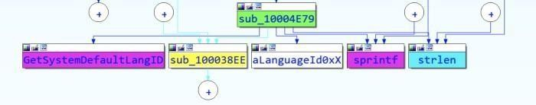

Figure 19: Proximity View of sub_10004E79

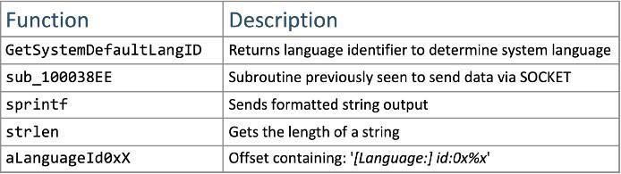

Figure 20: Functions called by sub_10004E79

The functions called from sub_10004E79(figure 20) indicate that the functionality is to identifythe language used on the system, and then pass that information through the SOCKET (as we’ve seen sub_100038EE before). It might make sense to rename sub_10004E79 to something like **getSystemLanguage**. While we’re at it, we might aswell rename sub_100038EE to something like **sendSocket**.

##### How many Windows API functions does DllMain call directly, and how many at a depth of 2?

Another way to view the API functions called from somewhere, is through View -> Graphs -> User XRef Chart. Set start and end addresses to DllMainand the Recursion depth to 1 to see four API functions called (figure 21). At a depth of 2, there are around 32, with some duplicates.

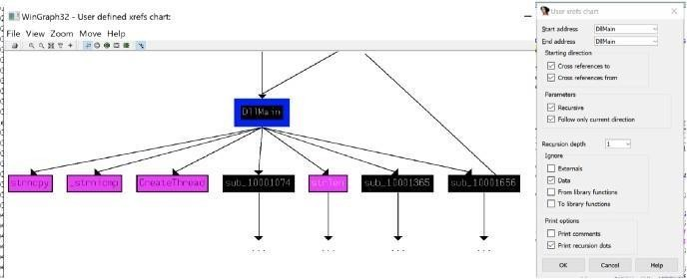

Figure 21: API functions called by DllMain.

Some of the more notable API calls which may provide indication of functionality are: sleep winexec gethostbyname inet_nota CreateThread WSAStartup inet_addr recv send socketconnectLoadLibraryA

##### How long will the Sleep API function at 0x10001358 execute for?

At first glance, one might think that the value passed to the sleep is 3E8h(1000), equating to 1 second, however it is a imulcall which means the value at eaxis getting multiplied by 1000.

Looking up, we see that aThisIsCti30 at the offset address is moved into eax and then the pointer is moved 13 along (similar to what's seen in Q2) (figure 22).

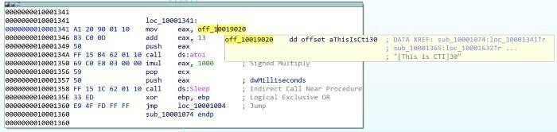

Figure 22: Sleep for 30 seconds

This means that the value of eaxwhen it is pushed is 30. atoiconverts the string to an integer,and it is multiplied by 1000. Therefore, the Sleep API function sleeps for 30 seconds.

##### xv & xvi. What are the three parameters for the call to socket at 0x10001701?

The three values pushed to the stack, labeled as protocol, type, and af, and are 6, 1, 2 respectively, are the three parameters used for the call to socket (figure 23).

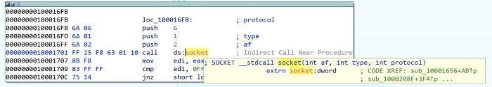

Figure 23: Call to socket at 0x10001701

These depict what type of socket is created. Using [Socket Documentation](https://docs.microsoft.com/en-us/windows/win32/api/winsock2/nf-winsock2-socket) we can determine that in this case, it is TCP IPV4. At this point, we might aswell rename those operands (figure 24).

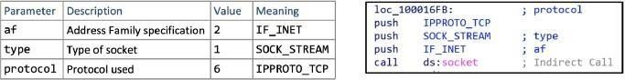

Figure 24: Definitions and renaming of socket parameters

##### xvii. Is there VM detection?

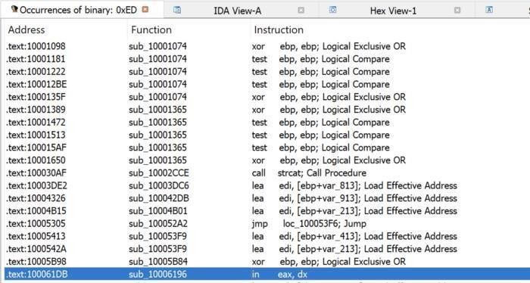

Figure 25: Searching for the in instruction using 0xED in binary.

The in instruction (opcode 0xED) is used with the string *VMXh* to determine whether the malware is running inside VMware. 0xEDcan be searched (alt+B) and look for the ininstruction(figure 25).

From here, we can navigate into the function and see what is going on within sub_10006196.

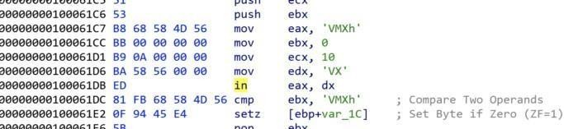

Figure 26: in instruction within sub_10006196

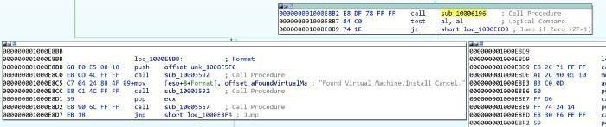Directly around the ininstruction, we see evidence of the string VMXh (converted from original hex value) (figure 26), which is potentially indicative of VM detection. If we look at the other xrefs of sub_10006196 we see three occurrences, each of which contains aFoundVirtualMa, indicating the install is canceling if a Virtual Machine is found (figure 27).

Figure 27: Found Virtual Machine string found after *VMXh string*

##### xviii, xix, & xx. What is at 0x1001D988?

The data starting at 0x1001D988 appears illegible, however, we can convert this to ASCII (by pressing A), albeit still unreadable (Figure 28).

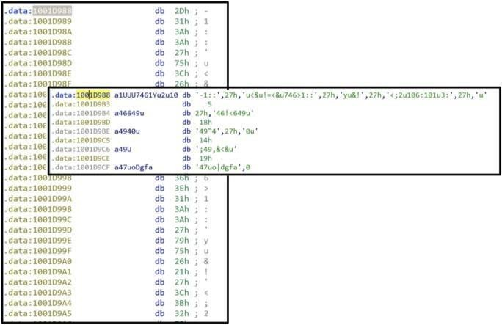

Figure 28: Random data at 0x1001D988

We have been provided a python script with the lab lab05–01.py which is to be used as an IDA plugin for a simple script. For 0x50bytes from the current cursor position, the script performs an XORof 0x55, and prints out the resulting bytes, likely to decode the text (figure 29).

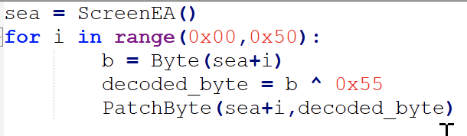

Figure 29: XOR 0x55 script

We are unable to do this within the free version of IDA, however we can loosely do it manually ourselves by taking the bytes from 0x1001D988and doing XOR 0x55.

Evidently, the conversion to ASCII and manual decoding has messed up something with the capitalisation, but we can see some plaintext and determine the completed message (figure 30)

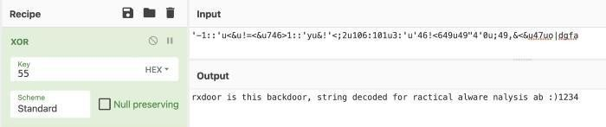

Figure 30: Manual XOR 0x55

1. **analyze the malware found in the file Lab06-01.exe.**

##### What is the major code construct found in the only subroutine called by main?

Before we start, it is worth noting that sometimes IDA does not recognise the main subroutine. We can find this quite quickly by traversing from the start function and finding sub_401040. This is main as it contains the required parameters (argcand **argv). I renamed the subroutineto main (figure 1).

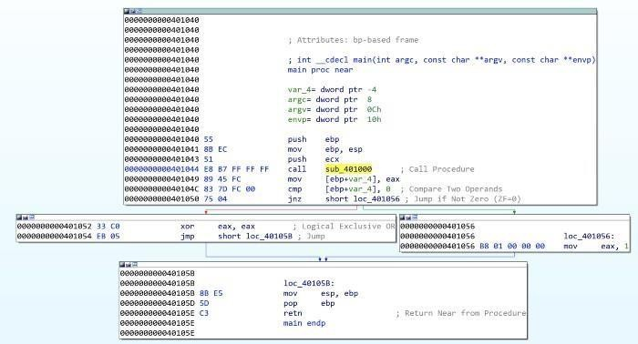

Figure 1: Lab06–01 | main subroutine

Navigating into the first subroutine called in main (sub_401000) (figure 2), we see it executes an external API call InternetGetConnectedState, which returns a TRUE if the system has an internet connection, and FALSE otherwise. This is followed by a comparison against 0 (FALSE) and then a JZ (Jump If Zero). This means the jump will be successful if InternetGetConnectedStatereturns FALSE

(0) (There is no internet connection).

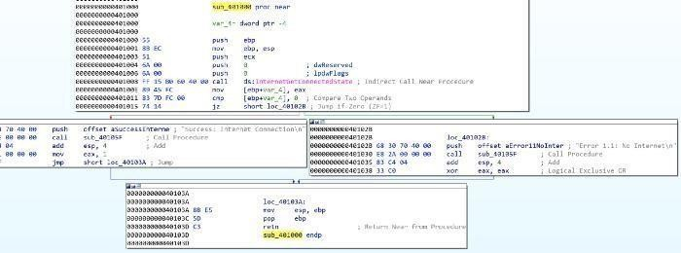

Figure 2: Lab06–01 | sub_401000 internet connection test

Therefore, the jump path (short loc_40102B) is taken and the string returned will be ‘*Error1.1: No Internet\n*’.

InternetGetConnectedStatereturns TRUE, then the jump is not successful, and the returnedstring is ‘*Success: Internet Connection\n*’.

Based upon this, it can be determined that the major code construct is a basic **If Statement**.

##### What is the subroutine located at 0x40105F?

Given the proximity to the strings at the offset addresses in each path, it can be assumed that sub_40105F is printf, a function used to print text with formatting (supported by the *\n* for newline in the strings).

IDA didn’t automatically pick this up for me, but with some cross-referencing and looking into what we would expect as parameters, we can be safe in the assumption.

##### What is the purpose of this program?

Lab06–01.exe is a simple program to test for internet connection. It utilises API call InternetGetConnectedState to determine whether there is internet, and prints an advisory string accordingly.

1. **Analyze the malware found in the file *Lab06–02.exe*.**

##### i & ii. What operation does the first subroutine called by main perform? What is the subroutine located at 0x40117F?

This is very similar to Lab06–01.exe. We can easily find the main subroutine again (this time sub_401130), and again we see the first subroutine called is sub_401000. This is very similar as it calls InternetGetConnectedStateand prints the appropriate message (figure 3). We also canverify that 0x40117F is still the printf function, which I’ve renamed.

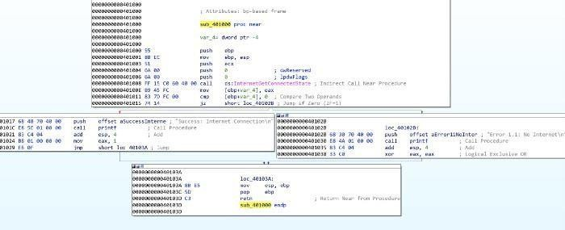

Figure 3: Lab06–02 | sub_401000 internet connection test & sub_40117F (printf)

##### What does the second subroutine called by main do?

This is something new now; the mainfunction in lab06–02.exeis a little more complex with anadded subroutine and another conditional statement (figure 4). We can see that sub_401040 is reached by the preceding cmpto 0being successful (jnzjump if not 0), which therefore means

we’re hoping for the returned value from sub_401000 to be not 0 — indication there IS internet connection.

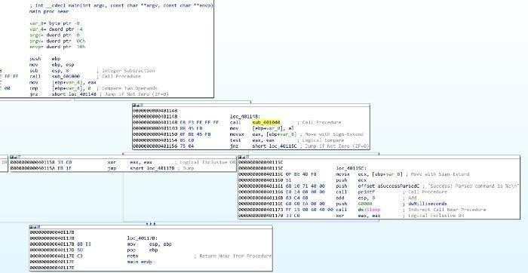

Figure 4: Lab06–02 | main subroutine

Navigating to sub_401040, we immediately see some key information, which supports the determination that this occurs if there is an internet connection.

The most stand-out information is the two API calls, InternetOpenA and InternetOpenUrlA, which are used to initiate an internet connection and open a URL. We also see some strings at offset addresses just before these, indicating these are passed to the API calls (figure 5).

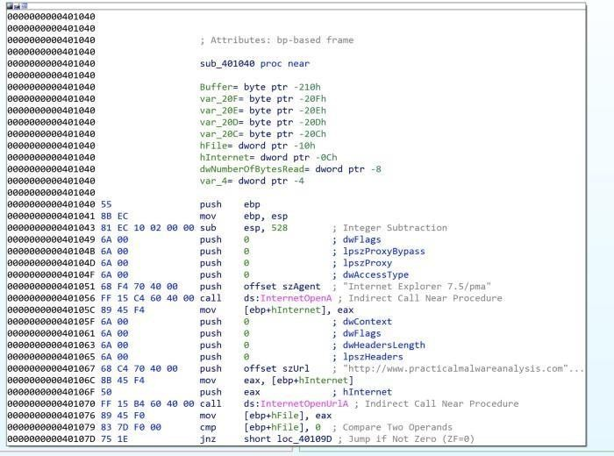

Figure 5: Lab06–02 | Internet connection API calls and strings

First, szAgent containing string “*Internet Explorer 7.5/pma*”, which is a User-Agent String, is passed to InternetOpenA.

szUrlcontains the string “[*http://www.practicalmalwareanalysis.com/cc.htm*](http://www.practicalmalwareanalysis.com/cc.htm)” which is the URLfor

InternetOpenUrlA.

This has another jnzwhere the jump is not taken if hFilereturned from InternetOpenUrlAis 0(meaning no file was downloaded), where a message is printed “*Error 2.2: Fail to ReadFile\n*” and the internet connection is closed.

##### What type of code construct is used in sub_40140?

If szURl **is** found, the program attempts to read 200h (512) bytes of the file (*cc.htm*) using the API call InternetReadFile(the jnzunsuccessful path leads to “*Error 2.2: Fail to ReadFile\n*”printed and connections closed) (figure 6).

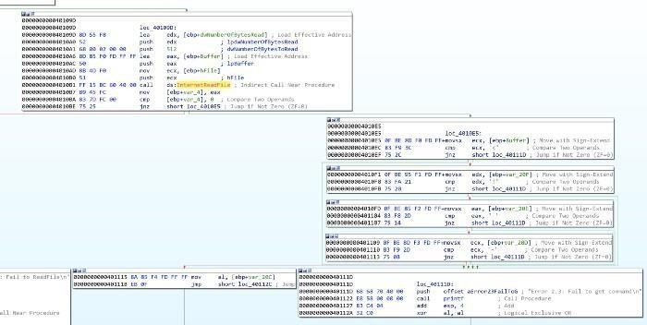

Figure 6: Lab06–02 | Reading first 4 bytes of cc.htm

There are then four cmp / jnz blocks which each comparing a single byte from the Buffer and several variables. These may also be seen as Buffer+1, Buffer+2, etc. This is a notable code construct in which a character array is filled with data from InternetReadFile and is read one by one.

These values have been converted (by pressing R) to ASCII. Combined these read <!--, indicative of the start of a comment in HTML. If the value comparisons are successful, then var_20C (likely the whole 512 byes in Buffer, but just mislabeled by IDA) is read. If at any point a byte read is incorrect, then an alternative path is taken and the string “*Error 2.3: Fail toget command\n*” is printed.

Looking back at main, if this all passes with no issues, the string “*Success: Parsed command is*

*%c\n*” is printed and the system does Sleepfor 60000 milliseconds (60 seconds) (figure 7). The command printed (displayed through formatting of %c is variable var_8) is the returned value from sub_401040, the contents of *cc.htm.*

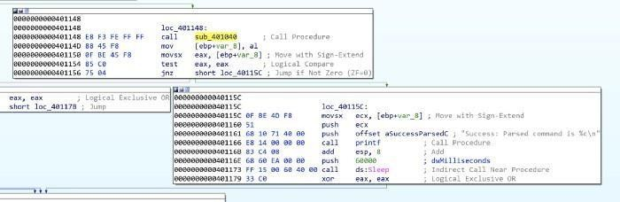

Figure 7: Lab06–02 | Reporting successful read of command and sleeping for 60 seconds

##### Are there any network-based indicators for this program?

The key NBIs (network-based indicators) from the program are the user-agent string and URL found related to the InternetOpenA and InternetOpenUrlA calls; *Internet Explorer 7.5/pma* and [*http://www.practicalmalwareanalysis.com/cc.htm*](http://www.practicalmalwareanalysis.com/cc.htm)

##### What is the purpose of this malware?

Very similar to Lab06–01.exe, Lab06–02.exe tests for internet connection and prints an appropriate message. Upon successful connection, however, the program then attempts to download and read the file from [*http://www.practicalmalwareanalysis.com/cc.htm.*](http://www.practicalmalwareanalysis.com/cc.htm)

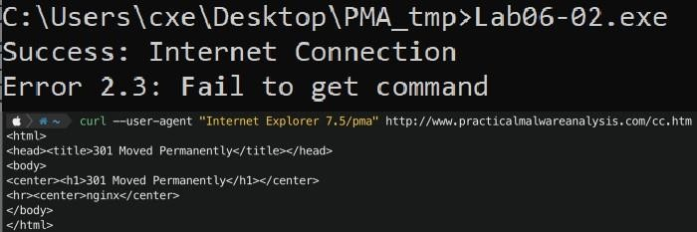

Figure 8: Lab06–02.exe | Tested execution

Upon testing, this file is not available on the server. The program did not successfully read the required first 4 bytes therefore an error message was printed (figure 8).

1. **Analyze the malware found in the file *Lab06–03.exe*.**

##### Compare the calls in main to Lab06–02.exe’s main method. What is the new function called from main?

For both executables, I have renamed all of the functions that we have already analysed. The differentiator between the two is an additional function once internet connection has been tested, the file has been downloaded, and the successful parsing of the command message has been printed — sub_401130(figure 9).

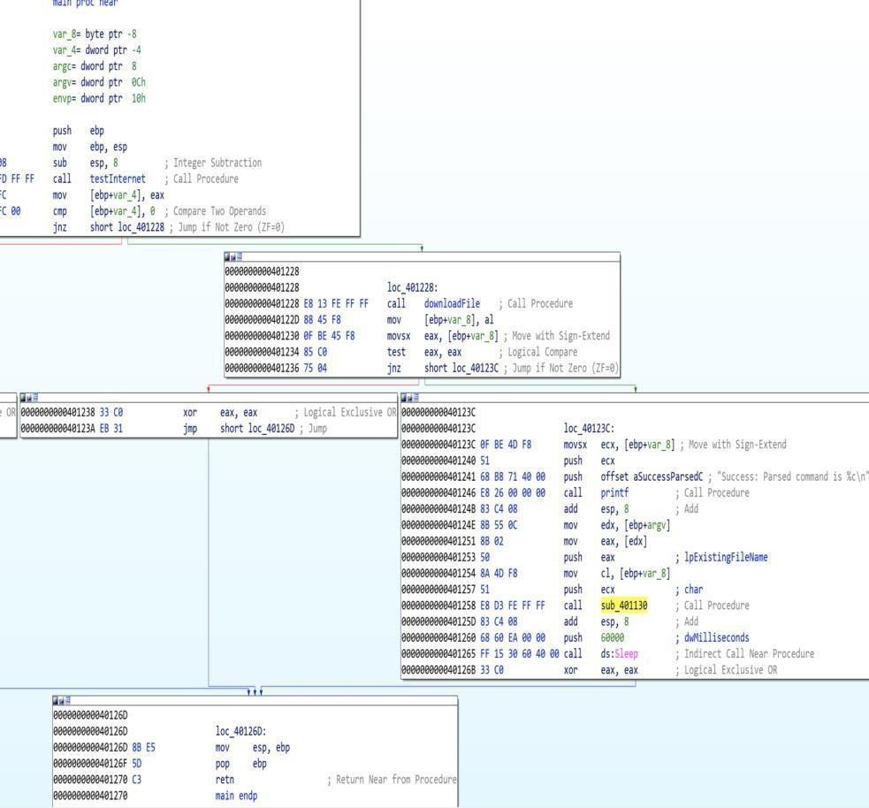

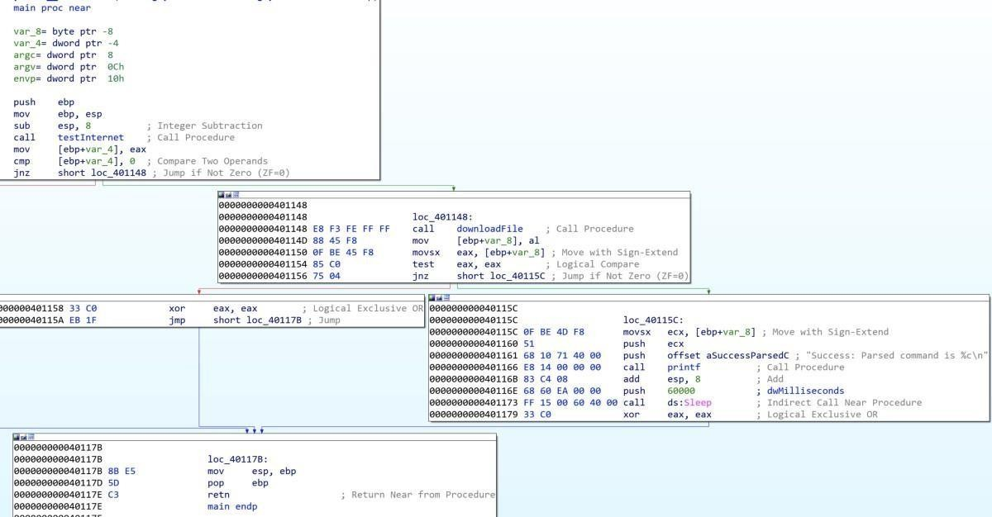

Figure 9: Lab06–03.exe | Comparisons of Lab06–03.exe (left) and Lab06–02.exe (right) main functions

##### What parameters does this new function take?

sub_401130 takes 2 parameters. The first is char, the command character read from [*http://www.practicalmalwareanalysis.com/cc.htm*](http://www.practicalmalwareanalysis.com/cc.htm)and lpExistingFileName (a long pointer to a character string, ‘Existing File Name’, which is the program’s name ( Lab06–03.exe) (figure 10). These were both pushed onto the stack as part of the mainfunction.

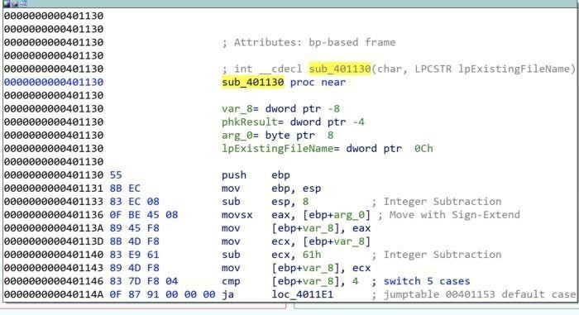

Figure 10: Lab06–03.exe | sub_401130 parameters.

##### What major code construct does this function contain?

IDA has helpfully indicated that the major code construct is a five-case switch statement by adding comments for 'switch 5 cases' and the 'jumptable 00401153 default case'. Wehave previously seen similar cmp which are if statements, however, in this case, there is a possibility of five paths. We can confirm this in the flowchart graph view, where there are five switch cases and one default case (figure 11).

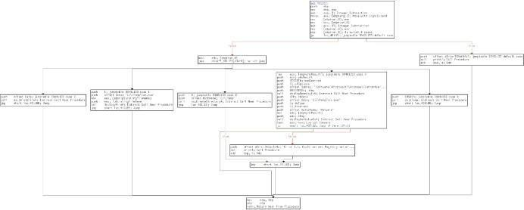

Figure 11: Lab06–03.exe | sub_401130 flowchart

##### What can this function do?

The five switchcases are as follows (figure 12):

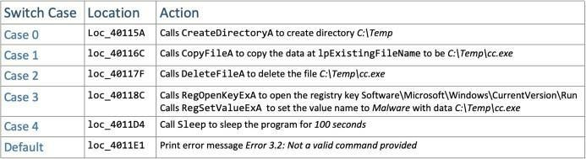

Figure 12: Lab06–03.exe | sub_401130 switch cases

Depending on the command provided (0–4) the program will execute the appropriate API calls to perform directory operations or registry modification. lpExistingFileName is the current file, Lab06– 03.exe*.* Setting the registry key Software\Microsoft\Windows\CurrentVersion\Run\Malware with file C:\Temp\cc.exe is a method of persistence to execute the malware on system startup.

##### Are there any host-based indicators for this malware?

The key HBIs (host-based indicators) are the file written to disk (C:\Temp\cc.exe), and the registry key used for persistence ( Software\Microsoft\Windows\CurrentVersion\Run /v Malware | C:\Temp\cc.exe)

##### What is the purpose of this malware?

Following on from the functionality of the simpler Lab06–01.exe and Lab06–02.exe, Lab06– 03.exe also tests for internet connection and prints an appropriate message. The program attempts to download and read the file from [*http://www.practicalmalwareanalysis.com/cc.htm.*](http://www.practicalmalwareanalysis.com/cc.htm)The program then has a set of possible functionalities based upon the contents of *cc.htm* and the switchcode construct to perform one of:

* + Create directory C:\Temp
  + Copy the current file (Lab06–03.exe) to C:\Temp\cc.exe
  + Set the Run registry key as Malware | C:\temp\cc.exefor persistence
  + Delete C:\Temp\cc.exe
  + Sleep the program for 100 seconds

## analyze the malware found in the file Lab06-04.exe.

##### What is the difference between the calls made from the main method in Lab06–03.exe and Lab06-04.exe?

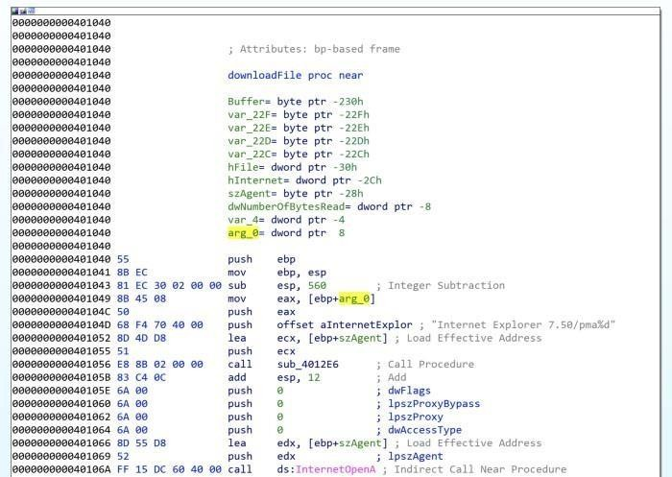

Figure 13: Lab06–04.exe | Modified downloadFile function with arg_0

Of the subroutines called from main we have analysed (renamed to testInternet, printf, downloadFile, and commandSwitch) only downloadFile has seen a notable change. The aInternetExplor address contains the value *Internet Explorer 7.50/pma%d* for the user-agent(szAgent) which includes an

*%d* not seen previously, as well as a new local variable arg_0 (figure 13).

This instructs the printffunction to take the passed variable arg_0as an argument and print asan int. The variable is a parameter taken in the calling of downloadFile , donated by IDA as var_C(figure 14).

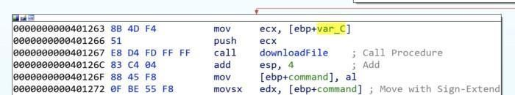

Figure 14: Lab06–04.exe | Variable passed to downloadFile

Some of the called subroutines have different memory addresses to what we saw in the previous Lab06–0X.exes, due to the mainfunction being somewhat more complex and expanded.

##### What new code construct has been added to main?

main has been developed upon to include a for loop code construct, as observed in the flowchart graph view (figure 15).

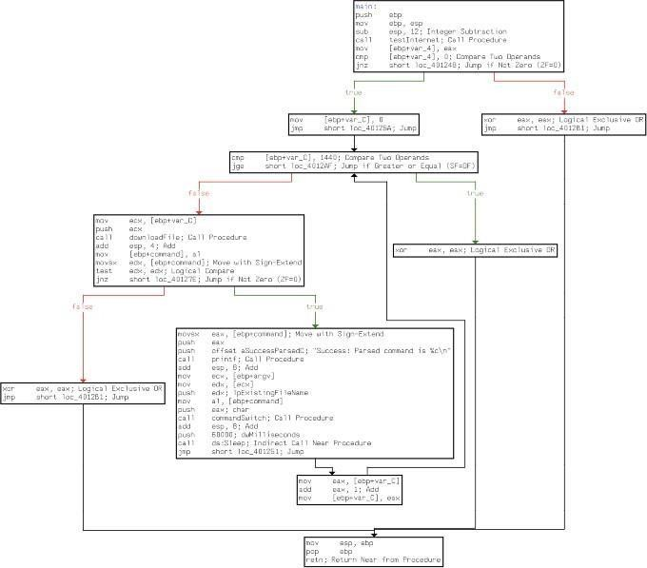

Figure 15: Lab06–04.exe | For loop within main

A for loop code construct contains four main components — initialisation, comparison, execution, and increment. All of which are observed within main(figure 16):

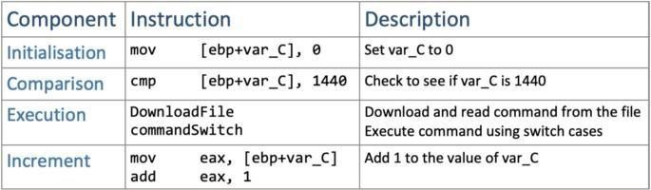

Figure 16: Lab06–04.exe | For loop components

##### What is the difference between this lab’s parse HTML function and those of the previous labs?

As previously identified, the parse HTML function (downloadFile) now includes a passed variable. Having analysed this and main, we can determine that it is the for loop’s current

conditional variable (var_C) value which is passed through to downloadFile’s user-agent *Internet Explorer 7.50/pma%d*, as arg_0as this will increment by 1 each time, it may potentiallybe used to indicate how many times it has been run.

1. 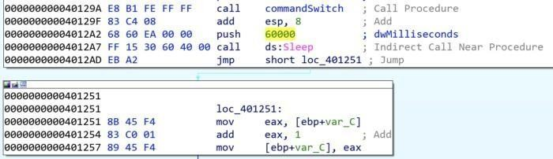**How long will this program run? (Assume that it is connected to the Internet.)** There are several aspects of main’s for loop which can help us roughly work how long the program will run. Firstly, we know that there is a Sleepfor 60 seconds, after the commandSwitchfunction. We also know that the conditional variable (var_C) is incremented by1 each loop. (Figure 17).

Figure 167: Lab06–04.exe | Sleep function and for loop increment

The for loopstarts var_Cat 0, and will break the loop once it reaches 1440. This means thatthere are 1440 60second loops, equalling 86400 seconds (24hours). The program may run for longer if the command instructs the switchwithin commandSwitchto sleep for 100seconds atany of the 1440 iterations.

##### Are there any new network-based indicators for this malware?

The only new NBI for Lab06–04.exe is the aInternetExplor“*Internet Explorer 7.50/pma%d”*, with “[*http://www.practicalmalwareanalysis.com/cc.htm*](http://www.practicalmalwareanalysis.com/cc.htm)” as the other, already known, indicator.

##### What is the purpose of this malware?

Lab06–04.exe is the most complex of the four samples, where a basic program to check for internet connection has been developed into an application that connects to a C2 domain to retrieve commands and perform specific actions on the host. The malware runs for a minimum of 24hrs or at least makes 1440 connections to the C2 domain with 60-second sleep intervals. The functionality of the malware allows it to copy itself to a new directory, set it as autorun for persistence by modifying a registry, delete the new file, or sleep for 100 seconds.

# Practical No. 3

#### Analyze the malware found in the file Lab07-01.exe.

##### How does this program ensure that it continues running (achieves persistence) when the computer is restarted?

Creates a service named “Malservice”. Establishes connection to the service control manager (OpenSCManagerA) — requires administrator permissions, then gets handle of current process (GetCurrentProcess), gets File name (GetModuleFileNameA). Creates the service named “**Malservice**” wich auto starts each time. (CreateServiceA)

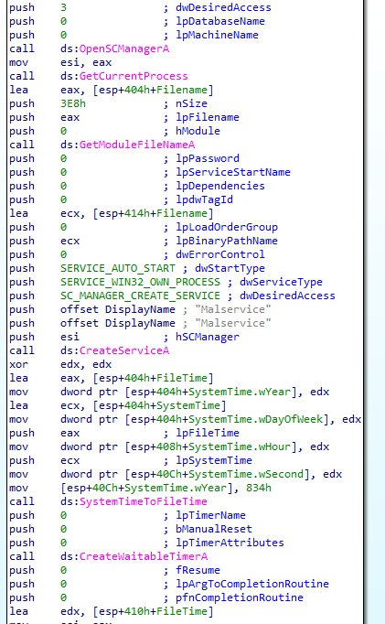

##### Why does this program use a mutex?

Program uses mutex to not reinfect the same machine again. Opens mutex (OpenMutexA) with the name “**HGL345**” with **MUTEX_ALL_ACCESS.** If instance is already created, terminates program, otherwise creates one.

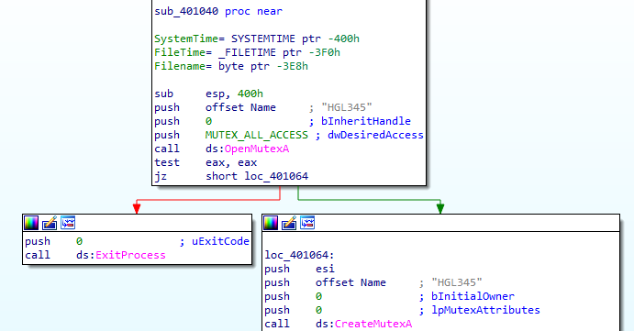

##### What is a good host-based signature to use for detecting this program?

Host-based signature are mutex “**HGL345**” and service “**Malservice**”, which starts the program.

##### What is a good network-based signature for detecting this malware?

User Agent is “Internet Explorer 8.0” good network-based signature and connects to server “[http://www.malwareanalysisbook.com](http://www.malwareanalysisbook.com/)" for infinity time.

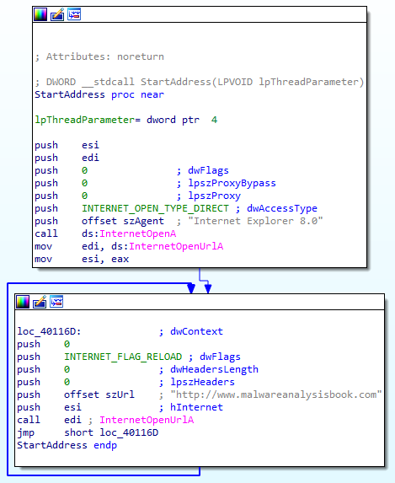

##### What is the purpose of this program?

Program is designed to create the service for persistence, waits for long time till 2100 years, creates thread, which connects to “[http://www.malwareanalysisbook.com](http://www.malwareanalysisbook.com/)" forever, this loop never ends. The rest code is not accessed: 20 times calls thread, which connects to web page and sleeps for 7.1 week long before program exits. Infinitive loop is created to **DDOS attack** the page. Attacker is only able to compromised the web page if has more resources than hosting provider can handle.

##### When will this program finish executing?

Program will wait 2100 Years to finish. This time represents midnight on January 1, 2100.

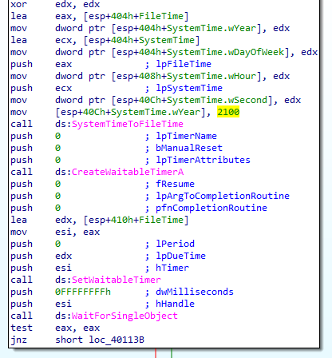

Creates new thread (CreateThread), important argument is lpStartAddress, which indicates the start of the thread and connects to internet (described at paragraph 4) for 20 times. Then sleeps for enormous time ~ 7.1 week and exits the program.

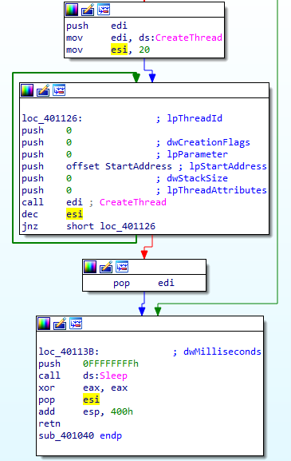

1. **Analyze the malware found in the file Lab07-02.exe.**

##### How does this program achieve persistence?

Program doesn’t achieve persistance. Initializes COM object (**OleInitialize**) creates single object with specified clsid (**CoCreateInstance**).

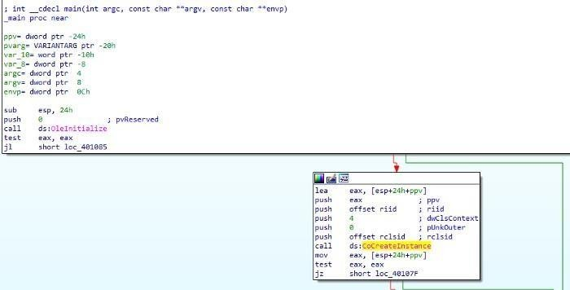

IDA PRO represents **rclsid** and **riid** like this:

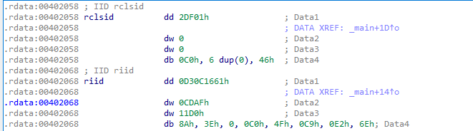

There are two ways to get GUID value of rclsid and riid.Conversion through size representation:dd (dword — 4 bytes)**0002 DF01**

dw 0 - **0000**

dw 0 - **0000**

db **C0** (takes only 1 byte)

**000000 46**GUID format is **{8–4–4–12}**If we write as GUID we get:

**{0002DF01–0000–0000-C000–000000000046}**Here is another way:The

interval of value rclsid is from [402058–402068). If we eliminate **image base** (40 0000), we get the interval [2058–2068**)** or [2058–2067**]** (we don’t want to take byte which belongs to other value).

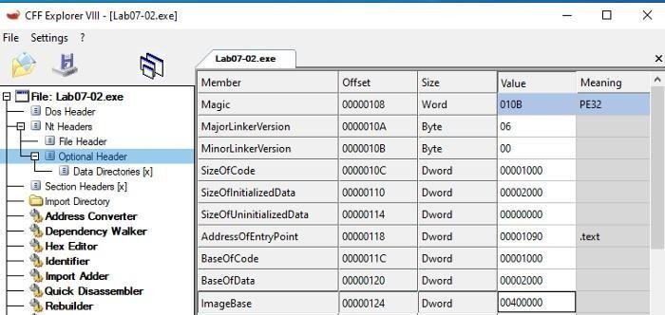

CFF Explorer showing the Image Base

I use HxD to select hex bytes Edit -> Select block…

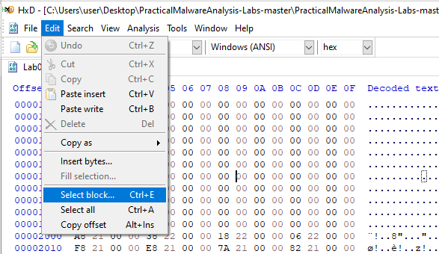

Set the ranges:

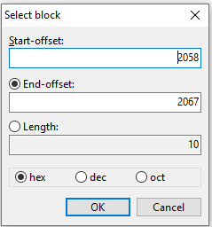

“Data inspector” view shows **rclsid** — GUID value (Byte ordershould be set to Little Endian):

##### {0002DF01–0000–0000-C000–000000000046}

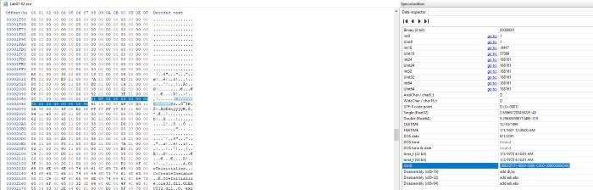

If we do the same for **riid** we get **{D30C1661-CDAF-11D0–8A3E-00C04FC9E26E}**

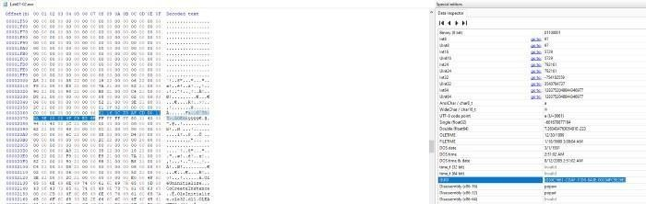

These registry keys will show clsid and riid meanings:**HKEY_CLASSES_ROOT\CLSID\** and **HKEY_CLASSES_ROOT\Interface\**P.S. HKEY_CLASSES_ROOT (HKCR) is a [shortcut](https://docs.microsoft.com/en-us/windows/win32/sysinfo/hkey-classes-root-key) of HKLM and HKCU, but in our case it doesn’t matter.HKEY_CLASSES_ROOT\CLSID\{0002DF01-0000-0000-C000-

000000000046} shows that CLSID belongs to **Internet Explorer(Ver1.0).**

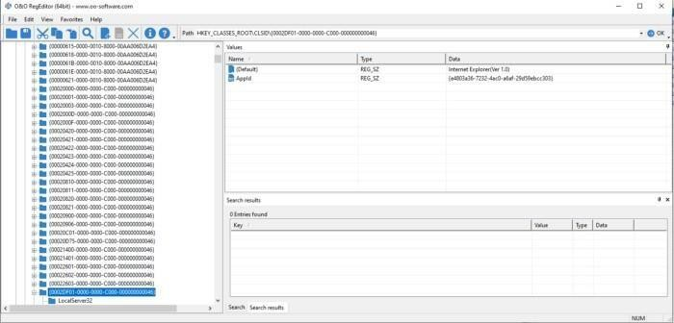

HKEY_CLASSES_ROOT\Interface\{D30C1661-CDAF-11D0-8A3E-

00C04FC9E26E}and the interface is **IWebBrowser2**.

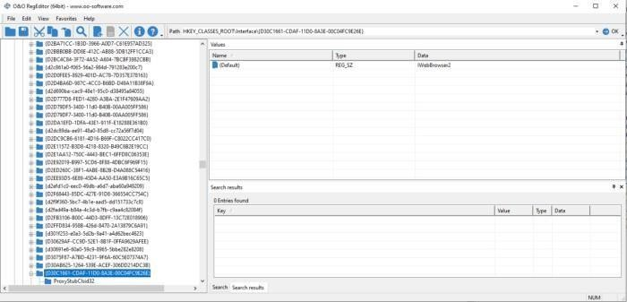

More info about could be found [here.](https://repo.zenk-security.com/Reversing%20.%20cracking/Reversing%20Encrypted%20Callbacks%20and%20COM%20Interfaces.pdf)After execution of **CoCreateInstance** one of arguments

***\*ppv*** contains the requestedinterface pointer.

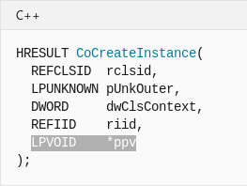

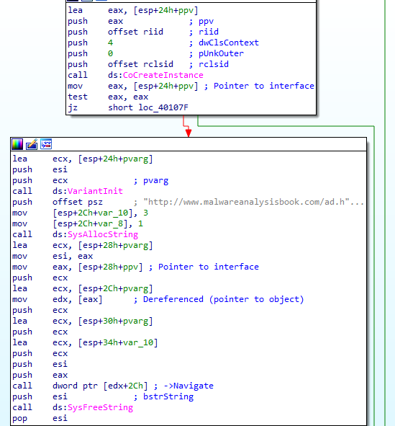Pointer *ppv is moved to eax. which is later de-referenced(pointer to object). From de-referenced object 2Ch is added (44 in dec).

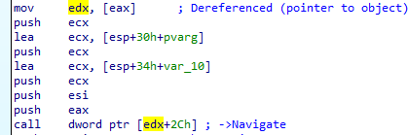

Structure of IWebBrowser2, can be found [here.](https://wasm.in/threads/kak-programmno-vvesti-nik-i-parol-cherez-interfejs-iwebbrowser2.32326/)

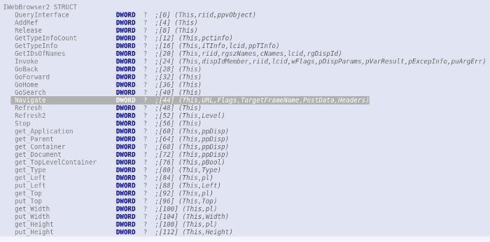44 means **Navigate** method is called.

##### What is the purpose of this program?

Program just opens Internet explorer with an advertisement. “[http://www.malwareanalysisbook.com/ad.html.”](http://www.malwareanalysisbook.com/ad.html)

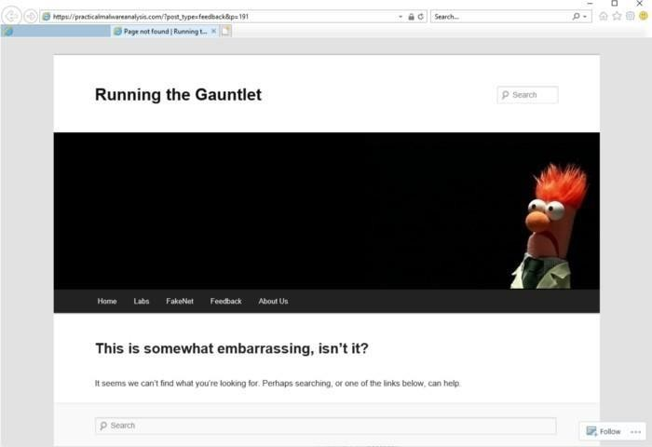

##### When will this program finish executing?

After some cleanup functions: **SysFreeString** and **OleUninitialize**

program terminates.

## For this lab, we obtained the malicious executable, Lab07-03.exe, and DLL, Lab07- 03.dll, prior to executing. This is important to note because the mal- ware might change once it runs. Both files were found in the same directory on the victim machine. If you run the program, you should ensure that both files are in the same directory on the analysis machine. A visible IP string beginning with 127 (a loopback address) connects to the local machine. (In the real version of this malware, this address connects to a remote machine, but we’ve set it to connect to localhost to protect you.)

##### i- How does this program achieve persistence to ensure that it continues running when the computer is restarted?

Persistence is achieved by writing file to “C:\Windows\System32\Kerne132.dll” and modifying every ".exe" file to import that library.

##### What are two good host-based signatures for this malware?

Good host-based signatures are:

1. “C:\\Windows\\System32\\Kerne132.dll” Mutex name “**SADFHUHF**”

##### What is the purpose of this program.

**Dynamic analysis**Execute program with correct argument

:"**WARNING_THIS_WILL_DESTROY_YOUR_MACHINE**" modifies "WinRAR.exe" in my case. Library "kerne**1**32.dll" is replaced instead of "kernel32.dll" toexecutable.

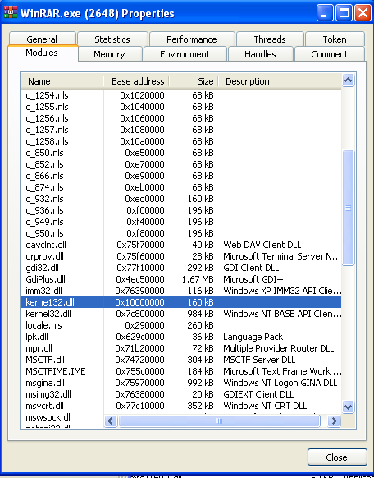

Using API Monitor from [Rohitab](http://www.rohitab.com/apimonitor) we identify what is it doing:Searching for executables ".exe" in C drive.

If found opens it, Creates file mapping object, opens it inmemory, searches if import is "kernel32.dll". Replaces with"kerne**1**.dll" Unmaps from memory. Closes handles.

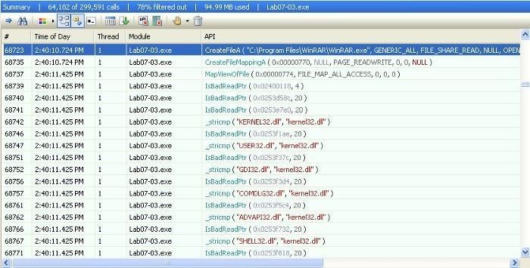

If any of executable (not in memory) is opened in “PEStudio”, we see there only “kerne**1**32.dll” library is imported.

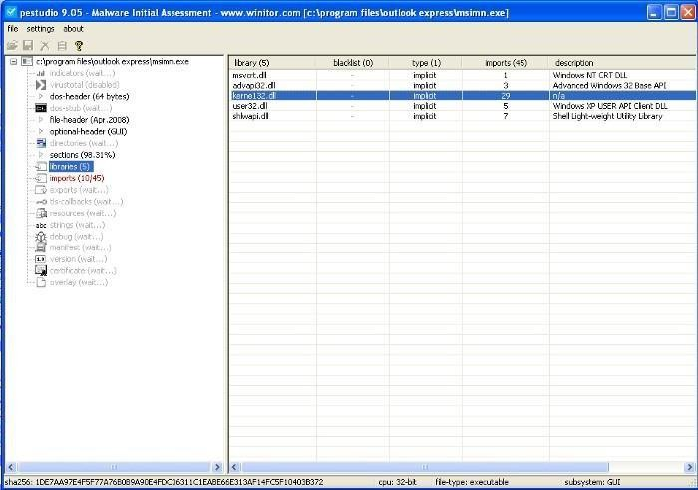

**Static analysis**Executable is launched with this parameter “**WARNING_THIS_WILL_DESTROY_YOUR_MACHINE**”

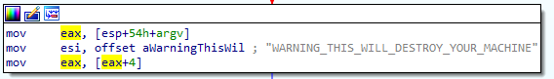

Opens file “C:\\Windows\\System32\\Kernel32.dll” (CreateFileA) with read permissions (File_Share_Read and Generic read). Creates mapping object (CreateFileMappingA with Page_Readonly permissions) for this file. This mapping object is used to map (copy) in to the memory.

Opens another file (CreateFileA in FILE_SHARE_READ mode) “Lab07–03.dll”. Exits if failed to open the library (Lab07–03.dll).

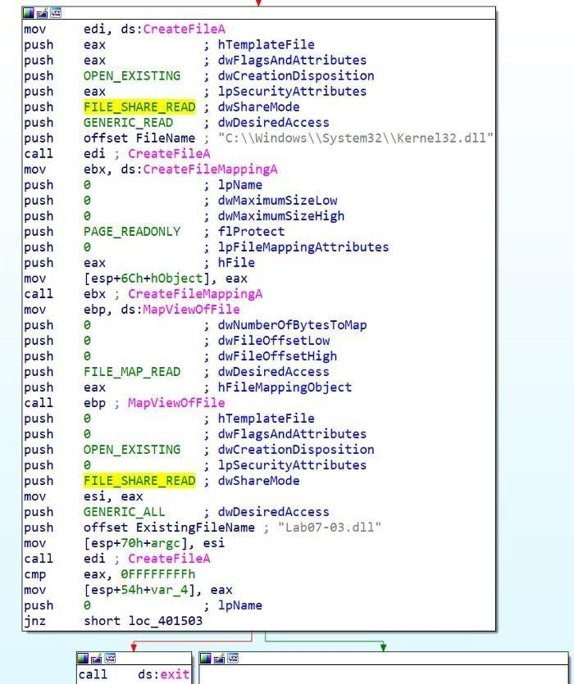

Creates file mapping object of the library "Lab07-03.dll" (CreateFileMappingA with PAGE_READWRITE protection). Maps this object in to the memory (MapViewOfFile with FILE_MAP_ALL_ACCESS). Exits if failed to map.

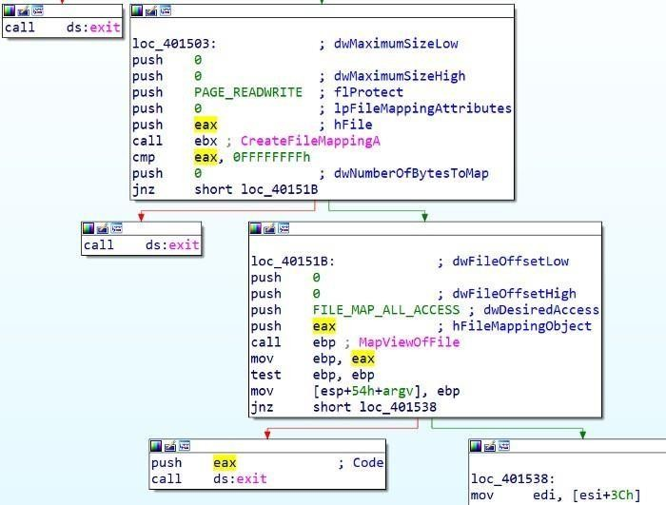

Closes both handles of libraries. Copies file “Lab07–03.dll” to “C:\\windows\\system32\\kerne**1**32.dll” (looks like original, except ”l” letter is misspelled as number “1”). Zero and string “C:\\*” is passed as args to another function. * means all files located in C directory.

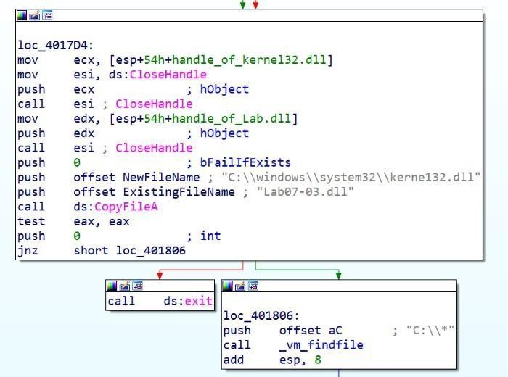

Searches for the first file or folder (FindFirstFileA). Checks if file attribute is directory (FILE_ATTRIBUTE_DIRECTORY).

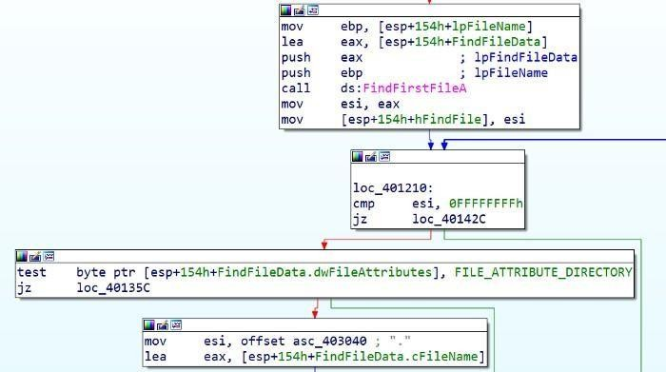

Calls function _mv_mapfile.

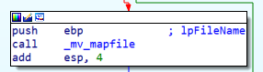

If not the directory checks if filename is equal to “.” (current directory).

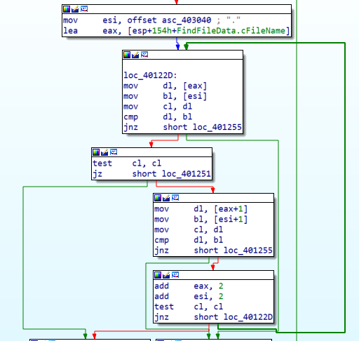

Also compares if it is root directory (“..”)

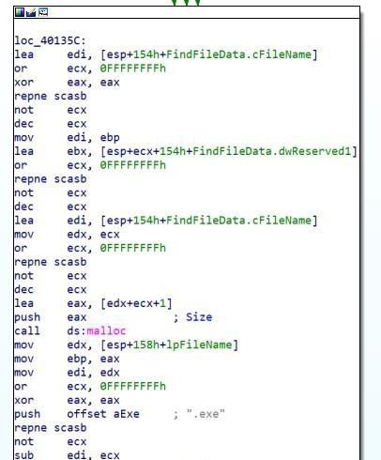

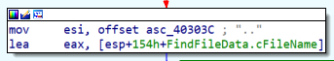

##### Explanation:

If you enter “dir” command in “cmd.exe” see one dot (current directory) and two dots (root directory).

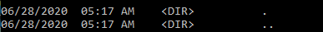

For example if current directory is “C:\WINDOWS\system32”, then root dir is “C:\WINDOWS”.Also compares if it is root directory (“..”)

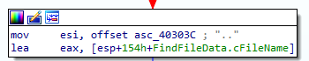

**lea edi, [esp+154h+FindFileData.cFileName]** ; edi points to filename

**or ecx, 0FFFFFFFFh** ; clever way to set ecx to -1

**xor eax, eax** ; set eax register to zero

**repne** [**scasb**](https://www.aldeid.com/wiki/X86-assembly/Instructions/scasb) ; repeat if eax and edi are not equal to null. Each cycle ecx is decremented, untill it finds null symbol at the endof string.

**not ecx** ; inverts negative number to positive. Have stringlength + 1 (null byte)

**dec ecx** ; string length

All these [assembly](http://www.int80h.org/strlen/) instruction do the same as [strlen](http://www.cplusplus.com/reference/cstring/strlen/) inc++.Allocates space for file name in memory (malloc). Checks if file extension is “.exe”.

When enumerates all files in the directory it pushes another string “\\*” and calls the same function again (recursive function). Enters the sub folder and repeat enumeration process. Find all executable files in the C drive (FindNextFileA).

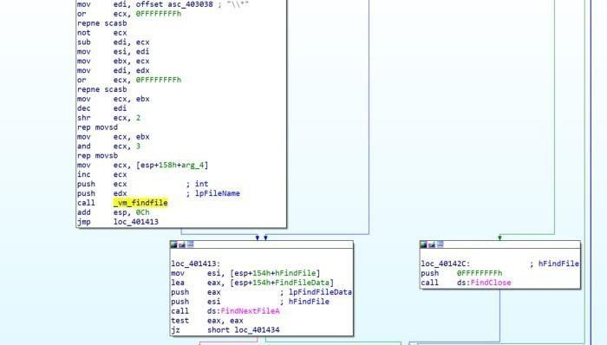

Checks if file has “**PE**” header.

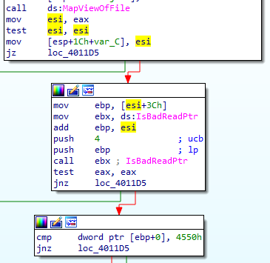

Example: **Image_File_Header** -> **e_lfanew** (Offset to PE Header)

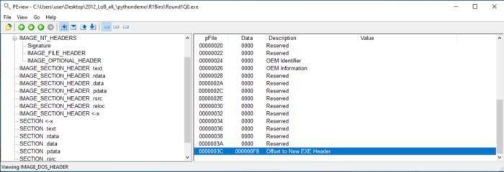

Dll creates or opens the mutex **“SADFHUHF”**. Mutex are usefull tocheck if instance of the program has been executed before or not.

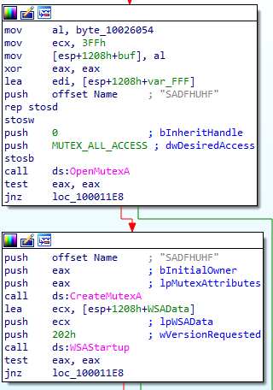

Initiates Winsock dll function (WSAStartup) uses **TCP** protocol to connect to server “**127.26.152.13:80”**.

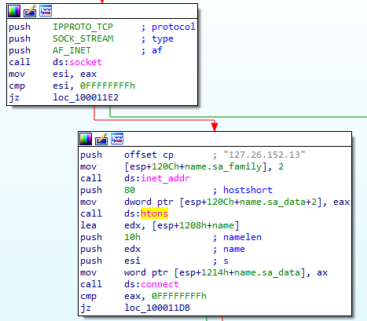

If connects to server, sends hello message: “**hello**”. Disables send on a socket (shutdown).

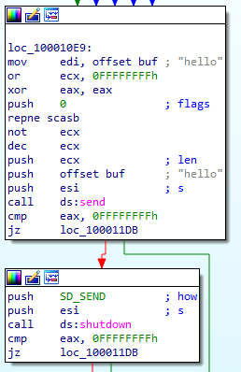

Ready to receive command from the server.Received message is up to 4096 bytes length. Compares if command is "**sleep"** (sleeps for 1 minand repeats the same from sending hello message).

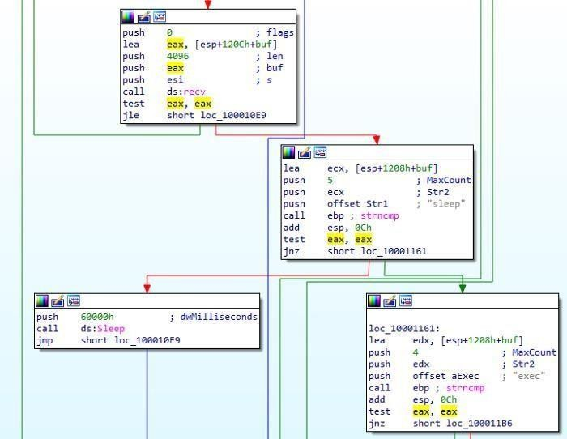

If command is “**exec**”, Creates process ([CreateProcessA](https://docs.microsoft.com/en-us/windows/win32/api/processthreadsapi/nf-processthreadsapi-createprocessa)) with argument “CREATE_NO_WINDOW”. One of the most important parameter is lpCommandLine. Looking backwads edx register is pushed on to the stack. edx has the addressof **CommandLine** (calculated using lea instruction).

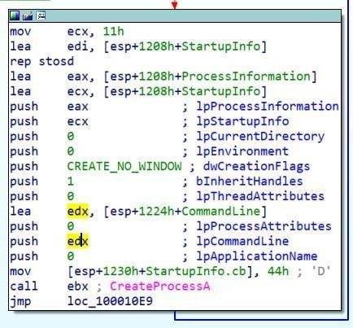

This address doesn’t appear anywhere except the beginning of function:

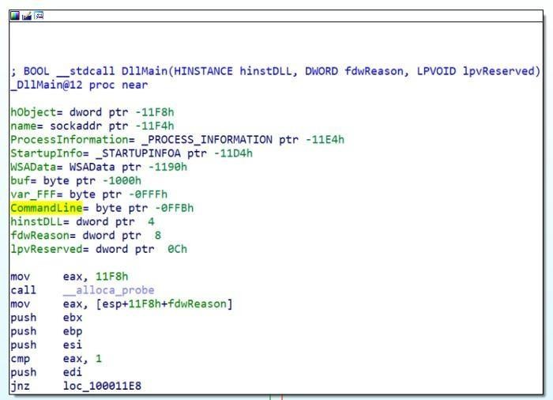

It means that it has not defined CommandLine already. The value appears on a runtime, when command is received from server.Variables has negative, while arguments - positive value. CommandLine is the variable. **buf** contains the received command and **CommandLine** contains what to execute. The difference between buf and CommandLine are 5 bytes. 1000h- FFBh=**5** (h means in hexdecimal).

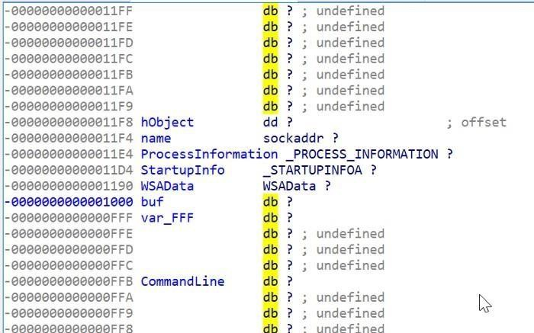

If we look at the received buff command, we got “**exec**”, which is 4 bytes long. Mostly the space (fifth byte) is the separator between exec and CommandLine.Strings are the arrays (index will be visualized as the arrow where it points). Index points before or after the symbol, not on the letter itself. Every array starts from zero index —

[0] (before “**e**” letter). Index of [1] -points after “e” and before“x”.

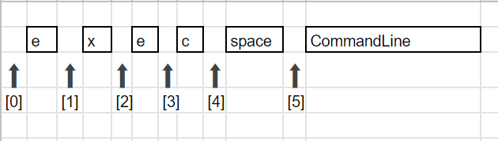

If command is “**q**” exits loop.If none of them — Sleep for 1 minute andloop.

When executable is found, calls mv_mapfile function (renamed by myself). Opens executable (CreateFileA). Creates mapping object (CreateFileMappingA). Maps file in to the memory (MapViewOfFile).

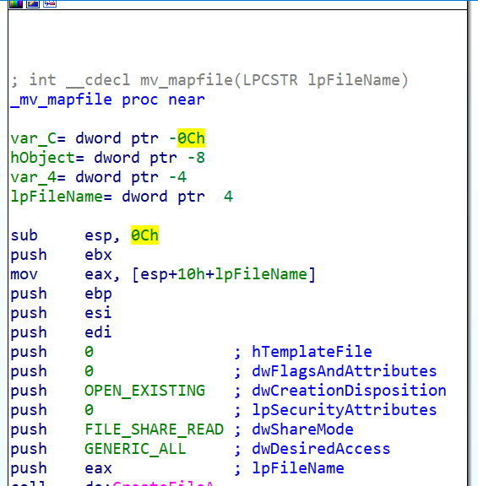

Esi register points to start of the file. mov ebp, [esi + **3Ch**]; dosheader->e_lfanew

cmp dword ptr [ebp+0], 4550h ; Check if valid ‘PE’ header. To understand this you should know [PE structure](http://opensecuritytraining.info/LifeOfBinaries.html).

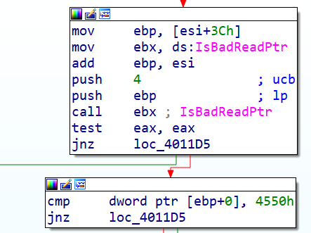

##### Explanation:

File is opened in PEViewer. 3Ch (RVA-Relative virtual address)points to **offset to New EXE Header**. In order to get the value (Data), it should be de referenced [] brackets grabs whats at that address: E8h (in our example).

DosHeader->e_lfanew (equivalent in c++)

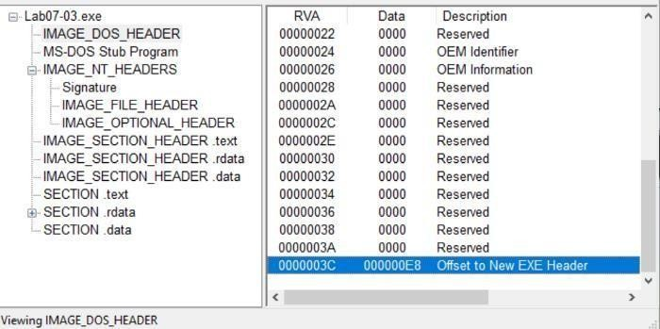

However grabbed **offset to New EXE Header** is another address.Should be de referenced again. **Image_NT_Signature** is at the address **E8h** (RVA)**.**

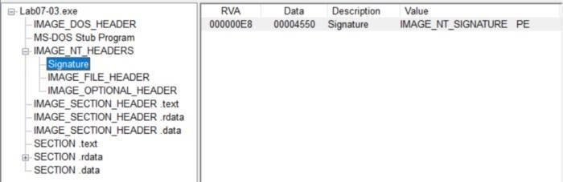

Checks if valid PE file:

ImageNtHeaders->Signature != 'PE' (equivalent in c++)Call **IsBadReadPtr** to check if the calling process has read access tothat memory region. String **Str1** is compared to “kernel32.dll”.

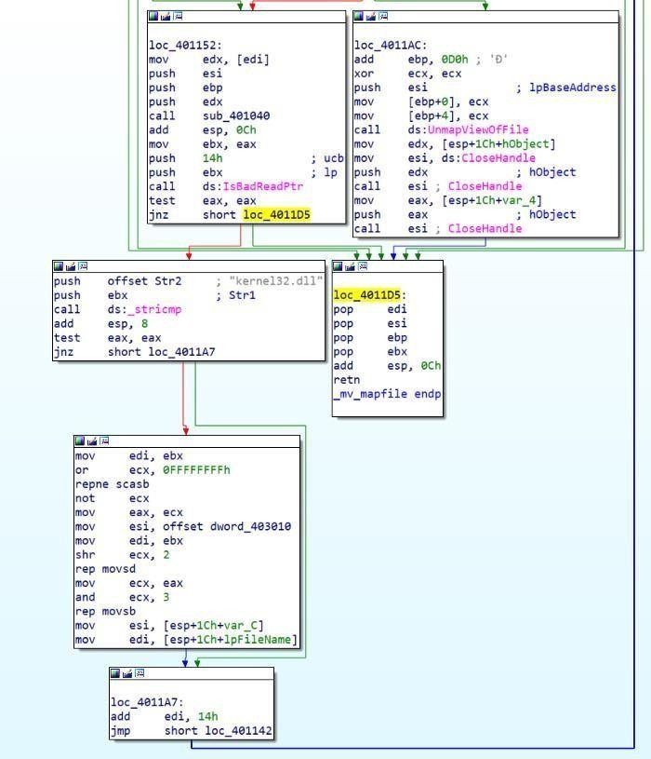

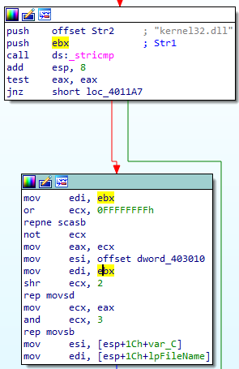

Two instructions represents strlen (repne scasb) and memcpy (repmovsd).Using repne scasb we get length of the string.rep movsd instruction moves byte from esi to edi register ecx times (ecx

=string length).mov esi, offset dword_403010

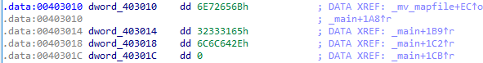

If we open dword_403010 we see that is actually ascii letters (looking in ascii table we see that numbers and letters startsfrom 30h to 7Ah)

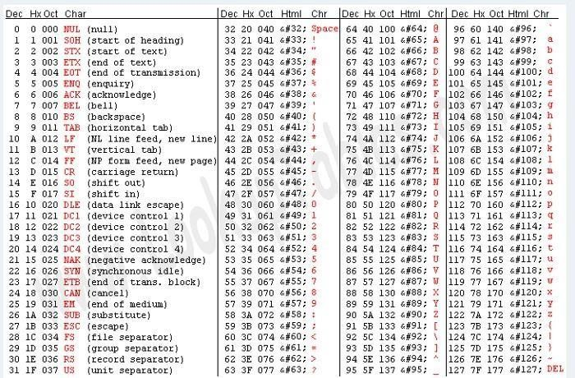

lookuptables.com By pressing “a” (convert data to string in IDA) two times we get“kerne**1**32.dll”:



String **Str1** is our source, which is “kerne**l**32.dll” and replaced by the string kernel**1**32.dll (destination).Access import table: mov ecx, [ebp+80h] ; Import table RVA: E8h+80h=168h

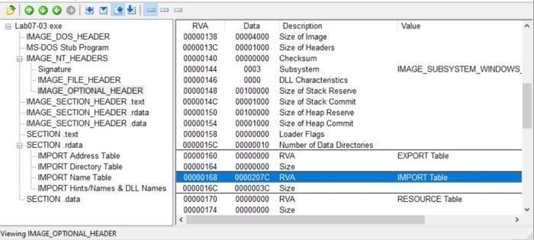

##### How could you remove this malware once it is installed?

Malware could be removed replacing imports to original "kernel32.dll" for every executable. Using automated program or script to do this.Or original "kernel32.dll" replaced of "kerne**1**32.dll**"**Or reinstall windows operating system.

## Analyze the malware found in the file Lab09-01.exe using OllyDbg and IDA Pro to answer the following questions. This malware was initially analyzed in the Chapter 3 labs using basic static and dynamic analysis techniques

##### How can you get this malware to install itself?

To install this malware, we need to reach the function @0x00402600. In this function, we can see function call to [OpenSCManagerA,](https://msdn.microsoft.com/en-us/library/windows/desktop/ms684323(v%3Dvs.85).aspx) [ChangeServiceConfigA,](https://msdn.microsoft.com/en-us/library/windows/desktop/ms681987(v%3Dvs.85).aspx) [CreateServiceA,](https://msdn.microsoft.com/en-sg/library/windows/desktop/ms682450(v%3Dvs.85).aspx) CopyFileA and registry creation. All these are functions to make the malware persistence.

To get to the install function @0x00402600 we would need to run this malware with either 2 or 3 arguments (excluding program name). We would need to enter a correct passcode as the last argument and “-in” as the 1st argument.

To install the malware just execute it as “**Lab09-01.exe -in abcd**”

We can also choose to patch the following opcode “**jnz**” to “**jz**” at address 0x00402B38 to bypass the passcode check.

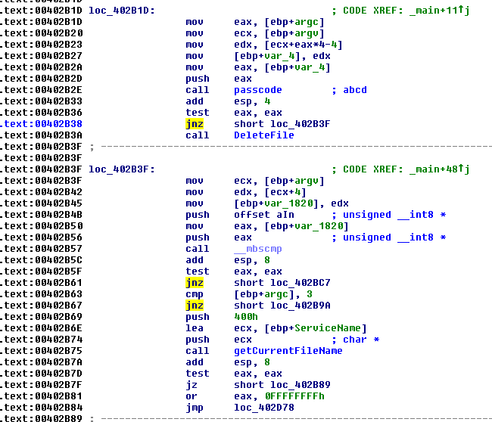

if you want to install it with a custom service name such as jmpRSP, you may execute it as “**Lab09-01.exe -in jmpRSP abcd**“.

##### What are the command-line options for this program? What is the password requirement?

The 4 command line accepted by the program are

* 1. -in; install
  2. -re; uninstall
  3. -cc; parse registry and prints it out
  4. -c; set Registry

The password for this malware to execute is “abcd”. Analyzing the function @0x00402510, we can easily derive this password. The below image contains comments that explains how I derived that the passcode is “abcd”.

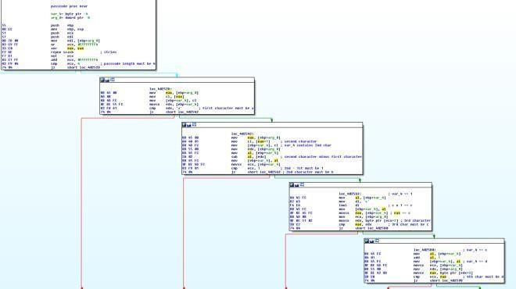

##### How can you use OllyDbg to permanently patch this malware, so that it doesn’t require the special command-line password?

As mentioned in Question i, we just need to patch 0x00402B38 to jz. To patch the malware in ollydbg, run the program in ollydbg and go to the address 0x00402B38.

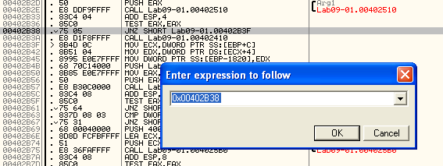

Right click on the address and press Ctrl-E (edit binary). Change the hex from 75 to 74 as shown below.

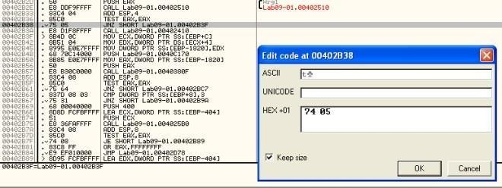

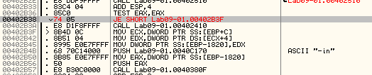Figure 4. Edit Binary

The next step is to save the changes. Right click in the disassembly window and select copy to executable -> all modifications. Then proceed to save into a file.

##### What are the host-based indicators of this malware?

To answer this question lets look at the dynamic analysis observations and IDA Pro codes.

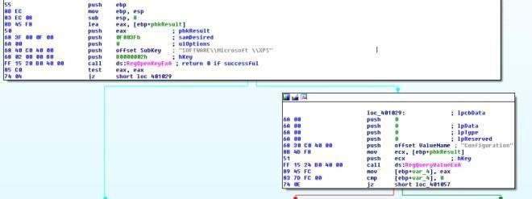

Figure 6. Registry trails in IDA Pro

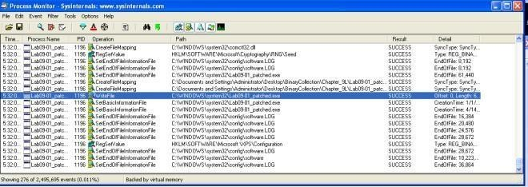

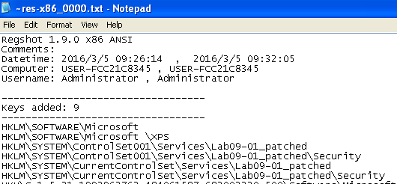Figure 8.

Figure 7. Proc Mon captured WriteFile and RegSetValue

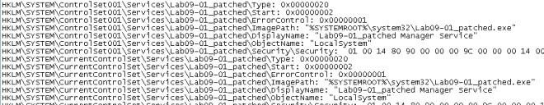Regshot captured registry creation and service creation

Figure 9. The service created in registry

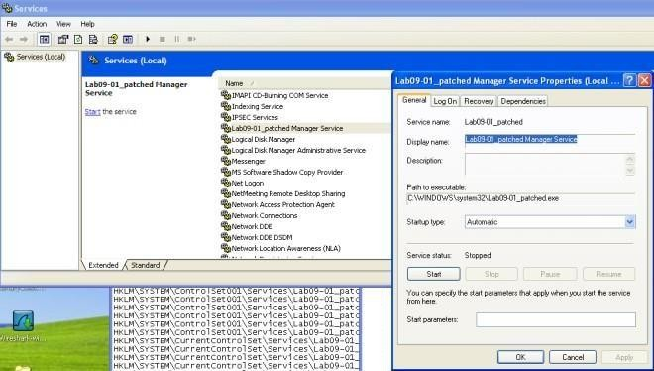

Figure 10. Services.msc

* 1. HKLM\\SOFTWARE\\Microsoft \\XPS\\Configuration
  2. Lab09-01_patched Manager Service
  3. %SYSTEMROOT%\\system32\\Lab09-01_patched.exe

##### What are the different actions this malware can be instructed to take via the network?

If no argument is passed into the executable, the malware will call the function @0x00402360. This function will parse the registry “HKLM\\SOFTWARE\\Microsoft \\XPS\\Configuration and call function 0x00402020 to execute the malicious functions.

Analyzing the function @0x00402020, we can conclude that the malware is capable of doing the following tasks

* 1. Sleep
  2. Upload (save a file to the victim machine)
  3. Download (extract out a file from the victim machine)
  4. Execute Command
  5. Do Nothing

##### Are there any useful network-based signatures for this malware?

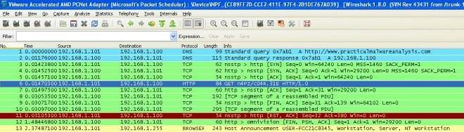

Figure 11. Network Traffic

From wireshark, we can see that the malware is attempting to retrieve commands from [http://www.practicalmalwareanalysis.com.](http://www.practicalmalwareanalysis.com/) A random page(xxxx/xxx.xxx) is retrieved from the server using HTTP/1.0. Note that the evil domain can be changed, therefore by fixing the network based signature to just practicalmalwareanalysis.com is not sufficient.

## Analyze the malware found in the file Lab09-02.exe using OllyDbg to answer the following questions.

##### i. What strings do you see statically in the binary?

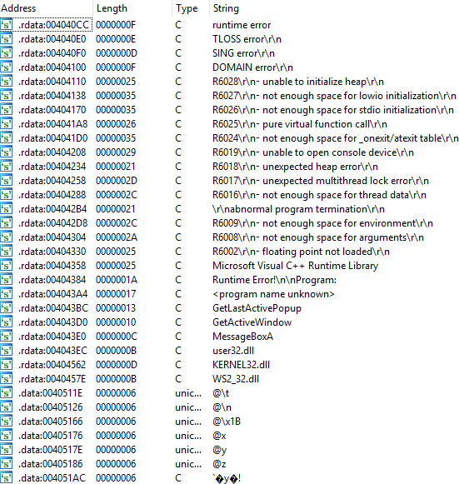

Nothing useful…

##### 2ii What happens when you run this binary?

The program just terminates without doing anything.

##### How can you get this sample to run its malicious payload?

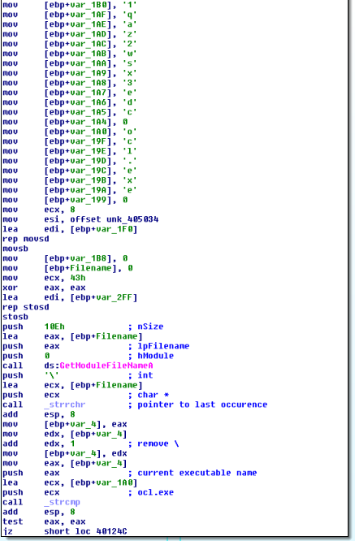

Figure 1. ocl.exe

From the above flow graph in main function, we can see that the binary retrieves its own executable name via **GetModuleFileNameA**. It then strip the path using **_strrchr**. The malware then compares the filename with **“ocl.exe”**. It it doesn’t match, the malware will terminates.

Therefore to run the malware we must name it as **“ocl.exe”**.

##### What is happening at 0x00401133?

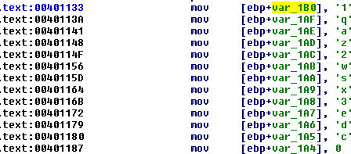

Figure 2. some passphrase?

We can see in the opcode that a string is formed character by character. The string is “1qaz2wsx3edc”. The way the author created the string prevented IDA Pro from displaying it as a normal string.

##### What arguments are being passed to subroutine 0x00401089?

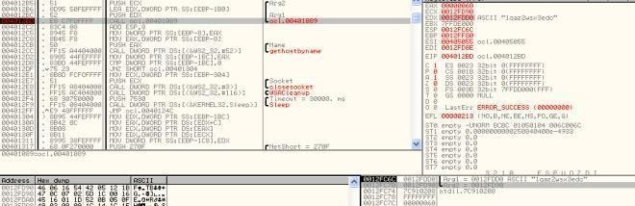

Figure 3. GetHostName

From the above ollydbg image, we can see that the string “1qaz2wsx3edc” is passed in to the subroutine 0x00401089. An unknown pointer (0x0012FD90) is also passed in.

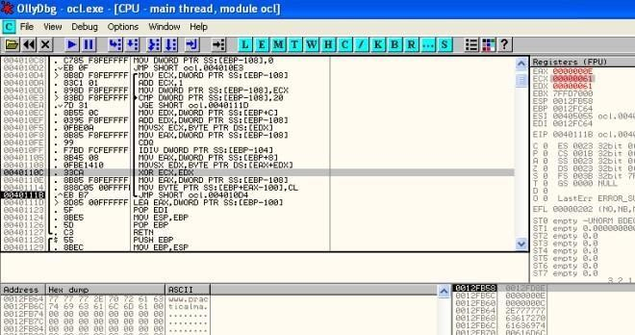

Figure 4. XOR decoding

Stepping into the subroutine, you will realize that the malware is trying to decode a string(0x0012FD90) with the xor key (1qaz2wsx3edc). As shown above, we can start to see the decoded string taking shape.

1. 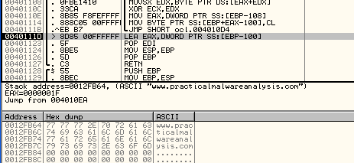What domain name does this malware use?

Figure 5. Domain Decoded

[http://www.practicalmalwareanalysis.com](http://www.practicalmalwareanalysis.com/)

1. What encoding routine is being used to obfuscate the domain name?

As mentioned in question 5, XOR is used to obfuscate the domain name.

1. 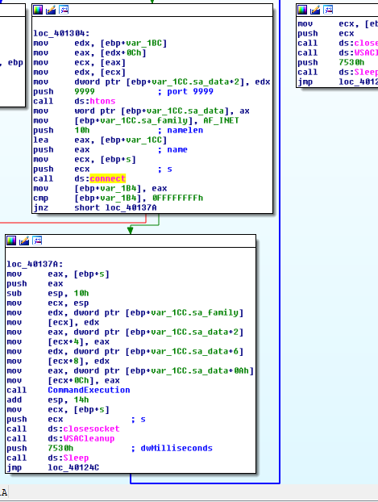What is the significance of the CreateProcessA call at 0x0040106E?

Figure 6. connecting to practicalmalwareanalysis.com:9999

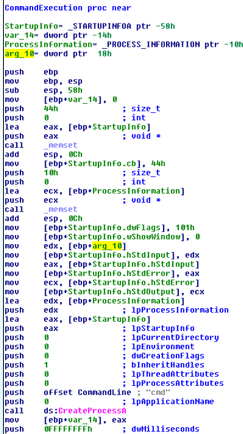The first block shows that we get the decoded domain name and get the ip by using [gethostbyname .](https://msdn.microsoft.com/en-us/library/windows/desktop/ms738524(v%3Dvs.85).aspx) In the second block, we can see that it is trying to connect to the derived ip at port 9999. In the third block, we can see that socket s is passed into the CommandExecution

subroutine as last argument.

Figure 7. passing io to socket

From the above figure, we can see that the StartupInfo’s hStdInput, hStdOutput, hStdError now points to the socket s. In other words, all input and output that we see in cmd.exe console will now be transmitted over the network. The CreateProcessA call for cmd.exe and is hidden via wShowWindow flag set to SW_HIDE(0). What it all meant was that a reverse shell is spawned to receive commands from the attacker’s server.

1. **Analyze the malware found in the file Lab09-03.exe using OllyDbg and IDA Pro. This malware loads three included DLLs (DLL1.dll, DLL2.dll, and DLL3.dll ) that are all built to request the same memory load location. Therefore, when viewing these DLLs in OllyDbg versus IDA Pro, code may appear at different memory locations. The purpose of this lab is to make you comfortable with finding the correct location of code within IDA Pro when you are looking at code in OllyDbg**

##### What DLLs are imported by Lab09-03.exe?

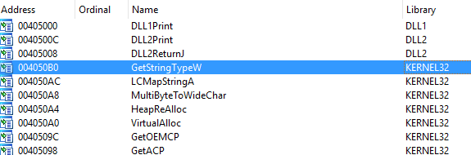

Figure 1. imports From IDA Pro we can see that DLL1, Dll2, KERNEL32 and NETAPI32 is imported by the malware. During runtime we can see more dlls being imported.

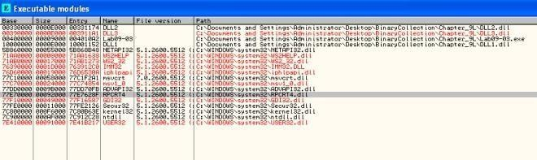

Figure 2. DLL3.dll being imported during runtime

##### What is the base address requested by DLL1.dll, DLL2.dll, and DLL3.dll?

Loading the dll in IDA Pro we can see the base address that each dll requests for. Turns out that all 3 dlls requests for the same image base at address 0x10000000.

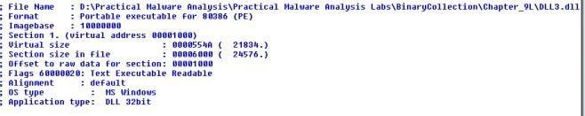

Figure 3. Imagebase: 0x10000000

##### When you use OllyDbg to debug Lab09-03.exe, what is the assigned based address for: DLL1.dll, DLL2.dll, and DLL3.dll?

From figure 2, we can observe that the base address for DLL1.dll is @0x10000000, DLL2.dll is @0x330000 and DLL3.dll is @0x390000.

##### When Lab09-03.exe calls an import function from DLL1.dll, what does this import function do?

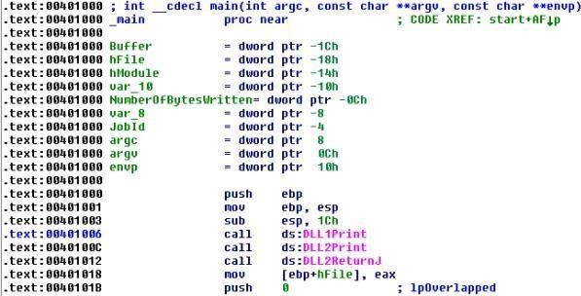

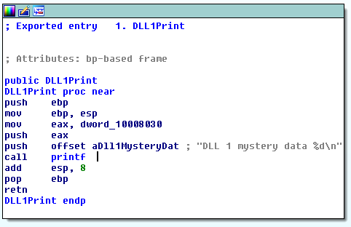Figure 4. Calling DLL1Print

Figure 5. DLL1Print

From figure 4, we can see that DLL1Print is called. In figure 1, we can see that DLL1Print is imported from DLL1.dll. Opening DLL1.dll in IDA Pro, we can conclude that DLL 1 mystery data %d\n is printed out. However %d is filled with values in dword_1008030 a global variable. xref check on this global variable suggests that it is being set by @0x10001009.

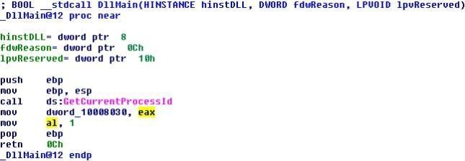

Figure 6. Setting global variable with process id

The above figure shows that once the dll is loaded, it will query its own process id and set the global variable dword_1008030 to the retrieved process id. To conclude DLL1Print will print out “**DLL 1 mystery data [CurrentProcess ID]**“.

##### writefileWhen Lab09-03.exe calls WriteFile, what is the filename it writes to?

Figure 7. File Handle from DLL2ReurnJ

Analyzing Lab09-03.exe, we can see that the File Handle is retrieved from DLL2ReurnJ subroutine (imported from DLL2.dll)

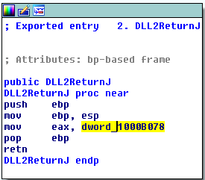

Figure 8. DLL2ReturnJ

From the above image, DLL2ReturnJ returns a global variable taken from dword_1000B078.

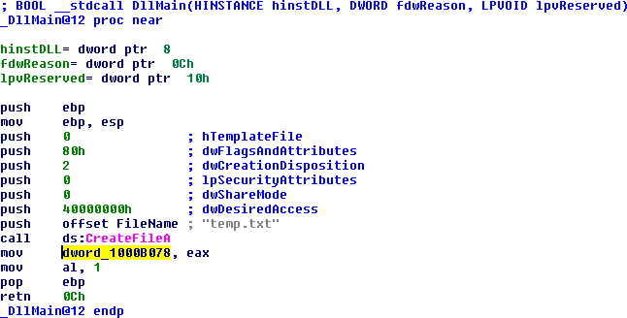

Figure 9. DLL2’s DLLMain

From the above image, things become clear. The returned File Handle points to **temp.txt**.

##### When Lab09-03.exe creates a job using NetScheduleJobAdd, where does it get the data for the second parameter?

According to msdn, [NetScheduleJobAdd](https://msdn.microsoft.com/en-us/library/windows/desktop/aa370614(v%3Dvs.85).aspx) submits a job to run at a specified future time and date. The second parameter is a pointer to a [AT_INFO](https://msdn.microsoft.com/en-us/library/windows/desktop/aa370248(v%3Dvs.85).aspx) Structure

NET_API_STATUS NetScheduleJobAdd(

_In_opt_ LPCWSTR Servername,

_In_ LPBYTE Buffer,

_Out_ LPDWORD JobId

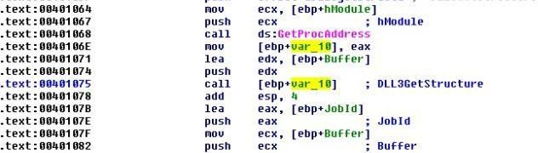);

Figure 10. AT_INFO structure

From Lab09-03.exe we can see that it is loading a dll dynamically during runtime by first calling [LoadLibraryA](https://msdn.microsoft.com/en-us/library/windows/desktop/ms684175(v%3Dvs.85).aspx)(“DLL3.dll”) then [GetProcAddress](https://msdn.microsoft.com/en-us/library/windows/desktop/ms683212(v%3Dvs.85).aspx)(“DLL3Print”) to get the pointer to the export function. The pointer is then called to get the AT_INFO structure.

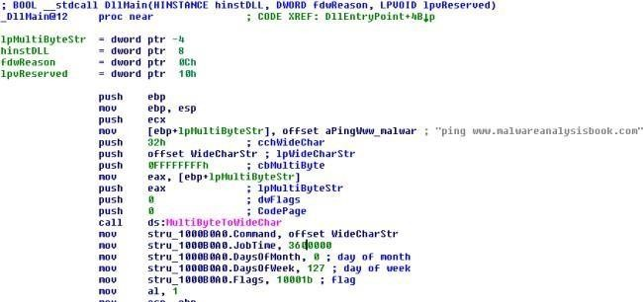

Figure 11. Get AT_INFO Structure

##### While running or debugging the program, you will see that it prints out three pieces of mystery data. What are the following: DLL 1 mystery data 1, DLL 2 mystery data 2, and DLL 3 mystery data 3?

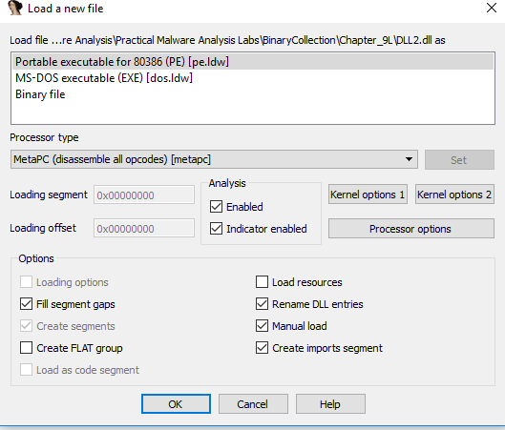

* + DLL 1 mystery data prints out the current process id
  + DLL 2 mystery data prints out the CreateFileA’s handle
  + DLL 3 mystery data prints out the decimal value of the address to the command string “ping http://www.malwareanalysisbook.com&#8221;

##### How can you load DLL2.dll into IDA Pro so that it matches the load address used by OllyDbg?

Figure 12. Manual Load

Select Manual Load checkbox when opening DLL2.dll in IDA Pro. You will be prompted to enter new image base address.

# Practical No. 4

#### a. This lab includes both a driver and an executable. You can run the executable from anywhere, but in order for the program to work properly, the driver must be placed in the C:\Windows\ System32 directory where it was originally found on the victim computer. The executable is Lab10-01.exe, and the driver is Lab10-01.sys

##### Does this program make any direct changes to the registry? (Use procmon to check.)

Not really. Looking at the following figure, the only direct changes made by the malware is RNG\Seed. However if you were to look into the registries created by services.exe, we will see that it is trying to add a service.

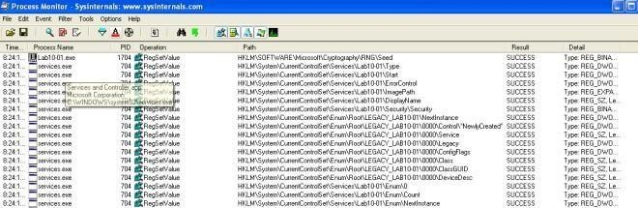

Figure 1. Registry changes

but this is not the case for regshot! There are some HKLM policies added to the machine.

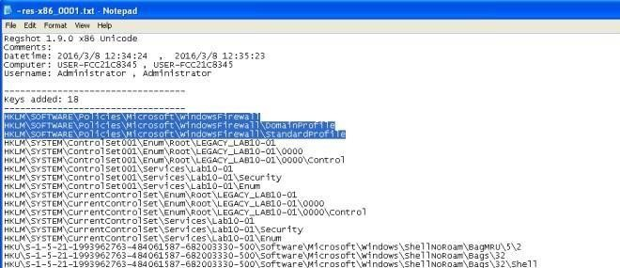

Figure 2. More Registry changes in Regshot

##### The user-space program calls the ControlService function. Can you set a breakpoint with WinDbg to see what is executed in the kernel as a result of the call to ControlService?

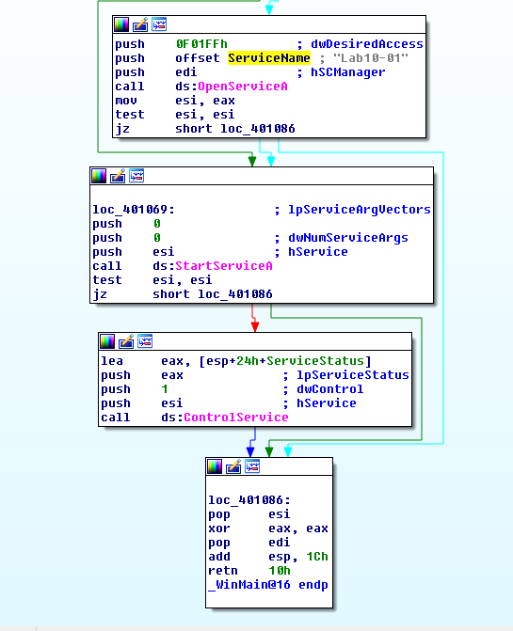

Figure 3. ControlService

The above figure shows the malware opening Lab10-01 service, starting the service and eventually closing it via [ControlService](https://msdn.microsoft.com/en-us/library/windows/desktop/ms682108(v%3Dvs.85).aspx); SERVICE_CONTROL_STOP.

breaking the kernel debugger and using the following command !object \Driver shows the loaded drivers…

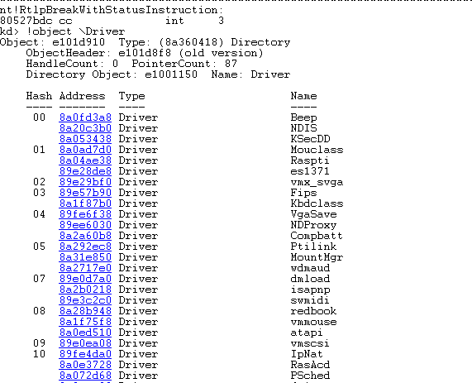

Figure 3. !object \Driver

SERVICE_CONTROL_STOP will call DriverUnload function. To figure out what is the address of DriverUnload function is I would first place a breakpoint on Lab10-01 Driver entry.

##### kd> bu Lab10_01!DriverEntry

Note that “-” is converted to “_”. Next we need to step till Lab10_01.sys is loaded. Use step out till you see this **nt!IopLoadUnloadDriver+0x45**.

##### kd> !object \Driver

to list the loaded drivers, then we use display type (dt) to display out the LAB10-01 driver.

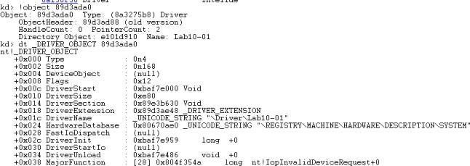

Figure 4. dt _DRIVER_OBJECT

In the above image, we can see the address for DriverUnload. Now we just need to set breakpoint on that address as shown below.

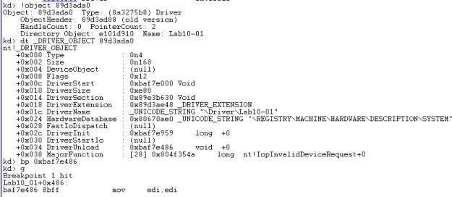Figure 5. breakpoint unload

Stepping through the functions we will see RtlCreateRegistryKey and RtlWriteRegistryValue being called.

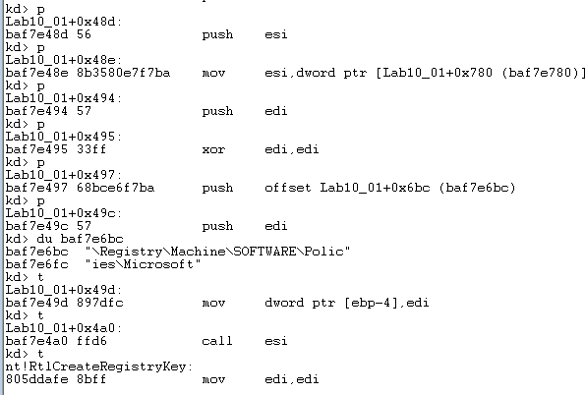

Figure 6. RtlCreateRegistryKey

The following image is the dissembled code of the driver in IDA Pro. Stepping the above instructions is the same as going through the instructions below.

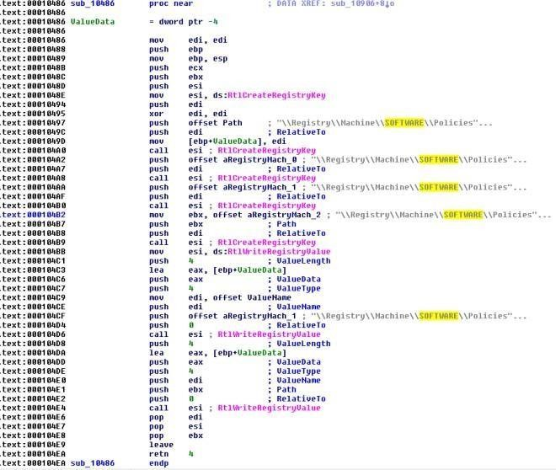

Figure 7. Lab10-01.sys IDA Pro

##### What does this program do?

The malware creates a service Lab10-01 that calls the driver located at “c:\windows\system32\Lab10-01.sys”. It then starts the service, executing the driver and then stops the driver causing the driver to unload itself. In the driver’s unload function the driver attempts to create and write registry key using kernel function call. The following are the registry modification made by the driver.

* **RtlCreateRegistryKey**: \\Registry\\Machine\\SOFTWARE\\Policies\\Microsoft
* **RtlCreateRegistryKey**: \\Registry\\Machine\\SOFTWARE\\Policies\\Microsoft\\WindowsFirewall
* **RtlCreateRegistryKey**: \\Registry\\Machine\\SOFTWARE\\Policies\\Microsoft\\WindowsFirewall

\\DomainProfile

* **RtlCreateRegistryKey**:\\Registry\\Machine\\SOFTWARE\\Policies\\Microsoft\\WindowsFirewall\\StandardProfile
* **RtlWriteRegistryValue**:\\Registry\\Machine\\SOFTWARE\\Policies\\Microsoft\\WindowsFirewa

ll\\DomainProfile – 0 (data)

* **RtlWriteRegistryValue**: \\Registry\\Machine\\SOFTWARE\\Policies\\Microsoft\\WindowsFirewa ll\\StandardProfile – 0 (data)

According to [msdn,](https://technet.microsoft.com/en-us/library/bb490624.aspx) the above registry modifications will disable Windows Firewall for both the domain and standard profiles on the victim’s machine.

#### b- The file for this lab is Lab10-02.exe

##### Does this program create any files? If so, what are they?

Cerbero Profiler highlighted that the malware contains a PE Resource. Instinct tells me that this malware behaves like a packer and will extract this resource onto the target’s machine.

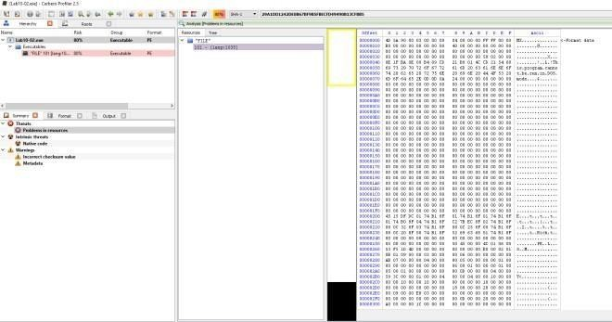

Figure 1. MZ header in resource

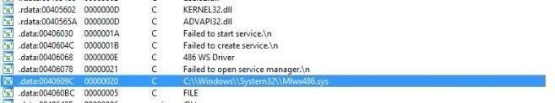

Figure 2. IDA Pro’s string

“C:\\Windows\\System32\\Mlwx486.sys” seems suspicious. xRef this string might help us to solve this problem.

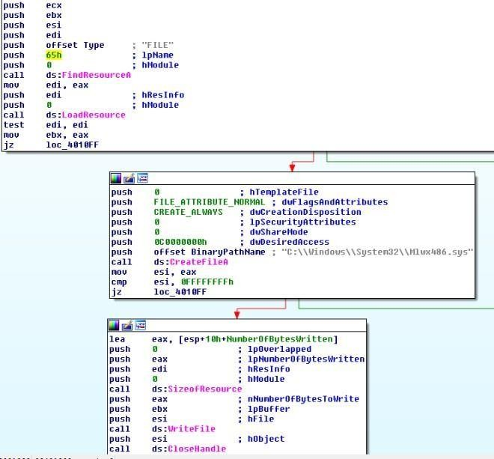

Figure 3. Extract Resource

In the main method, we can see that the code is trying to extract the FILE resource into “C:\\Windows\\System32\\Mlwx486.sys”.

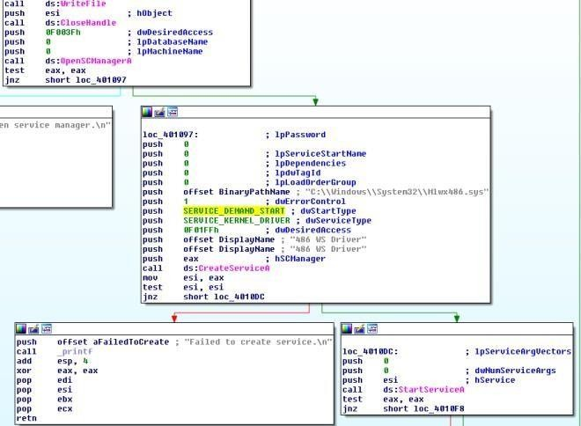

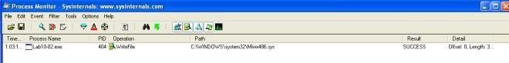After extracting the driver, the malware then goes on to create a service (486 WS Driver) and start it using StartServiceA.

Using Proc mon we can observe that WriteFile to “C:\\Windows\\System32\\Mlwx486.sys” was captured by the tool.

##### Does this program have a kernel component?

Attempts to locate the dropped driver in system32 folder was fruitless. Somehow the file is not in the folder. So instead I decided to extract the driver out from the resource directly. Firing up IDA Pro we can see DriverEntry function suggesting that this executable is a driver.

##### What does this program do?

DrierEntry leads us to the following subroutine in IDA Pro (0x10706). The malware is attempting to change the flow of the kernel Service Descriptor Table and the target that it is attempting to hook is the NtQueryDirectoryFile. The malware calls MmGetSystemRoutineAddress to get the pointer to the NtQueryDirectoryFile and KeServiceDescriptorTable subroutine. Then it loops through the service descriptor table looking

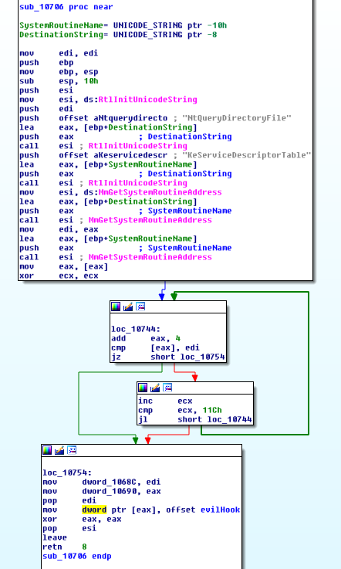for the address of NtQueryDirectoryFile. Once found, it will overwrite the address with the evil hook (custom subroutine).

Figure 6. Evil Hook

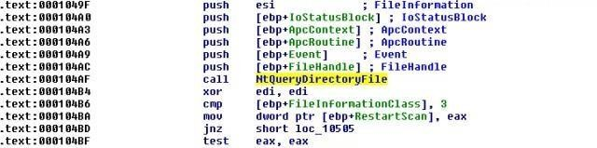

Figure 6. NTQueryDirectoryFile

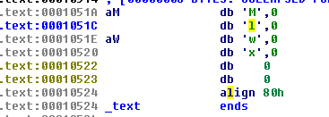In the driver, **NTQueryDirectoryFile** function is used. According to [msdn,](https://msdn.microsoft.com/en-us/library/windows/hardware/ff556633(v%3Dvs.85).aspx) this function returns various kinds of information about files in the directory specified by a given file handle. Further down, we can see that **RtlCompareMemory** is called. A comparison was made between the filename and the following string “**Mlwx**“. If it matches, the file will be hidden.

Figure 7. Mlwx string

To see all this win action, fire up Windbg and attach it to the kernel. use the following command to list the service descriptor table. This table has yet been tamperedwith…

##### kd> dps nt!KiServiceTable l 100

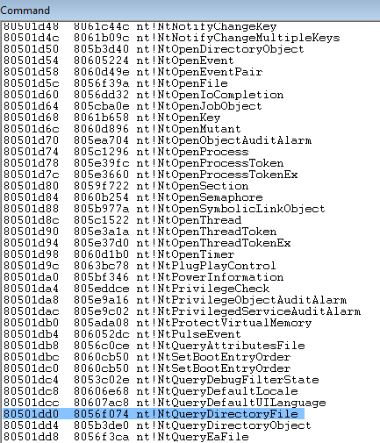

Figure 8. Default Service Descriptor Table

Set breakpoint by using this command **bu Mlwx486!DriverEntry**. Run Lab10-02.exe and windbg should break.Set breakpoint at **nt!IopLoadDriver+0x66a** and let the program run again. Once the kernel breaks, you will be able to run **!object \Driver** to list the loaded drivers.

DriverInit for the malware has yet been executed at this stage so you can set your breakpoint from this point on.

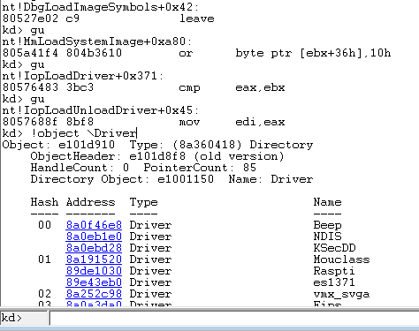

Figure 9. Break @ DriverEntry

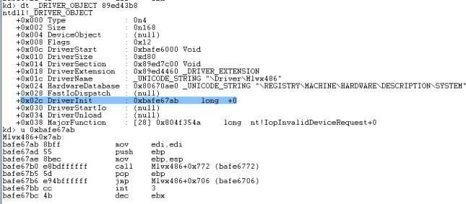

Figure 10. DriverInit

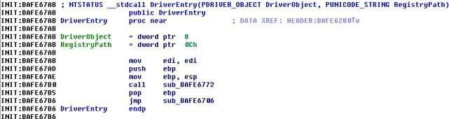

Figure 11. DriverEntry

From Figure 10 & 11, we can see that DriverInit is actually DriverEntry in IDA Pro.

runing **kd> dps nt!KiServiceTable l 100** now shows that the service descriptor table has been modified.

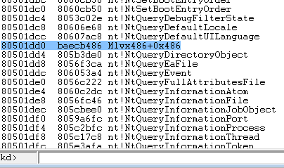

Figure 12. Service Descriptor Table modified

To conclude, the malware uses ring 0 rootkit to hide files that starts with “**Mlwx**” via hooking of the service descriptor table.

# Practical No. 5

#### Analyze the malware found in Lab11-01.exe

##### What does the malware drop to disk?

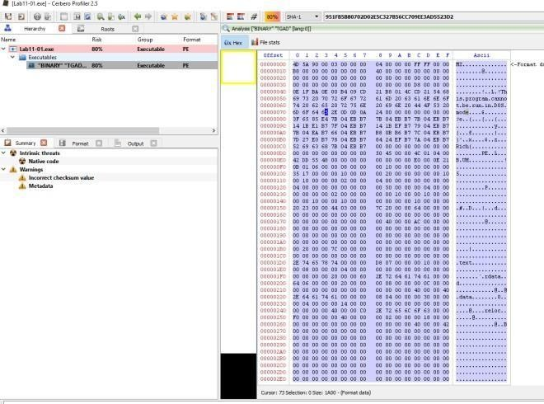

Figure 1. Binary resource in Lab11-01.exe’s TGAD

There is a binary in the resource section of Lab11-01.exe.

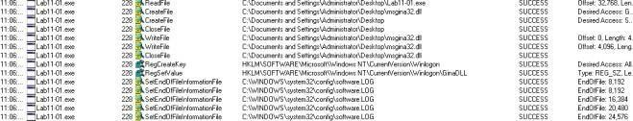

Figure 2. msgina32.dll dropped

From Proc Mon we can observe that msgina32.dll and software.LOG are dropped on the machine.

##### How does the malware achieve persistence?

In figure 2, the malware adds “HKLM\SOFTWARE\Microsoft\Windows NT\CurrentVersion\Winlogon\GinaDLL” into the registry.

According to [MSDN,](https://msdn.microsoft.com/en-us/library/windows/desktop/aa380543(v%3Dvs.85).aspx) [*Winlogon*](https://msdn.microsoft.com/en-us/library/windows/desktop/ms721635(v%3Dvs.85).aspx#_security_winlogon_gly), the [*GINA*](https://msdn.microsoft.com/en-us/library/windows/desktop/ms721584(v%3Dvs.85).aspx#_security_gina_gly), and network providers are the parts of the interactive logon model. The interactive logon procedure is normally controlled by Winlogon, MSGina.dll, and network providers. To change the interactive logon procedure, MSGina.dll can be replaced with a customized GINA DLL. Winlogon will trigger the use of the malicious dll and that is how the malware achieve persistency.

##### How does the malware steal user credentials?

Looking at the dropped dll’s export, it seems like it is a custom dll to hook to the winlogon process.

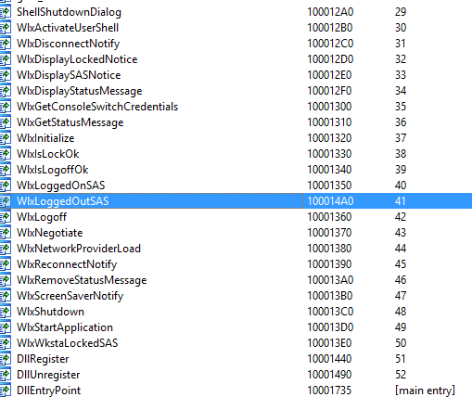

Figure 3. WlxLoggedOutSAS

After checking through the exports function, only 1 function (**WlxLoggedOutSAS**) behaves suspiciously. The rest simply pass the inputs to the original function address.

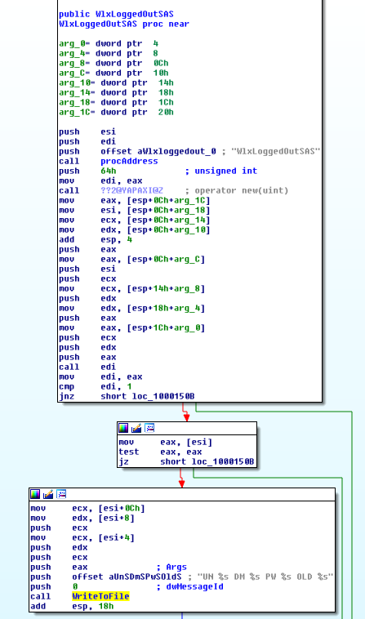

Figure 4. Intercepting WlxLoggedOutSAS

The above figure is pretty straight forward, the inputs are passed to the original WlxLoggedOutSAS function and a copy of the inputs are passed to a function to write to a file.

##### What does the malware do with stolen credentials?

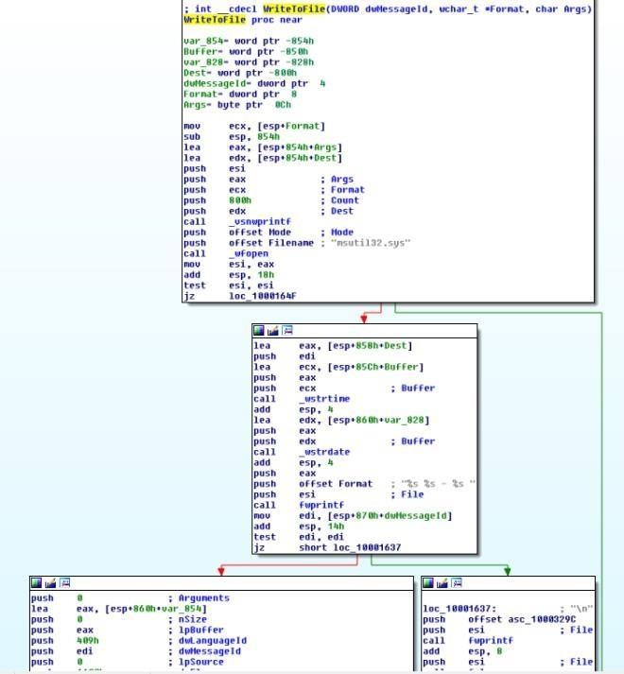

Figure 5. Write to file

The above figure shows the malicious dll writing the stolen values into c:\windows\system32\msutil32.sys file.

##### How can you use this malware to get user credentials from your test environment?

By rebooting the machine or by logging off and re-login

again. **c:\windows\system32\msutil32.sys** will contains the password used to login to the windows.

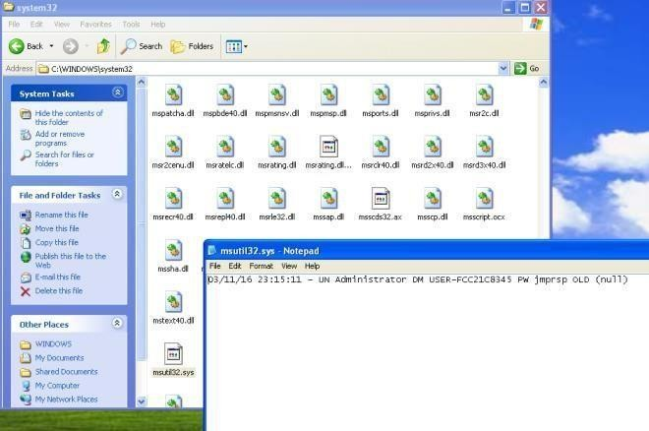

Figure 6. Captured Password

1. **Analyze the malware found in *Lab11-02.dll*. Assume that a suspicious file named *Lab11-02.ini* was also found with this malware.**

##### What are the exports for this DLL malware?



Figure 1. Exports

##### What happens after you attempt to install this malware using rundll32.exe?

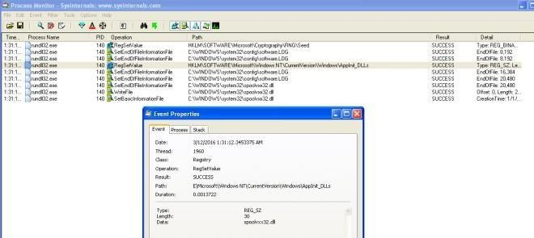

Figure 2. Set Registry & WriteFile

The malware add a registry value in **HKLM\\SOFTWARE\\Microsoft\\Windows NT\\CurrentVersion\\Windows\\AppInit_DLLS**.

It then copy itself; the dll as **C:\Windows\System32\spoolvxx32.dll**. The malware then tries to open **C:\Windows\System32\Lab11-02.ini.**

##### Where must Lab11-02.ini reside in order for the malware to install properly?

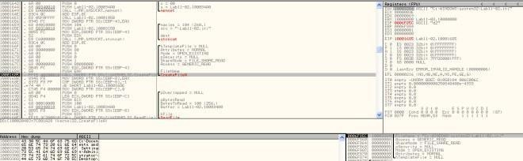

Figure 3. Loads config file

The malware will attempt to load the config from **C:\Windows\System32\Lab11-02.ini**. We would need to place the ini file in system32 folder.

##### How is this malware installed for persistence?

According to [MSDN,](https://msdn.microsoft.com/en-us/library/windows/desktop/dd744762(v%3Dvs.85).aspx) AppInit_DLLs is a mechanism that allows an arbitrary list of DLLs to be loaded into each user mode process on the system. By adding AppInit_DLLs

in **HKLM\\SOFTWARE\\Microsoft\\Windows NT\\CurrentVersion\\Windows\\** we are loading the malicious DLL into each user mode process that gets executed on the system.

##### What user-space rootkit technique does this malware employ?

If we look at the subroutine @0x100012A3, you will see that it is attempting to get the address of send from wscock32.dll. It then pass the address to subroutine @0x10001203.

The subroutine @0x10001203 is employing the inline hook technique. It first get the offset from the hook position to the function where it wants to jump to. It then uses VirtualProtect to make 5 bytes of space from the start of the subroutine address

to **PAGE_EXECUTE_READWRITE.** Once it is done it then rewrite the code to jmp to the hook function. Finally it reset the 5 bytes of memory space back to the old protection attributes.

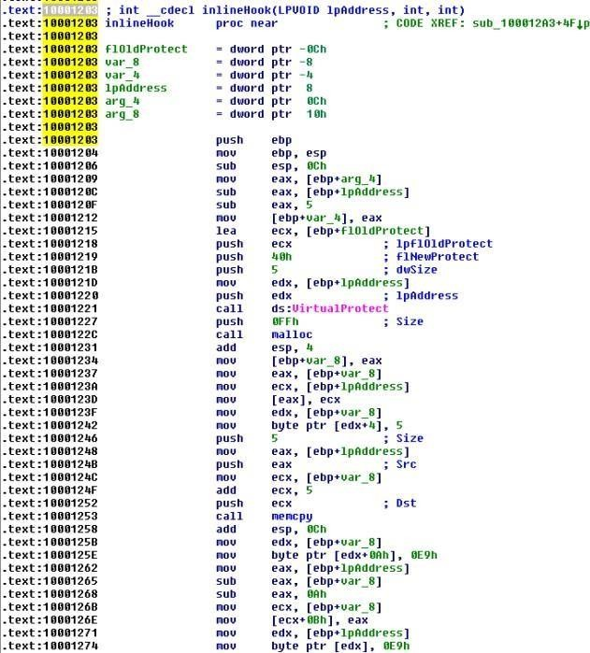

Figure 4. inline hook

However, the malware only hook 3 programs; THEBAT.EXE, OUTLOOK.EXE, MSIMM.EXE.

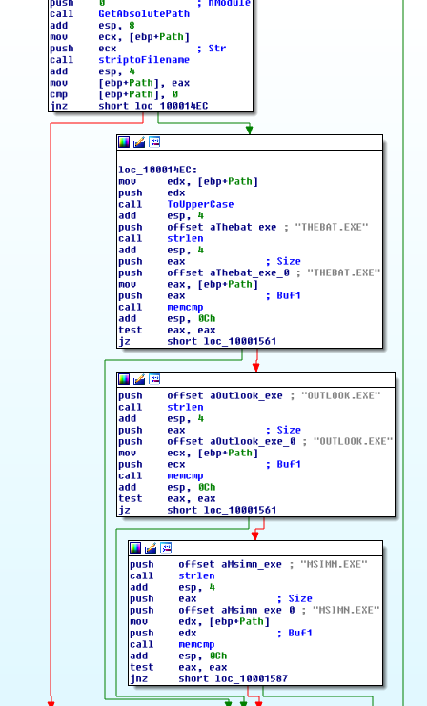

Figure 5. Hook selected programs

To conclude, the malware is attempting to do an inline hook on wsock32.dll’s send function for selected programs.

##### What does the hooking code do?

We first look at what the malware is retrieving from the config file.

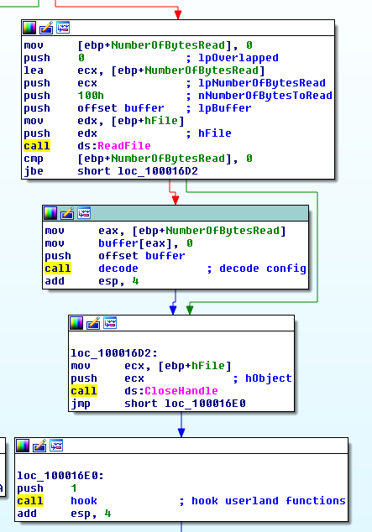

Figure 6. Decoding config

After reading the data from the config file, the malware then decode it by calling the subroutine @0x100016CA. If we dive into this subroutine, you will realize that it is a xor decoding function. Let’s place a hook there in ollydbg to see what comes out.

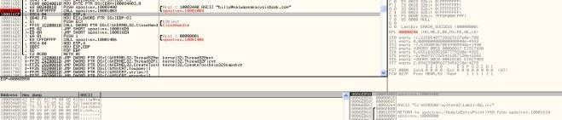

Figure 7. [billy@malwareanalysisbook.com](mailto:billy@malwareanalysisbook.com)

This decoded string will be use in the following function.

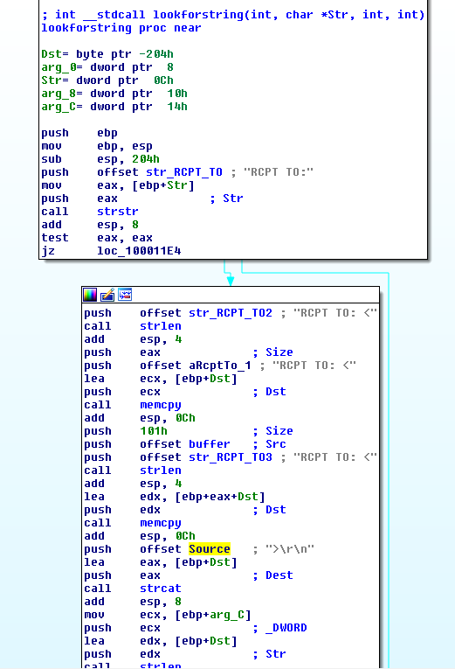

Figure 8. replacing send data

The inline hook jumps to the above function. Its starts off with checking if the send buffer contains the string “RCPT TO”. If it does, it will create a new buffer “**RCPT T**[**O:<b**](mailto:billy@malwareanalysisbook.com)**il[ly@](mailto:billy@malwareanalysisbook.com)m**[**alwareanalysisbook.com**](mailto:billy@malwareanalysisbook.com)**>\r\n**” and send it off via the original send function. The function will then end of by simply forwarding the original data to the send function.

##### Which process(es) does this malware attack and why?

As answered in question v… the malware only hook 3 programs; THEBAT.EXE, OUTLOOK.EXE, MSIMM.EXE. They are all email clients.

##### What is the significance of the .ini file?

As answered in question v… the config.ini contains the encoded attacker email address. It is use to replace recipient address causing email to be send to the attacker instead.

## Analyze the malware found in Lab11-03.exe and Lab11-03.dll. Make sure that both files are in the same directory during analysis.

##### netstartWhat interesting analysis leads can you discover using basic static analysis? Lab11-03.exe

Figure 1. Installation

The main method in Dll11-03.exe is pretty straight forward. It first copy the Lab11-03.dll to **C:\\Windows\\System32\\inet_epar32.dll**. It then attempts to modify **C:\\Windows\\System32\\cisvc.exe** and executes the infected executable by starting a service via the command “**net start cisvc**”

##### Lab11-03.dll

The dll contains some interesting stuff… In export, we can see a suspicious looking function;

##### zzz69806582.

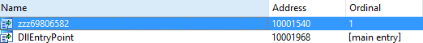

Figure 2. Export function surface a funny function

The imports contains **GetAsyncKeyState** and **GetForegroundWindow** which highly suggests that this is a keylogger.

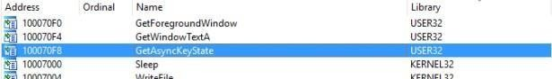

Figure 3. imports

The function @zzz69806582 is pretty simple. It just creates a thread.

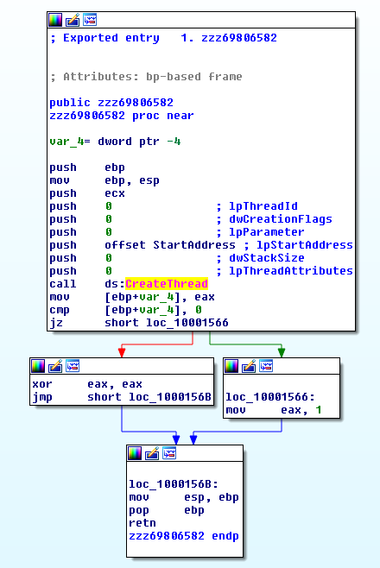

Figure 3. function zzz69806582

The thread that the above function creates first check for mutex; **MZ**. It then create a file @ **C:\\Windows\\System32\\kernel64x.dll**.

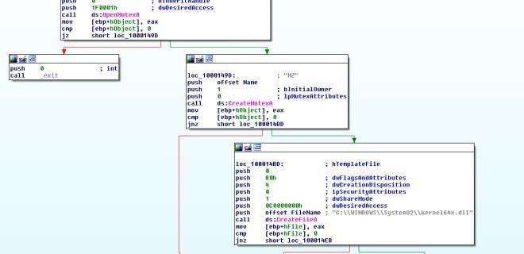

Figure 4.Mutex MZ

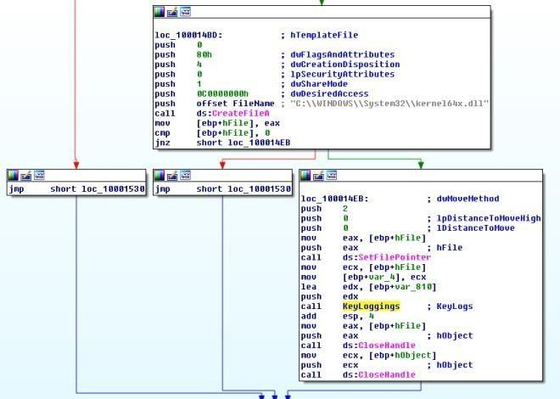

Next, the thread calls a subroutine to record keystrokes.

Figure 5. Keylogs

##### What happens when you run this malware?

As answered in question 1, It first copy the Lab11-03.dll to **C:\\Windows\\System32\\inet_epar32.dll**. It then attempts to modify **C:\\Windows\\System32\\cisvc.exe** and executes the infected executable by starting a service via the command “**net start cisvc**”

The infected service then begin to log keystroke and save it in **C:\\Windows\\System32\\kernel64x.dll**.

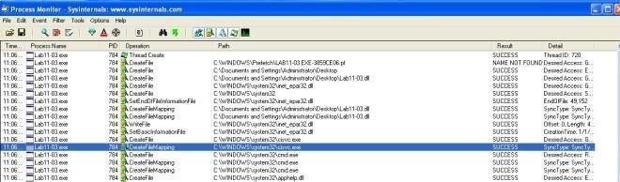

Figure 6. Procmon showing file creation in infected system

##### How does Lab11-03.exe persistently install Lab11-03.dll?

It infects **C:\\Windows\\System32\\cisvc.exe;** an indexing service by inserting shellcodes into the program. The infected cisvc.exe will load **C:\\Windows\\System32\\inet_epar.dll** as shown in the figure below.

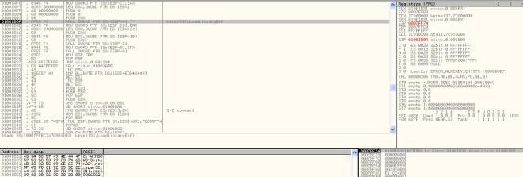

Figure 7. LoadLibrary

Comparing the infected executable with the original one, we could see some additional functions added to it. On top of that we can observe that the entry point has been changed.

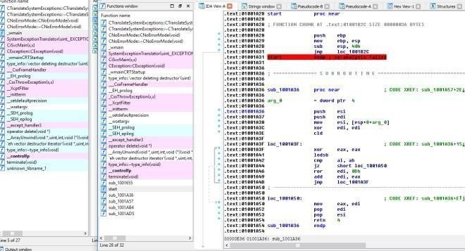

Figure 8. Additional Functions

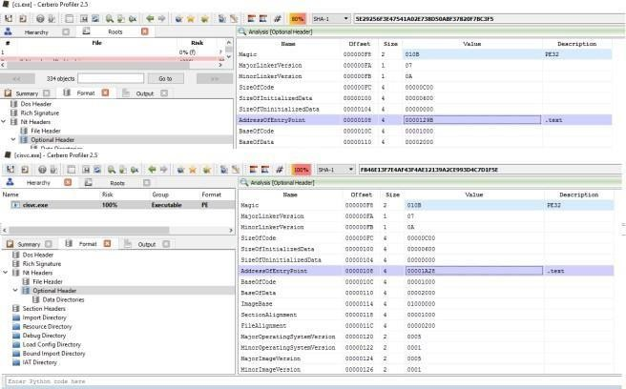

Figure 9. Changes in Entry Point

##### Which Windows system file does the malware infect?

It infects **C:\\Windows\\System32\\cisvc.exe**.

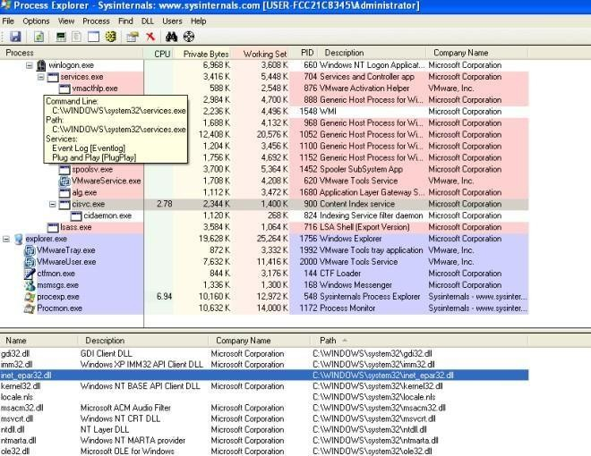

Figure 10. inet_epar32.dll loaded in cisvc.exe

##### What does Lab11-03.dll do?

Using **GetAsyncKeyState** and **GetForegroundWindow**, the dll logs keystrokes

into **C:\\Windows\\System32\\kernel64x.dll**. The dll also uses a mutex “MZ” to prevent multiple instances of the keylogger is running at once.

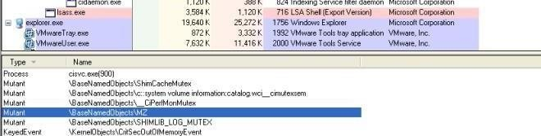

Figure 11. Mutex MZ

##### Where does the malware store the data it collects?

In **C:\\Windows\\System32\\kernel64x.dll**

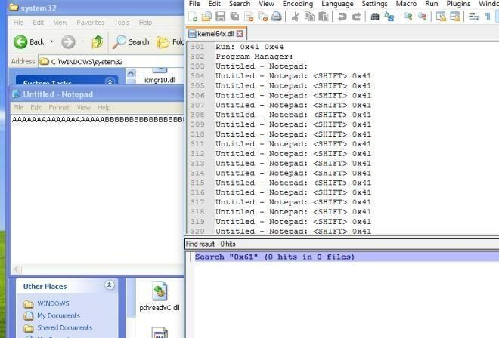

Figure 12. Key Logs Captured

# Practical No. 6

## Analyze the malware found in the file *Lab12-01.exe* and *Lab12-01.dll*. Make sure that these files are in the same directory when performing the analysis.

##### What happens when you run the malware executable?

A Message box with a incremental number in its title pops up every now and then…

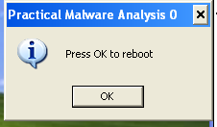

##### What process is being injected?

In the imports table, CreateRemoteThread is used by the exe which highly suggests that the malware might be injecting DLL into processes.

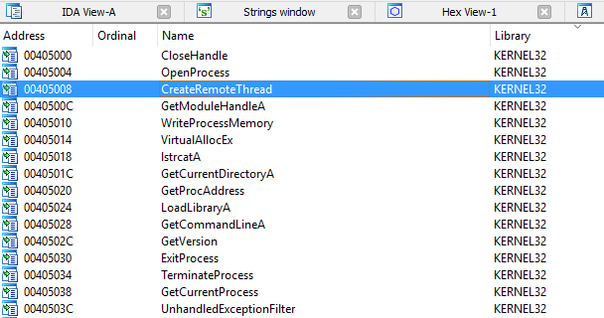

Figure 2. CreateRemoteThread in imports

“explorer.exe” is found in the list of string. X-ref the string and we will come to the following subroutine. Seems like explorer.exe is being targeted to be injected with the malicious dll.

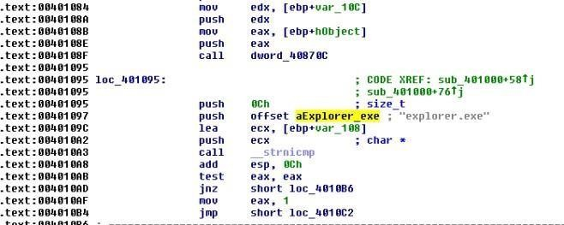

Figure 3. explorer.exe

We can confirm our suspicion using process explorer as shown below.

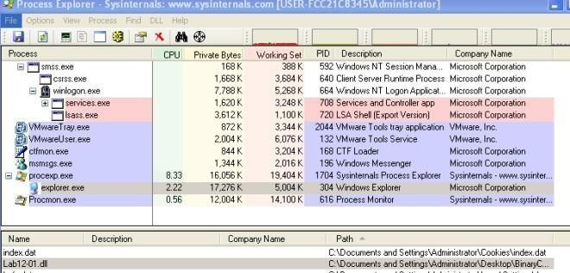

Figure 4. Explorer.exe injected with dll

##### How can you make the malware stop the pop-ups?

Kill explorer.exe and re-run it again

##### How does this malware operate?

**Lab12-01.exe**

The malware begins by using psapi.dll’s [EnumProcesses](https://msdn.microsoft.com/en-us/library/windows/desktop/ms682629(v%3Dvs.85).aspx) to loop through all running processes. Also note that it attempts to form the absolute path for the malicious dll. This will be used later to inject the dll in remote processes.

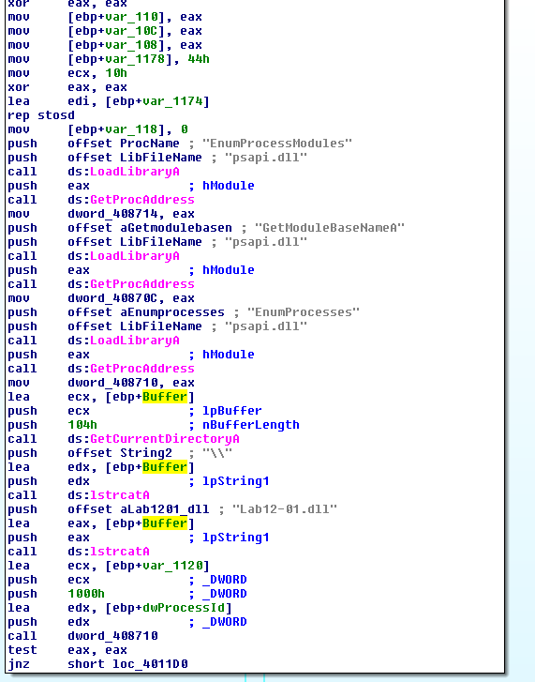

Figure 5. EnumPorcesses

While looping through the processes only “explorer.exe” will be injected. The following figure shows the filtering taking place.

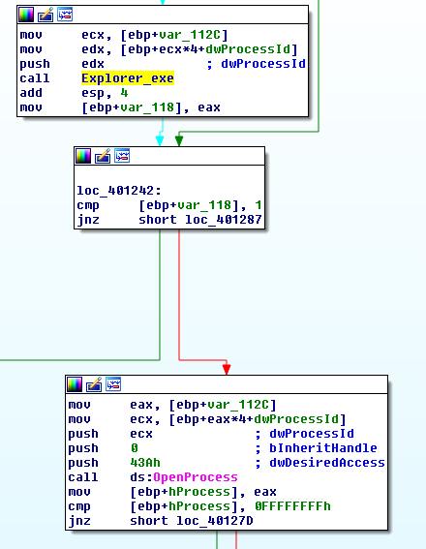

Figure 6. Check for explorer.exe

Once the malware located the “explorer.exe” process, it will ask the remote process (explorer.exe) to allocate a heap space. The space will contains the malicious dll’s absolute path as mentioned earlier. It will then get the LoadLibraryA address of explorer.exe and triggers the function via CreateRemoteThread. Explorer.exe will then invoke LoadLibraryA with the input as the malicious dll’s absolute path which is already in its heap memory and that is how explorer.exe got injected. =)

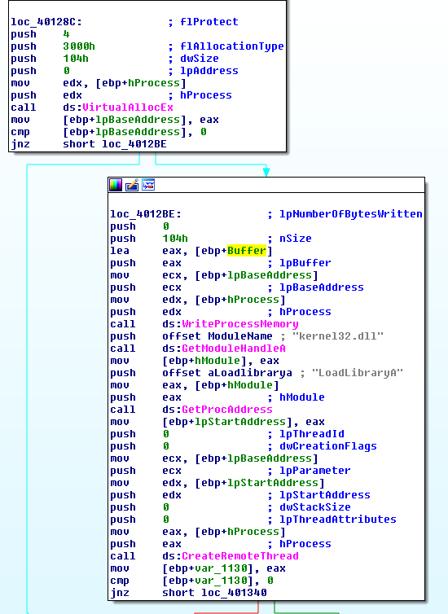

Figure 7. Injecting

##### Lab12-01.dll

The DllMain first creates a thread @ subroutine 0x1001030.

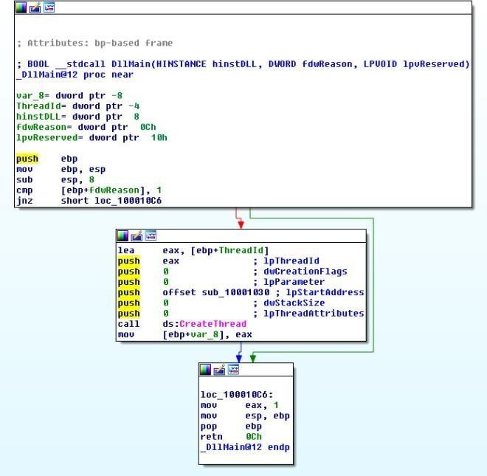

Figure 8. Create Thread

Inside this subroutine, we will find a infinite loop popping a message box every 1 minute. The title of the message box is “Practical Malware Analysis %d” where %d is the value of the loop counter.

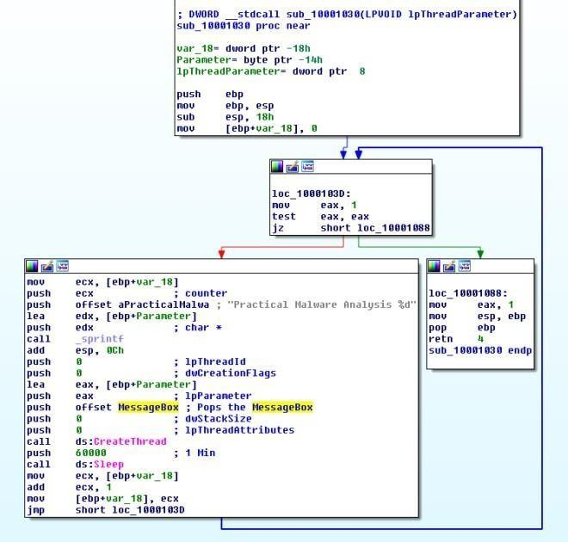

Figure 9. Popping MsgBox every minute

1. **Analyze the malware found in the file *Lab12-02.exe*.**

##### What is the purpose of this program?

Based on dynamic analysis results using procmon and process explorer, we can conclude that this is a keylogger that performs process hollowing on svchost.exe.

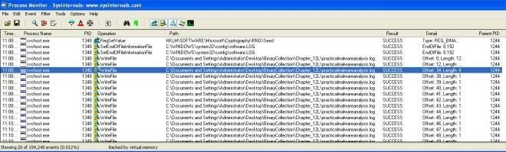

Figure 1. Write file to practicalmalwareanalysis.log

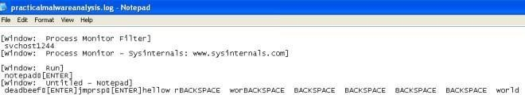

Figure 2. Keystrokes in log file

##### How does the launcher program hide execution?

The subroutine @0x004010EA is highly suspicious. It is trying to create a process in suspended state, calls UnmapViewOfSection to unmap the original code and tries to write process memory in it. Finally it resumes the process. This is a recipe for process hollowing technique in which the running process will look like svchost.exe (in this case) but it is actually running something else instead.

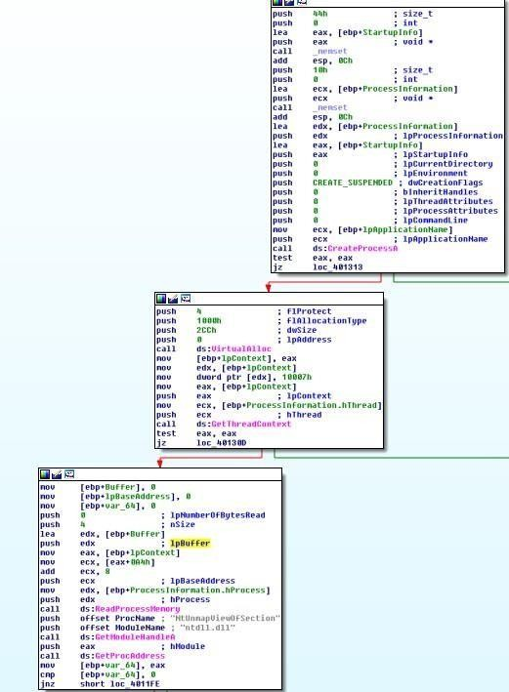

Figure 3. Create Suspended process, unmap memory

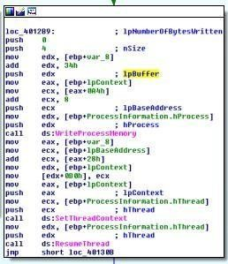

Figure 4. WriteProcessMemory, ResumeThread

##### Where is the malicious payload stored?

In the resource, we can see a suspicious looking payload. IDA Pro further confirmed that this is the payload that will be extracted out.

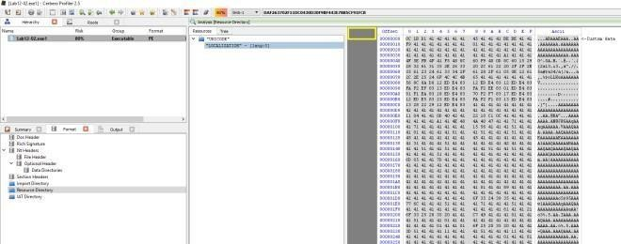

Figure 5. Resource with lots of As in it

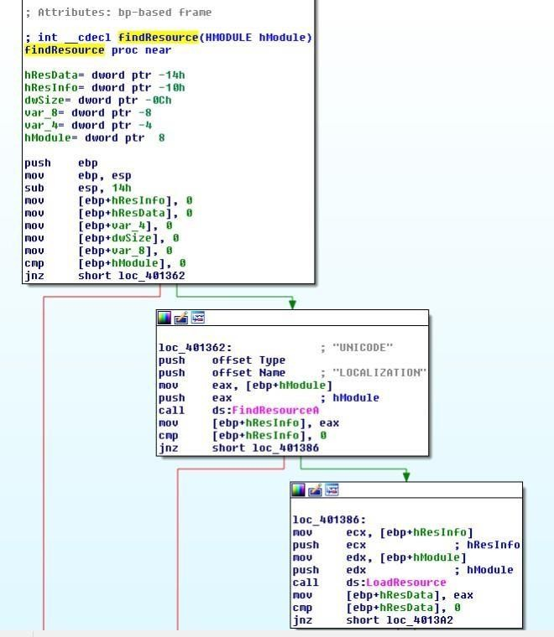

##### How is the malicious payload protected?

By analyzing the find resource function @0x0040132C we will come across the following codes that suggests to us that the payload is XOR by “A”.

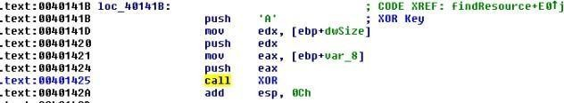

Figure 7. XOR by A

##### How are strings protected?

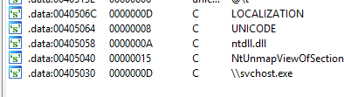The strings are in plain… correct me if i am wrong

Figure 8. Strings in plain

1. **Analyze the malware extracted during the analysis of Lab 12-2, or use the file**

***Lab12-03.exe***

##### What is the purpose of this malicious payload?

The use of SetWindowsHookExA with WH_KEYBOARD_LL as the id which suggests that this is a keylogger.

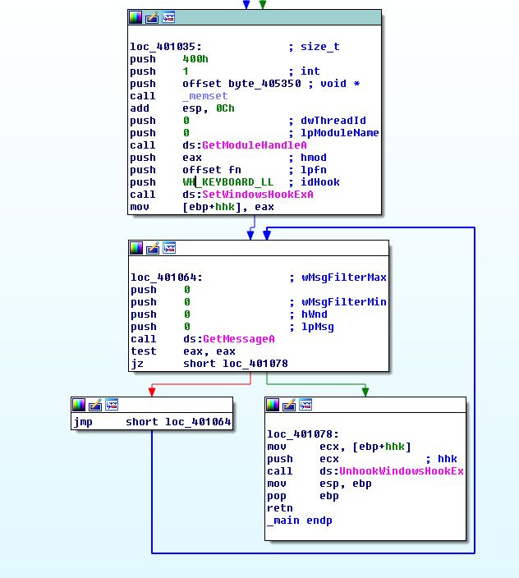

Figure 1. SetWindowsHookExA

##### How does the malicious payload inject itself?

It uses Hook injection. Keystrokes can be captured by registering high- or low-level hooks using the WH_KEYBOARD or WH_KEYBOARD_LL hook procedure types, respectively. For WH_KEYBOARD_LL procedures, the events are sent directly to the process that installed the hook, so the hook will be running in the context of the process that created it. The malware can intercept keystrokes and log them to a file as seen in the figure below.

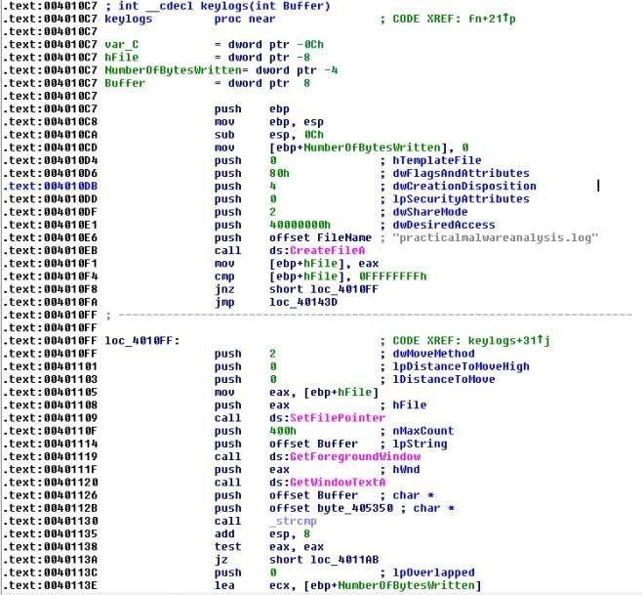

Figure 2. Log to practicalmalwareanalsysis.log

##### What filesystem residue does this program create?

The malware will leave behind a log file containing the keylogs; practicalmalwareanalsysis.log.

1. **Analyze the malware found in the file *Lab12-04.exe*.**

##### What does the code at 0x401000 accomplish?

The subroutine check if the process with the given process id is Winlogon.exe. If it is, it returns 1 else it returns 0.

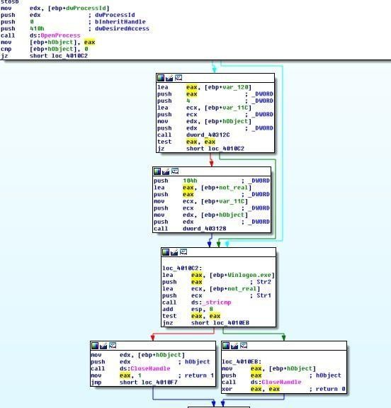

##### Which process has code injected?

Winlogon.exe is being targeted for injection. Subroutine @0x00401174 is responsible for process injection via CreateRemoteThread. If we trace back, we can see that only winlogon’s pid is being passed to the subroutine.

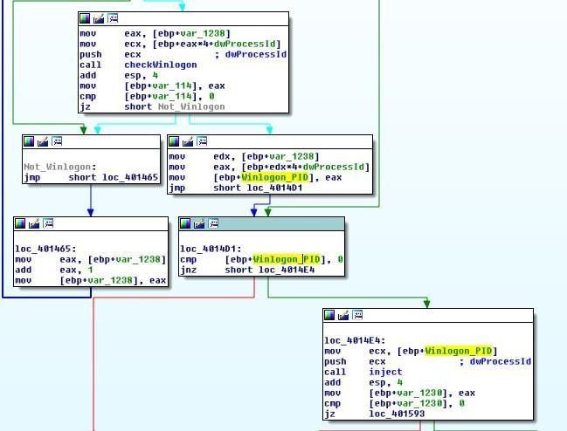

Figure 2. Winlogon Pid being pushed as argument to inject subroutine

##### What DLL is loaded using LoadLibraryA? sfc_os.dll

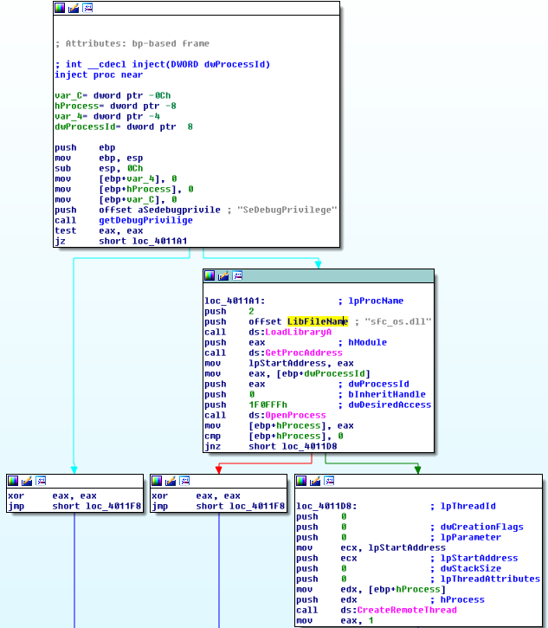

Figure 3. sfc_os.dll

##### What is the fourth argument passed to the CreateRemoteThread call?

Based on figure 3, the fourth argument is lpStartAddress in which if we were to trace up we will uncover that lpStartAddress is the address return by GetProcAddress(LoadLibraryA(“sfc_os.dll”),2).

Loading sfc_os.dll in ida pro we can see the exports that points to ordinal 2 which resovles to SfcTerminateWatcherThread() as shown in figure 5..

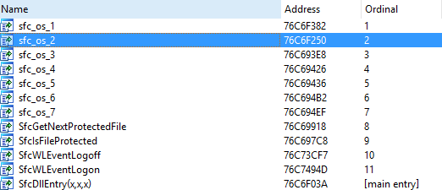

Figure 4. sfc_os.dll’s ordinal 2

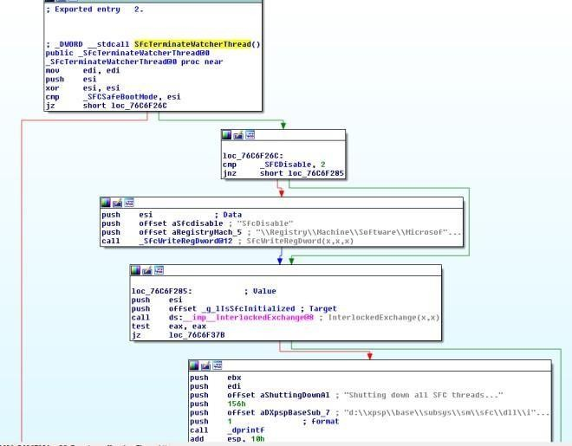

Figure 5. SfcTerminateWatcherThread()

##### What malware is dropped by the main executable?

Analyzing the main method, we can see file movement from “**C:\WINDOWS\system32\wupdmgr.exe**” to a temp folder “**C:\DOCUME~1\ADMINI~1\LOCALS~1\Temp\\winup.exe**”

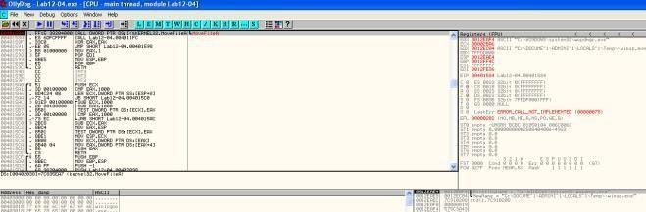Figure

6. Backing up wupdmgr.exe

The following subroutine is then called to extract the resource out from the executable and using it to replace “**C:\WINDOWS\system32\wupdmgr.exe**”

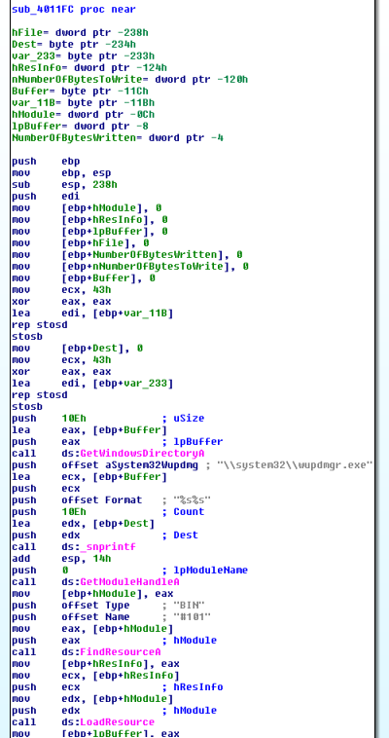

Figure 7. dropping form resource to system32\\wupdmgr.exe

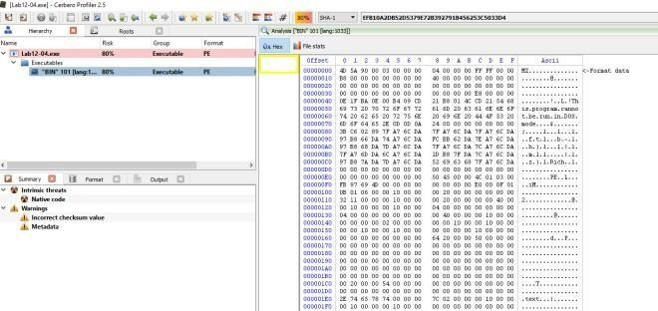

Figure 8. Bin 101 in the resource section

##### What is the purpose of this and the dropped malware?

Apparently in order for **SfcTerminateWatcherThread()** to work, the caller must be from winlogon.exe. That explains why the malware goes through the trouble in looping through all running threads to locate winlogon.exe and it even attempts to get higher privileges by using **AdjustTokenPrivileges** to change token privilege to **seDebugPrivilige**. With the higher privilege, the malware then calls **CreateRemoteThread** to ask Winlogon to

invoke **SfcTerminateWatcherThread()**. With that, file protection mechanism will be disabled and the malware can freely change the system protected files until the next reboot.

The dropped malware in “**C:\\windows\\system32\\wupdmgr.exe**” executes the original wupdmgr.exe (which is now in the temp folder) and it attempts to download new malware from “[**http://www.practicalmalwareanalysis.com/updater.exe”**](http://www.practicalmalwareanalysis.com/updater.exe) and save it

##### as “C:\\windows\\system32\\wupdmgr.exe”

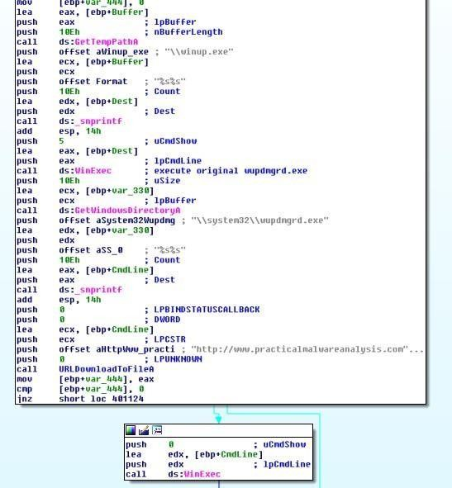

Figure 9. URLDownloadToFileA

# Practical No. 7

1. **Analyze the malware found in the file *Lab13-01.exe*.**

##### Compare the strings in the malware (from the output of the strings command) with the information available via dynamic analysis. Based on this comparison, which elements might be encoded?

In IDA Pro, we can see the following strings which are of not much meaning. However on execution, if we were to strings the memory using process explorer and sniff the network traffic, we can observe some new strings such as [**http://www.practicalmalwareanalysis.com**.](http://www.practicalmalwareanalysis.com/)

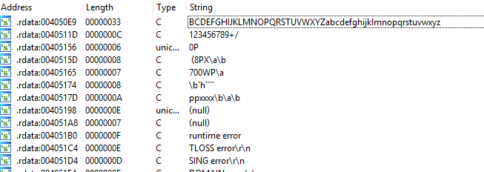

Figure 1. Meaningless string

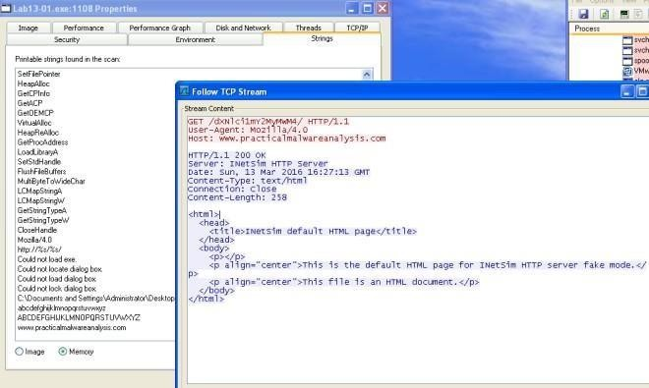

Figure 2. URL found

##### Use IDA Pro to look for potential encoding by searching for the string xor. What type of encoding do you find?

The subroutine @0x00401300 loads a resource in the binary and xor the value with “**;**“.

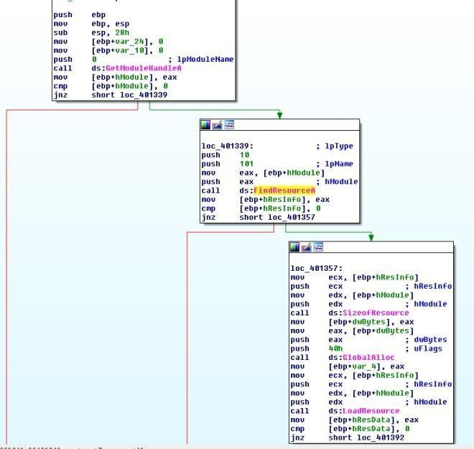

Figure 3. FIndResourceA 101

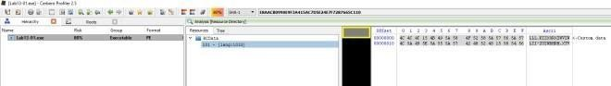

Figure 4. Resource String

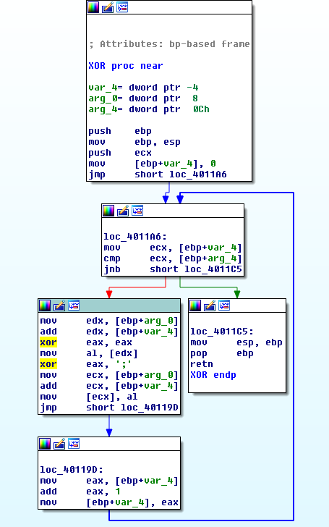

Figure 5. XOR with ;

##### What is the key used for encoding and what content does it encode?

The key used is “**;**“. The decoded content is [**http://www.practicalmalwareanalysis.com**](http://www.practicalmalwareanalysis.com/).

##### Use the static tools FindCrypt2, Krypto ANALyzer (KANAL), and the IDA Entropy Plugin to identify any other encoding mechanisms. What do you find?

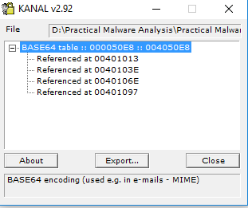

KANAL plugin located 4 addresses that uses “**ABCDEFGHIJKLMNOPQRSTUVWXYZabcdefghijklmnopqrstuvwxyz0123456789+/**”

##### What type of encoding is used for a portion of the network traffic sent by the malware?

base64 encoding is used to encode the computer name.

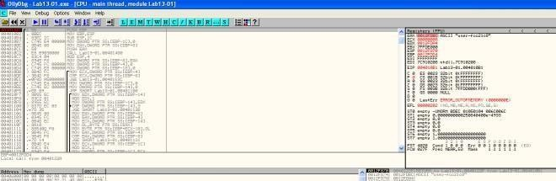

Figure 7. Encoding string

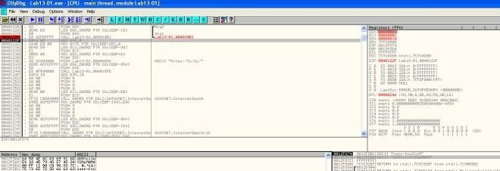

Figure 8. String encoded

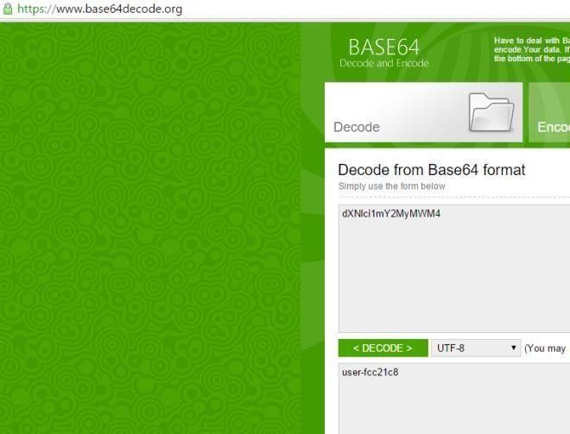

Figure 9. Checking base64 encoded string

##### Where is the Base64 function in the disassembly?

At address 0x004010B1.

##### What is the maximum length of the Base64-encoded data that is sent? What is encoded?

The maximum length is 12 characters. The maximum base64 length is 16 bytes.

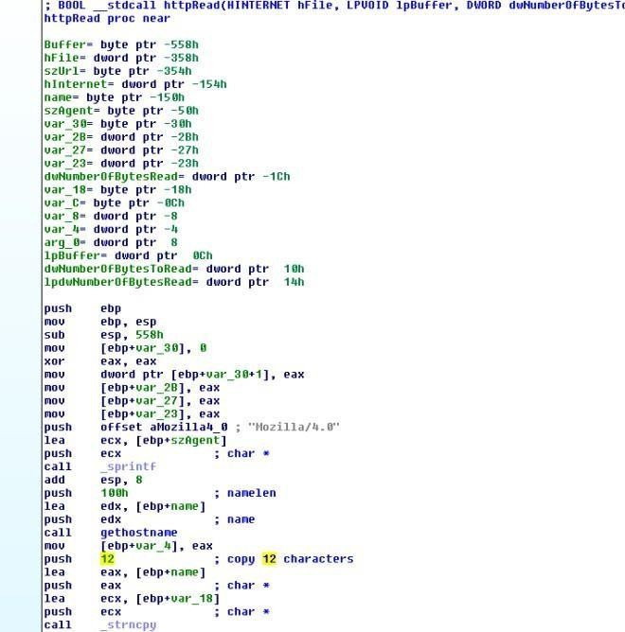Figure

10. Only 12 Characters

##### In this malware, would you ever see the padding characters (= or ==) in the Base64- encoded data?

According to [wiki.](https://en.wikipedia.org/wiki/Base64#Padding) If the plain text is not divisible by 3, padding will present in the encoded string.

##### What does this malware do?

It keeps sending the computer name (max 12 bytes)

to [**http://www.practicalmalwareanalysis.com** every](http://www.practicalmalwareanalysis.comevery/) 30 seconds until 0x6F is received as the first character in the response.

1. **Analyze the malware found in the file *Lab13-02.exe***

##### Using dynamic analysis, determine what this malware creates.

A file with size 6,214 KB is written on the same folder as the executable every few seconds. The naming convention of the file is **temp[8xhexadecimal]**. The file created seems random.

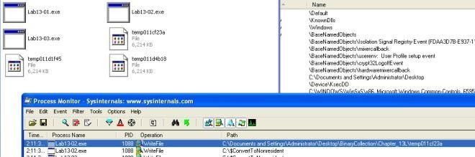

Figure 1. Proc Mon

##### Use static techniques such as an xor search, FindCrypt2, KANAL, and the IDA Entropy Plugin to look for potential encoding. What do you find?

Only managed to find XOR instructions. Based on the search result, we would need to look at the following subroutine

1. 0x0040128D

2. 0x00401570

3. 0x00401739

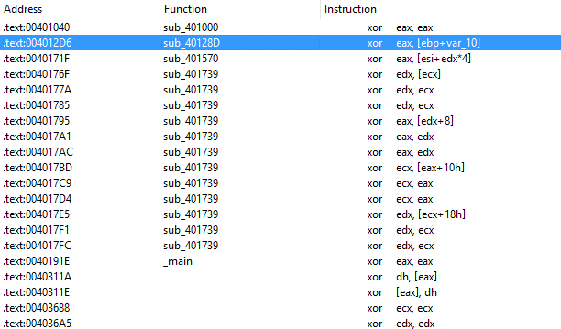

Figure 2. XOR

##### Based on your answer to question 1, which imported function would be a good prospect for finding the encoding functions?

WriteFile. Trace up from WriteFile and we might locate the function responsible for encoding the contents.

##### Where is the encoding function in the disassembly?

The encoding function is @0x0040181F. Tracing up from WriteFile, you will come across

a function @0x0040181F. The function calls another subroutine(0x00401739) that performs the XOR operations and some shifting operations.

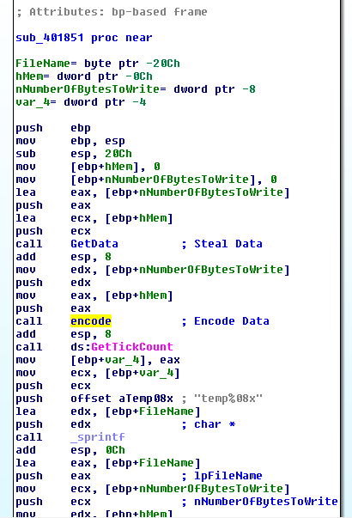Figure 3. encode

##### Trace from the encoding function to the source of the encoded content. What is the content?

Based on the subroutine @0x00401070. The malware is taking a screenshot of the desktop.

[GetDesktopWindow](https://msdn.microsoft.com/en-us/library/windows/desktop/ms633504(v%3Dvs.85).aspx): Retrieves a handle to the desktop window. The desktop window covers the entire screen. The desktop window is the area on top of which other windows are painted.

[GetDC](https://msdn.microsoft.com/en-us/library/windows/desktop/dd144871(v%3Dvs.85).aspx): The **GetDC** function retrieves a handle to a device context (DC) for the client area of a specified window or for the entire screen. You can use the returned handle in subsequent GDI functions to draw in the DC. The device context is an opaque data structure, whose values are used internally by GDI.

[CreateCompatibleDC](https://msdn.microsoft.com/en-us/library/windows/desktop/dd183489(v%3Dvs.85).aspx): The **CreateCompatibleDC** function creates a memory device context (DC) compatible with the specified device.

[CreateCompatibleBitmap](https://msdn.microsoft.com/en-us/library/windows/desktop/dd183488(v%3Dvs.85).aspx): The **CreateCompatibleBitmap** function creates a bitmap compatible with the device that is associated with the specified device context.

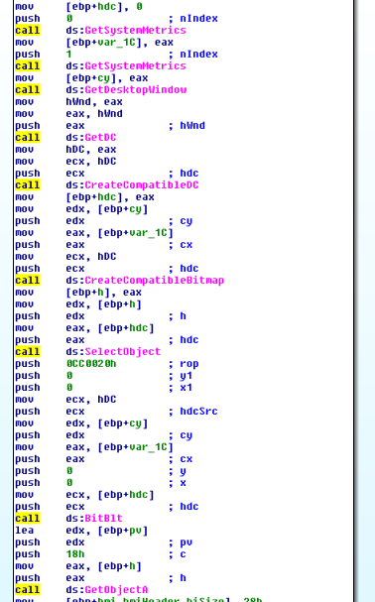[BitBlt](https://msdn.microsoft.com/en-us/library/windows/desktop/dd183370(v%3Dvs.85).aspx): The **BitBlt** function performs a bit-block transfer of the color data corresponding to a rectangle of pixels from the specified source device context into a destination device context.

Figure 4. Screenshot

##### Can you find the algorithm used for encoding? If not, how can you decode the content?

The encoder used is pretty lengthy to go through, However if we look at the codes in 0x401739, we can see lots of xor operations. If it is xor encoding we might be able to get back the original data if we call this subroutine again with the encrypted data.

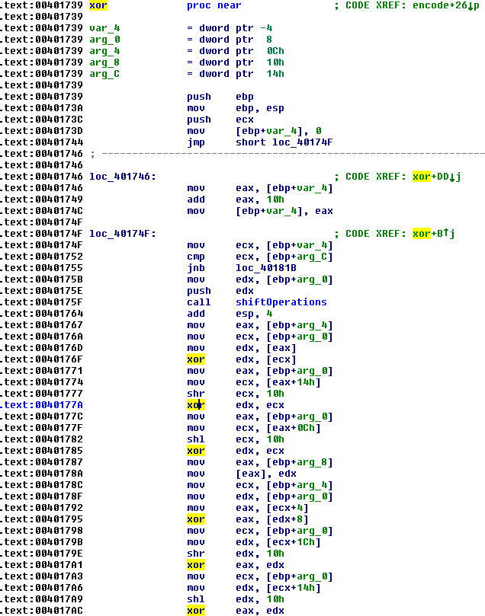

Figure 5. xor operations

##### Using instrumentation, can you recover the original source of one of the encoded files?

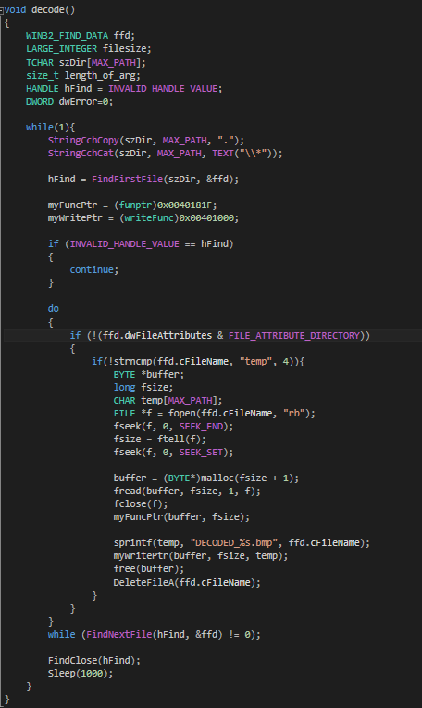My way of decoding the encoded files is to use DLL injection. To do that, i write my own DLL and create a thread to run the following function on **DLL_PROCESS_ATTACHED**. To attach the DLL to the malware process, we first run the malware and use a tool called **Remote DLL injector** by securityxploded to inject the DLL into the malicious process.

Figure 6. Decode Function

The above codes simply scan the path in which the executable resides in for encoded files that start with “**temp**“. It then reads the file and pass the data to the encoding function **@0x40181F**. Once the data is decoded, we make use of the function **@0x401000** to write out the file to

“**DECODED_[encoded file name].bmp**“. Last but not least i shall delete the encoded file so as not to clutter the folder.

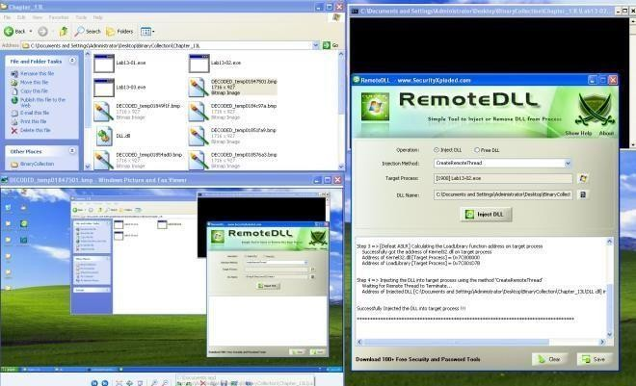

1. **Analyze the malware found in the file *Lab13-03.exe*.**

##### Compare the output of strings with the information available via dynamic analysis. Based on this comparison, which elements might be encoded?

Based on Wireshark and program response we could see the following strings.

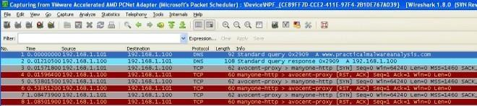

Figure 1. [http://www.practicalmalwareanalysis.com](http://www.practicalmalwareanalysis.com/)

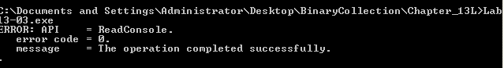

Figure 2. Error Message

In IDA Pro we can see the domain host name and some possible debug messages.

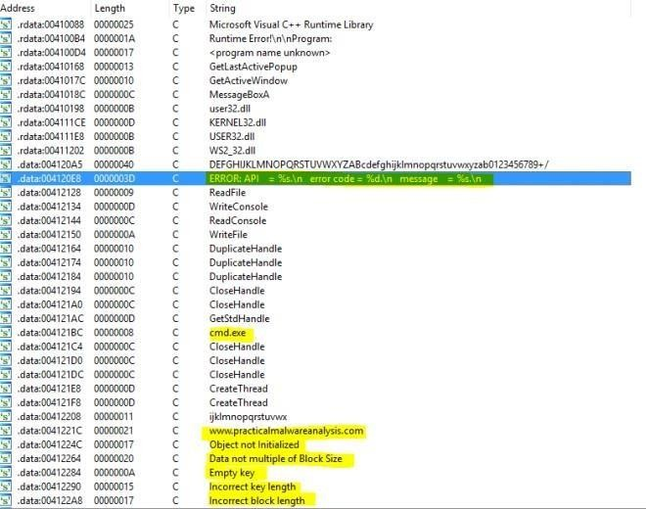

Figure 3. IDA Pro strings

##### Use static analysis to look for potential encoding by searching for the string xor. What type of encoding do you find?

There are quite a lot of xor operations to go through. But based on the figure below, it is highly possible that AES is being used; The **Advanced Encryption Standard** (**AES**) is also known as **Rijndae**.

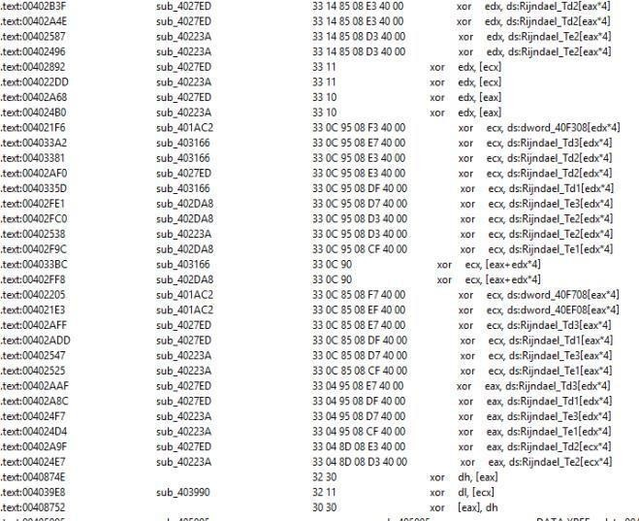Figure

4. XOR operations

##### Use static tools like FindCrypt2, KANAL, and the IDA Entropy Plugin to identify any other encoding mechanisms. How do these findings compare with the XOR findings?

Most likely AES is being used in the malware.

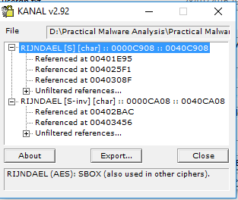

Figure 5. PEID found AES

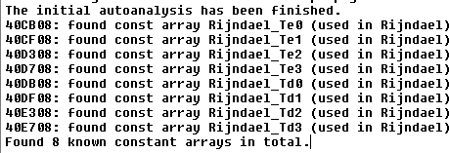

Figure 6. Find Crypt 2 Plugin Found AES

##### Which two encoding techniques are used in this malware?

@0x4120A4 we can see a 65 characters string. Which seems like a custom base64 key. The standard base64 key should be “ABCDEFGHIJKLMNOPQRSTUVWXYZabcdefghijklmnopqrstuvwxyz0123456789+/=” which consists of A-Z, a-z, 0-9, +, / and =.



Figure 7. Custom Base64

A custom Base64 and AES are used in this malware.

##### For each encoding technique, what is the key?

The custom base64 string uses “**CDEFGHIJKLMNOPQRSTUVWXYZABcdefghijklmnopqrstuvwxyzab0123456789+/**” To test if this key is valid i used a online custom base64 tool to verify.

Online Tool: <https://www.malwaretracker.com/decoder_base64.php>

Using the above tool with the custom key, I encoded HELLOWORLD and pass it to the program via netcat to decode. True enough, the encoded text was decoded back to the original text.

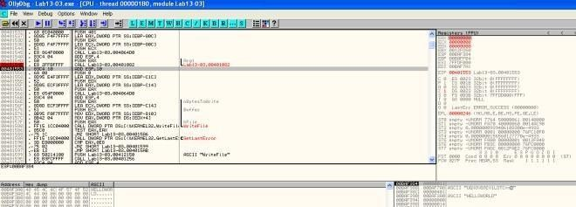

Figure 8. Base64 decode

Based on some debug message, this function (0x00401AC2) seems to be initializing the AES key.

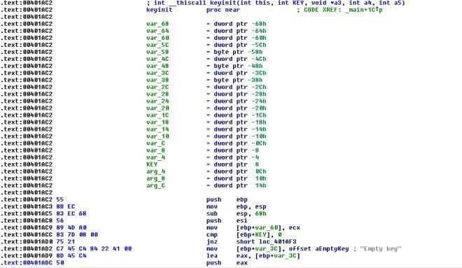

Figure 9. Init Key

x-ref the function and locate the 2nd argument… the key is most likely to be “**ijklmnopqrstuvwx**“.

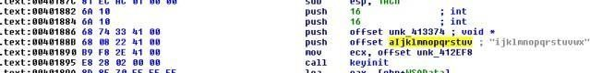

Figure 10. Key pass in as 2nd argument

##### For the cryptographic encryption algorithm, is the key sufficient? What else must be known?

For custom base64, we would just need the custom base64 string. For AES, we would need the Cipher’s encryption mode, key and IV.

##### What does this malware do?

The malware connects to an [http://www.practicalmalwareanalysis.com’s](http://www.practicalmalwareanalysis.com/) 8190 port and establishes a remote shell. It then reads input from the attacker. The inputs are custom base64 encoded. Once decoded, the command is pass to cmd.exe for execution. The return results is encrypted using AES and send back to the attacker’s server.

##### Create code to decrypt some of the content produced during dynamic analysis. What is this content?

Using the key, we use CBC mode with no IV to decrypt the AES encrypted packet. The content is the response from the command sent earlier via the remote shell from the attacker.

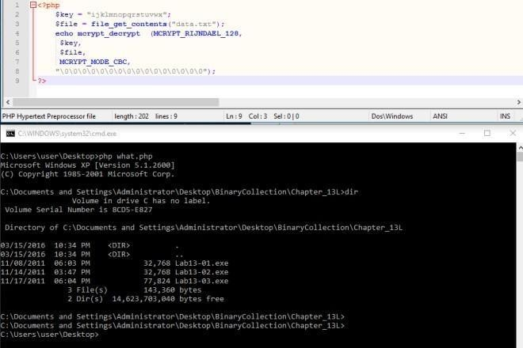

Figure 11. Decrypted Data

# Practical No. 8

#### Analyze the malware found in file *Lab14-01.exe*. This program is not harmful to your system.

##### Which networking libraries does the malware use, and what are their advantages?

The networking library used is urlmon’s [URLDownlaodToCacheFileA.](https://msdn.microsoft.com/en-us/library/ms775123(v%3Dvs.85).aspx)

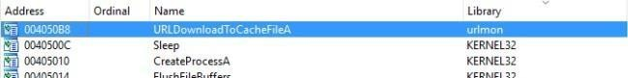

Figure 1. urlmon’s URLDownlaodToCacheFileA

The advantage of using this api call is that the http packets being sent looks like a typical packet from the victim’s browser.

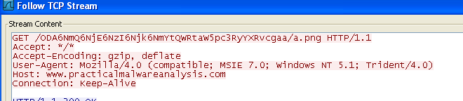

Figure 2. User-Agent

##### What source elements are used to construct the networking beacon, and what conditions would cause the beacon to change?

From the figure below, we can observe that the networking beacon is constructed from a partial GUID(19h to 24h) via [GetCurrentHWProfileA](https://msdn.microsoft.com/en-us/library/windows/desktop/ms724311(v%3Dvs.85).aspx) and username via [GetUserNameA.](https://msdn.microsoft.com/en-us/library/windows/desktop/ms724432(v%3Dvs.85).aspx)

Based on MSDN, **szHwProfileGuid** is a globally unique identifier (GUID) string for the current hardware profile. The string returned by [**GetCurrentHwProfile**](https://msdn.microsoft.com/en-us/library/windows/desktop/ms724311(v%3Dvs.85).aspx)encloses the GUID in curly braces, {}; for example: {12340001-4980-1920-6788-123456789012}.

Therefore on different machine, the GUID should be different which infers that the beacon will change. On top of that, another variable used is the username therefore different users logging in to the same infected machine will generate a different beacon as well.

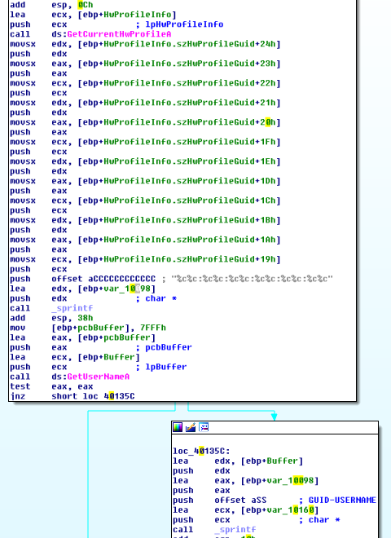

Figure 3. GUID & Username

##### Why might the information embedded in the networking beacon be of interest to the attacker?

So that the attacker can have a unique id to keep track of the infected machines and users.

##### Does the malware use standard Base64 encoding? If not, how is the encoding unusual?

Yes except that the padding used is different.

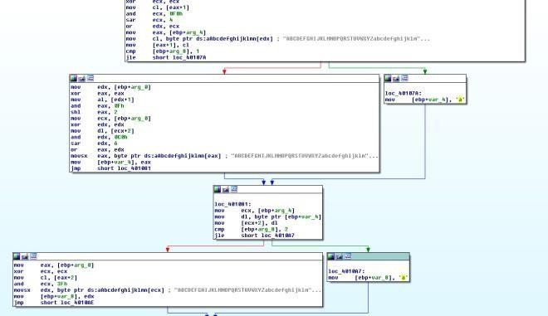

Figure 4.padding ‘a’ is used instead of ‘=’

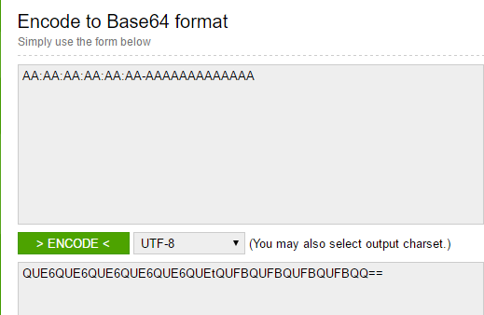To prove that let’s try it using ollydbg. Set breakpoint @0x004013A2 and we can step through the base64 algo in action. In my test experiment i used AA:AA:AA:AA:AA:AA- AAAAAAAAAAAAA to let it encode. By right the standard base64 should give me the following results.

Figure 5.

Encoding AA:AA:AA:AA:AA:AA-AAAAAAAAAA

However we got back QUE6QUE6QUE6QUE6QUE6QUEtQUFBQUFBQUFBQUFBQQaa instead. Which further reinforced what we have seen earlier in IDA Pro where ‘a’ is used instead of ‘=’ for padding.

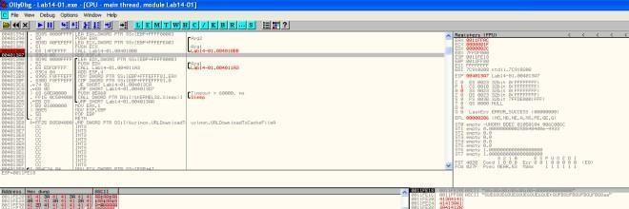

Figure 6. Encoding in ollydbg

##### What is the overall purpose of this malware?

The malware attempts to download file from the c2 server and executes it every 60 seconds.

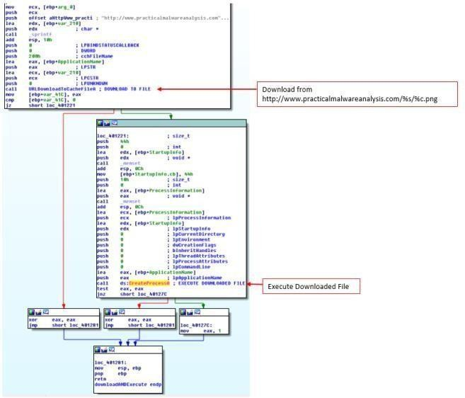

Figure 7. Download and execute

##### What elements of the malware’s communication may be effectively detected using a network signature?

We can use to following elements to detect for this malware

* 1. domain: [http://www.practicalmalwareanalysis.com](http://www.practicalmalwareanalysis.com/)
  2. Get request ends with **/[%c].png**

3. Get request pattern is as follows “/[A-Z|a-z|0-9]{3}6[A-Z|a-z|0-9]{3}6[A-Z|a-z|0-9]{3}6[A-Z|a- z|0-9]{3}6[A-Z|a-z|0-9]{3}6[A-Z|a-z|0-9]{3}t[A-Z|a-z|0-9]*\/[A-Z|a-z|0-9].png/”

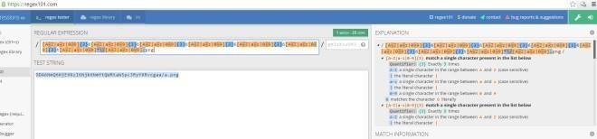

Figure 8. online reg exp tool

##### What mistakes might analysts make in trying to develop a signature for this malware?

* 1. thinking that the GET request is a static base64 string
  2. thinking that the file requested is “a.png”

##### What set of signatures would detect this malware (and future variants)?

refer to question vi.

1. **Analyze the malware found in file *Lab14-02.exe*. This malware has been configured to beacon to a hard-coded loopback address in order to prevent it from harming your system, but imagine that it is a hard-coded external address.**

##### What are the advantages or disadvantages of coding malware to use direct IP addresses?

**Pro**

If the attacker’s IP were to be blocked, other same variant of malware that uses different IP would not be affected.

**Con**

If the IP is blacklisted as malicious and blocked by the feds, the attacker would have lost access to the malware. If the attacker were to use a domain name, he can easily just redirect to another IP.

##### Which networking libraries does this malware use? What are the advantages or disadvantages of using these libraries?

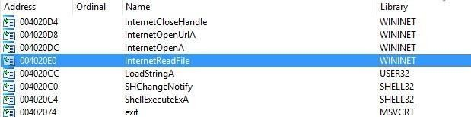

Figure 2. WININET

WININET library is used by this malware.

**Pro**

Caching and cookies are automatically set by the OS. If cache are not cleared before re- downloading of files, the malware could be getting a cached file instead of a new code that needs to be downloaded.

**Con**

User agent need to be set by the malware author, usually the user agent is hard coded.

##### What is the source of the URL that the malware uses for beaconing? What advantages does this source offer?

The url is hidden in the string resource. Once a malware is compiled, the attacker would just need to reset the resource to another ip without recompiling the malware. Also using a resource make do without an additional config file.

##### Which aspect of the HTTP protocol does the malware leverage to achieve its objectives?

Threads are created by the malware. One to send data out in the user agent field after encoding it using custom base64. The other to receive data.

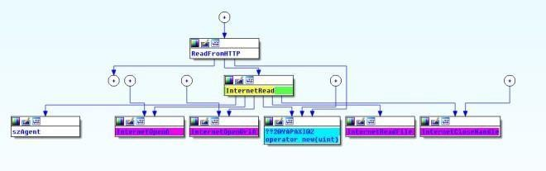

Figure 3. Read Data

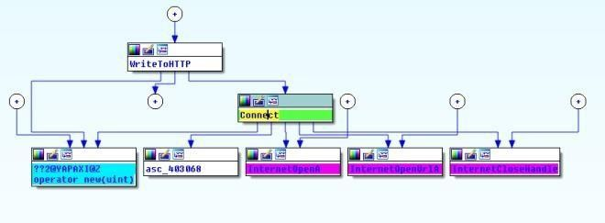

Figure 4. Send Data

Read Data Thread uses a static user agent “Internet Surf” as shown below.

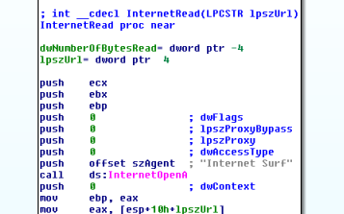

Figure 5. Internet Surf User-agent

##### What kind of information is communicated in the malware’s initial beacon?

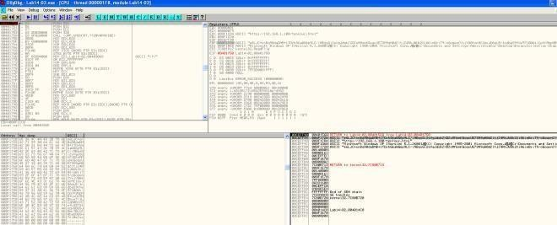Setting a breakpoint @0x00401750, we will break before the malware attempts to send packets out. Here you will see a custom base64 encoded data being package ready to send out.

Figure 6. Base64 encoded data

The decoded text is the cmd.exe prompt.

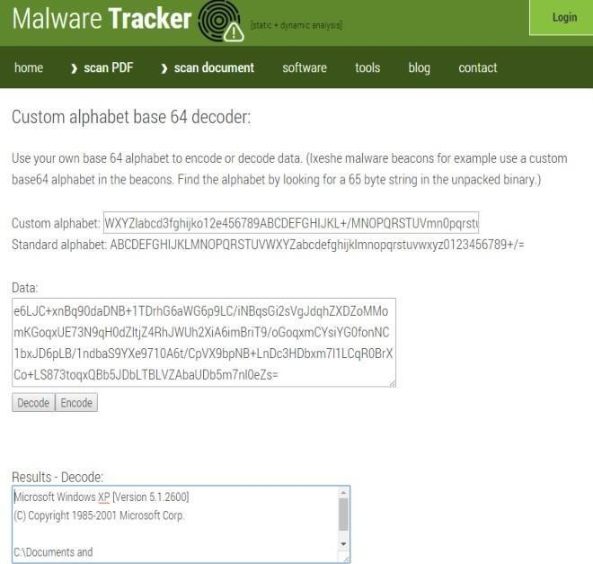

Figrue 7. Decoded Base64

##### What are some disadvantages in the design of this malware’s communication channels?

* 1. Only outgoing traffic is encoded thus incoming commands are in plain for defender to see
  2. The user agent used is hard coded for one of the thread which makes it easy to form a signature to detect it.
  3. The other user agent looks out of place and defender can spot it if he/she go through the packet header.

##### Is the malware’s encoding scheme standard?

No. We can see the custom base64 key in the following figure.

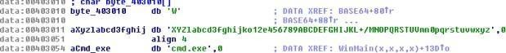

Figure 8. Custom base64 key

##### How is communication terminated?

In the subroutine @0x00401800, once the malware reads the word **exit** from the C2 server, the thread will exit.

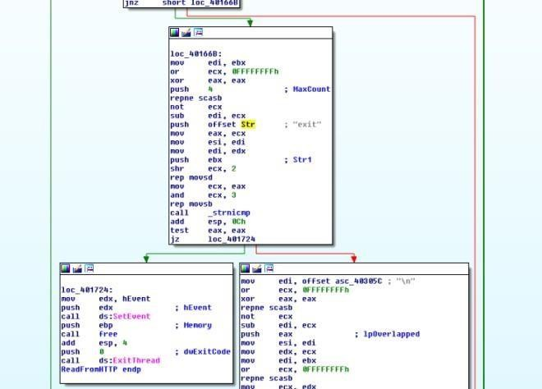

Figure 9. exit keyword

##### What is the purpose of this malware, and what role might it play in the attacker’s arsenal?

Reverse Shell via http. On termination of the malware a subroutine (0x00401880) will be called to delete itself from the system.

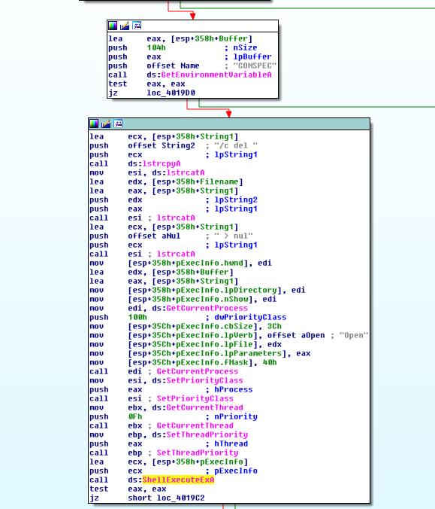

Figure 10. self delete

##### This lab builds on Practical 8 a. Imagine that this malware is an attempt by the attacker to improve his techniques. Analyze the malware found in file *Lab14-03.exe*.

1. **What hard-coded elements are used in the initial beacon? What elements, if any, would make a good signature?**

From the figure below, we can see hard-coded user-agent and headers (Acccept, Accept- Language, Accept-Encoding, and a unique UA-CPU field). All of these can be used as a signature especially the **UA-CPU** field. It is also noted that the author pass the string “**User- Agent: xxx**” into InternetOpenA API call. This results in User-Agent field being set to **User-**

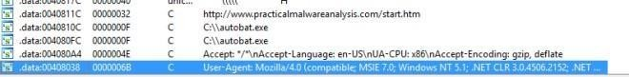**Agent:User-Agent:xxx**… A duplicate error in which we can used it to generate a good signature too.

Figure 1. HTTP Headers

##### What elements of the initial beacon may not be conducive to a longlasting signature?

In the subroutine @0x401457, we can see that the url “[**http://www.practicalmalwareanalsysis.com/start.htm**](http://www.practicalmalwareanalsysis.com/start.htm)” is being set as the beacon destination. However that is provided that “**c:\\autobat.exe**” does not exists, if it exists, the contents will be read and parsed as the beacon destination instead.

Using “[**http://www.practicalmalwareanalsysis.com/start.htm**](http://www.practicalmalwareanalsysis.com/start.htm)” as a signature might not be a good idea since an attacker might be able to change the beacon destination.

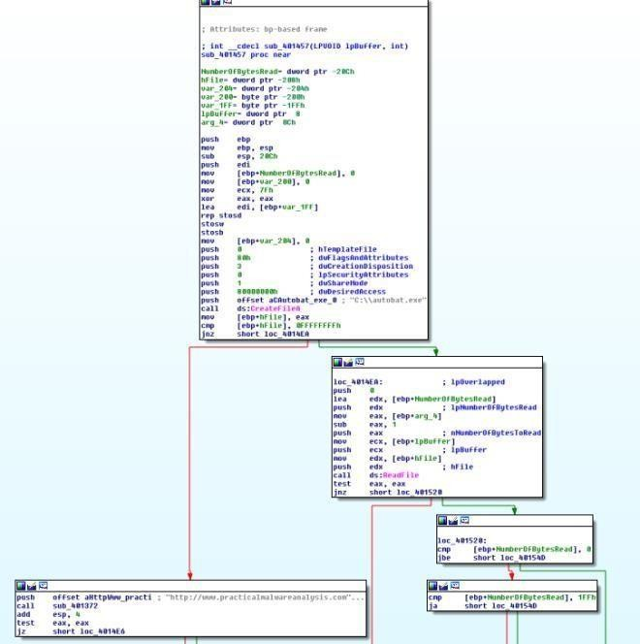

Figure 2. autobat.exe

##### How does the malware obtain commands? What example from the chapter used a similar methodology? What are the advantages of this technique?

The malware scan the response for a **<noscript>** tag. The text after the tag is the command to execute. The advantage of using this technique is that it is hiding the commands in plain sight that blends in the returned html page. Therefore making detection hard for defender.

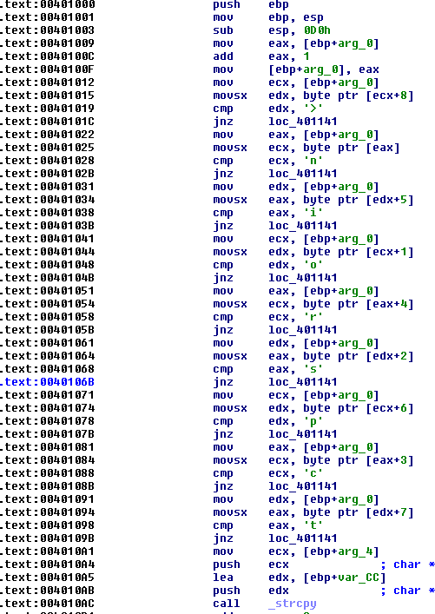

Figure 3. <noscript>

##### When the malware receives input, what checks are performed on the input to determine whether it is a valid command? How does the attacker hide the list of commands the malware is searching for?

Analyzing subroutine @00401000 & 0x00401684. The checks are as follows

* 1. starts with <noscript>
  2. url exists after <noscript>
  3. url ends with “69′”
  4. commands must be in the form of /command/parameter

The attacker hides the commands by using only the first character to switch between predefined commands. Therefore he can use different words to represent same command so long as the first character matches in the switch.

1. What type of encoding is used for command arguments? How is it different from Base64, and what advantages or disadvantages does it offer?

The malware divides the parameters by 2 characters. Each 2 characters are passed to atoi function to convert it to integer. It then references the following string to get the exact character it represents.

Figure 4. Decode string

**Pro**

It is a custom encoding technique thus not easily detected by existing tools

**Con**

It is pretty simple to reverse.

##### What commands are available to this malware?

|  |  |
| --- | --- |
| **Comman d** | **Description** |
| d | Download & Execute |
| n | Exit |
| s | Sleep |
| r | Write autobat.exe |

1. **What is the purpose of this malware?**

The malware serves as a backdoor by downloading and execute new codes on the victim’s machine via http request. It can also rewrite the config file “autobat.exe” to let it connect to a different C2 Server.

1. This chapter introduced the idea of targeting different areas of code with independent signatures (where possible) in order to add resiliency to network indicators. What are some distinct areas of code or configuration data that can be targeted by network signatures?
   1. “[http://www.practicalmalwareanalsysis.com/start.htm&#8221](http://www.practicalmalwareanalsysis.com/start.htm%26#8221);
   2. Any new url found in “c:\\autobat.exe”
   3. Headers such as UA-CPU and User Agent (duplicated User-Agent)
   4. http response contains <noscript>[url][69′]

##### What set of signatures should be used for this malware?

refer to question 8.

1. **Analyze the sample found in the file Lab15-01.exe. This is a command-line program that takes an argument and prints “Good Job!” if the argument matches a secret code.**

##### What anti-disassembly technique is used in this binary?

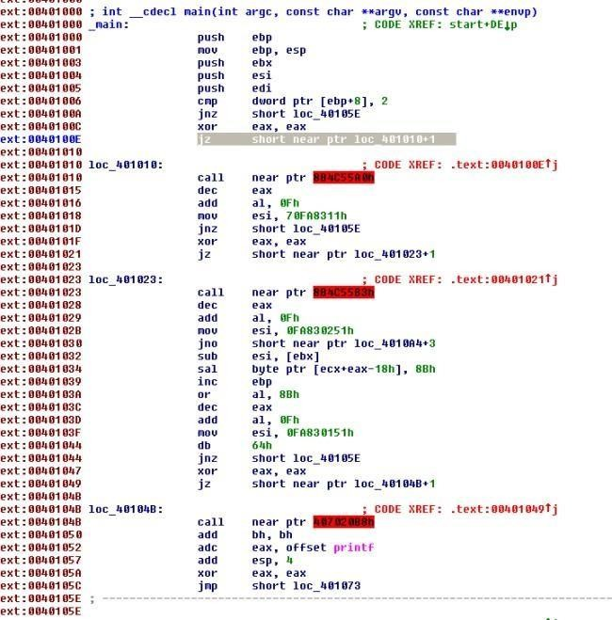Xor was used followed by jz to trick the disassembler into making a jump. An opcode “E8” is used to make IDA Pro disassemble the code wrongly.

Figure 1. A confuse looking IDA Pro

We can undefine the code and reanalyze the code as shown below.

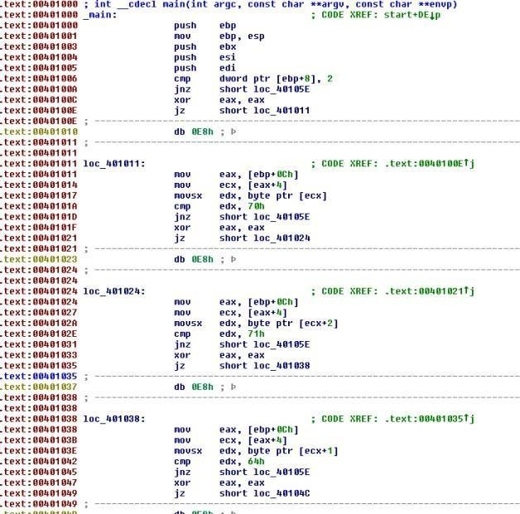

Figure 2. Reanalyzing opcodes

##### What rogue opcode is the disassembly tricked into disassembling?

E8 was used to trick the dis assembler.

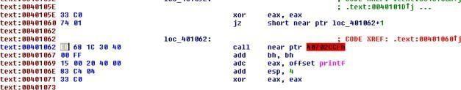

Figure 3. E8 opcode

##### How many times is this technique used?

5 times. Just count the number of 0xE8(refer to figure 2) you can find.

##### What command-line argument will cause the program to print “Good Job!”?

Based on the analysis of the following codes, we need to pass in a pass phrase “**pdq**“.

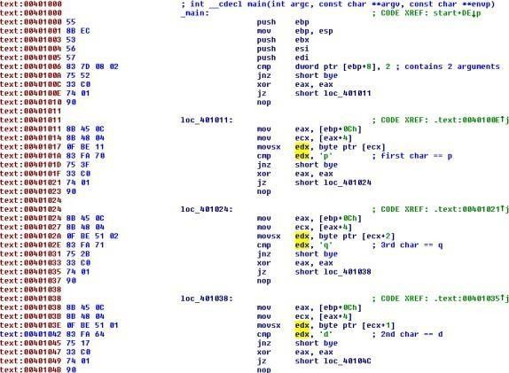

Figure 4. decoding the pass phrase

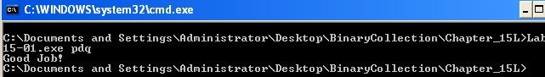

Figure 5. Good Job!

## e- Analyze the malware found in the file Lab15-02.exe. Correct all anti- disassembly countermeasures before analyzing the binary in order to answer the questions.

##### What URL is initially requested by the program?

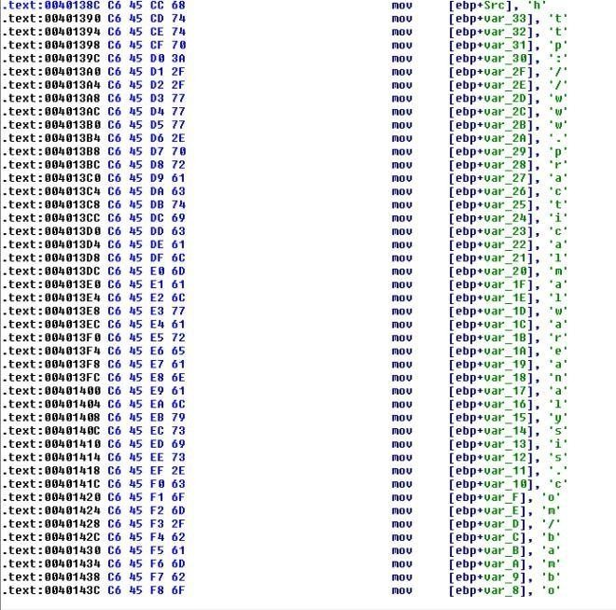

Figure 1. URL <http://www.practicalmalwareanalysis.com/bamboo.html>

##### How is the User-Agent generated?

via modifying [GetHostName](https://msdn.microsoft.com/en-us/library/windows/desktop/ms738527(v%3Dvs.85).aspx) returned string.

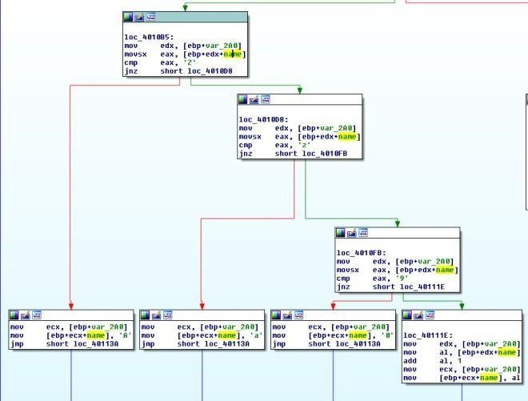

Figure 2. shift right

The above code will shift the string by 1 character. To prevent invalid ascii, Z is changed to A, z is changed to a and 9 is changed to 0.

##### What does the program look for in the page it initially requests?

Bamboo::

Figure 3. strstr

##### bambooWhat does the program do with the information it extracts from the page?

It extracts out another url and download its content via **InternetOpenUrlA** and **InternetReadFile** saving it under **Account Sumamry.xls.exe**. It then executes it via **ShellExecuteA**.

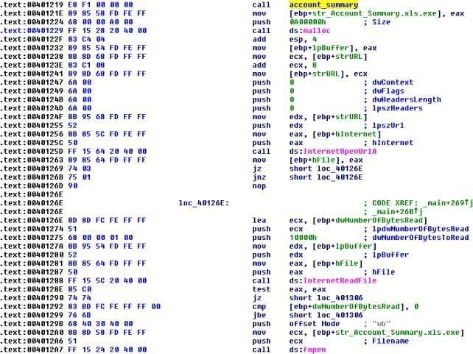

Figure 4. InternetOpenUrlA followed by InternetReadFile followed by fopen,fwrite then ShellExecuteA

## f. Analyze the malware found in the file *Lab15-03.exe*. At first glance, this binary appears to be a legitimate tool, but it actually contains more functionality than advertised.

##### How is the malicious code initially called?

The return address was overwritten by the malicious code address at the start of the program. the stack which contains the ret address was written with 0x40148c.

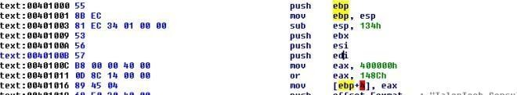

Figure 1. Overwriting return address

##### What does the malicious code do?

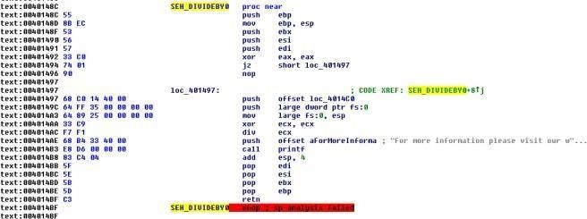

Figure 2. SEH

@0x40148c we can see that the malware is adding a SEH handler (0x4014C0) via fs:0. It then performs a divide by 0 error to trigger the SEH.

The handler download a file from a url and executes it via WinExec.

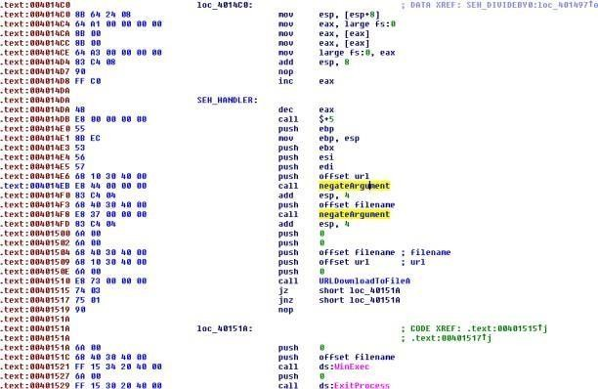

Figure 3. SEH Handler

##### What URL does the malware use?

I decided to write a script to decode the url. the decoding function is simple… just negate the inputs.

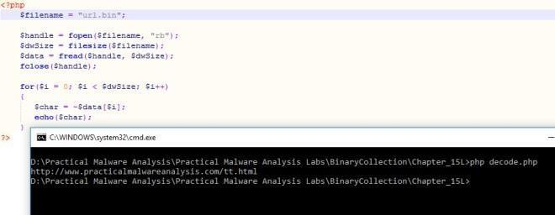

Figure 4. Decoded URL

The url is: [**http://www.practicalmalwareanalaysis.com/tt.html**](http://www.practicalmalwareanalaysis.com/tt.html)

1. **What filename does the malware use? spoolsrv.exe**

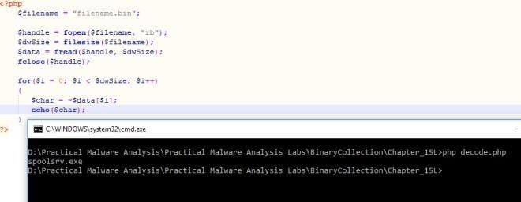

Figure 5. Decoded filename

# Practical No. 9

## a- Analyze the malware found in *Lab16-01.exe* using a debugger. This is the same malware as *Lab09-01.exe*, with added anti-debugging techniques.

##### Which anti-debugging techniques does this malware employ?

Based on the figures below, the anti debugging techniques used are

* 1. checking being debugged flag
  2. checking process heap[10h]
  3. checking NtGlobalFlag

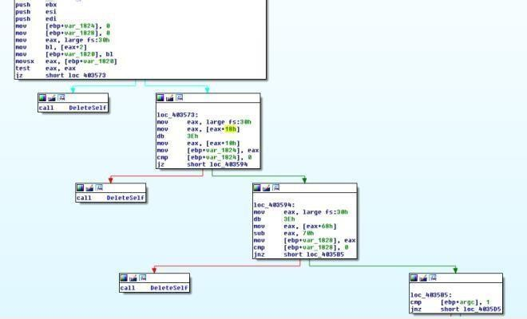

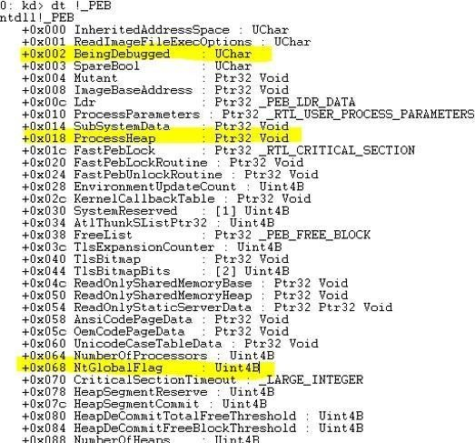Figure 1. Anti debugger

Figure 2. the offset used

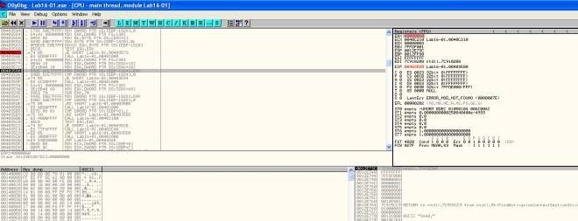

Figure 3. Checking process heap

##### What happens when each anti-debugging technique succeeds?

It will self delete and then terminates by calling the subroutine @00401000.

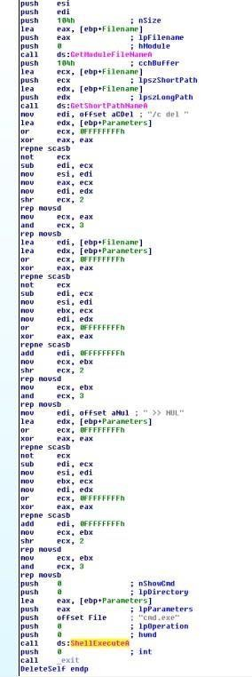

Figure 4. Self Delete & terminates

##### How can you get around these anti-debugging techniques?

* 1. Set breakpoint at the checks and manually change the flow in ollydbg
  2. Patch the program to make jz to jnz etc
  3. use plugins such as phantom.

##### How do you manually change the structures checked during runtime?

use command line and enter dump fs:[30]+2 (refer to figure 2). Set the byte to 0.

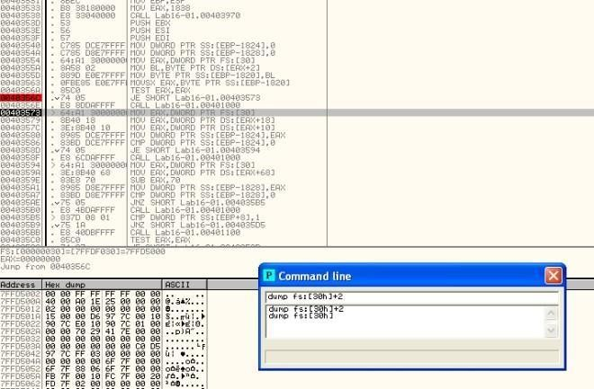

Figure 5. Changing structure

##### Which OllyDbg plug-in will protect you from the anti-debugging techniques used by this malware?

PhantOm plugin will do the job

##### Analyze the malware found in *Lab16-02.exe* using a debugger. The goal of this lab is to figure out the correct password. The malware does not drop a malicious payload.

1. **What happens when you run Lab16-02.exe from the command line?**

Picture worth a thousand words.

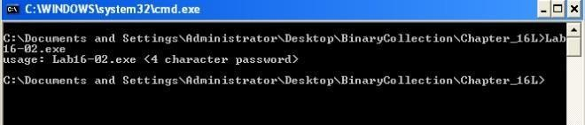

Figure 1. password required

##### What happens when you run Lab16-02.exe and guess the command-line parameter?

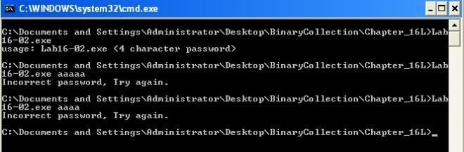

Figure 2. Incorrect password

##### What is the command-line password?

To get the command-line password, we can set breakpoint @0040123A to see what the malware is comparing the password against. However, on running the malware, the program simply terminates.

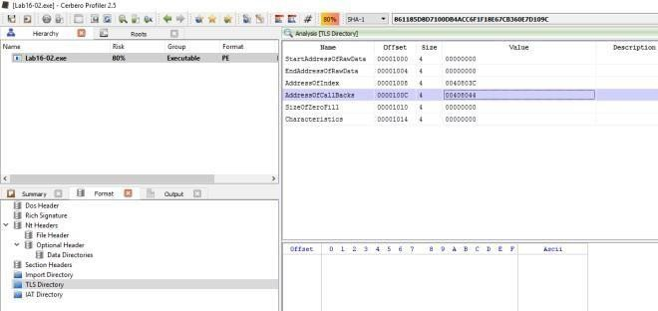

Figure 3. Callbacks

Seems like 0x00408033 subroutine was called before we reach main method. Analyzing it in IDA Pro, this subroutine is checking for OLLYDBG window via FindWindowA and it is also using OutputDebugString to detect for debugger. Just nop the function at let it return to bypass these checks.

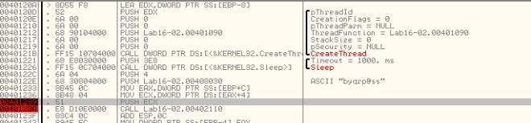

Figure 4. byqrp@ss

and so we got the password… however this password is invalid when tried on the command line with debugger attached.

Lets look at the subroutine @00401090 which is called by the CreateThread function. This function is responsible for generating the password to check against.

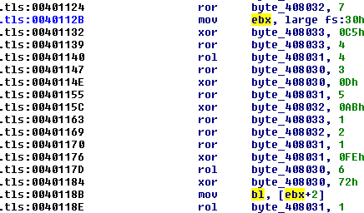Figure 5.

BeingDebugged Flag

In the subroutine we can see that there is a check against BeingDebugged Flag… maybe this is the cause of it. Let’s fix the structure and see how it goes.

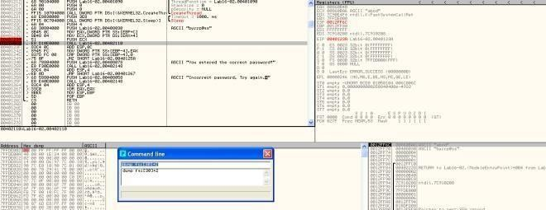

Figure 6. byrrp@ss

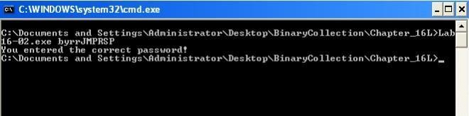The decoded password is “byrrp@ss”. However the strncmp will only compare the first 4 characters.

Figure 7. Correct Password

##### Load Lab16-02.exe into IDA Pro. Where in the main function is strncmp found?

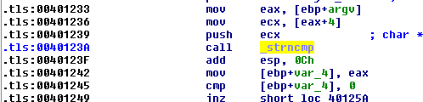@0x40123A

Figure 8. strncmp

##### What happens when you load this malware into OllyDbg using the default settings?

The program just terminates. In fact even if I am running it in command line but ollydbg is running in the background, the application will also terminates.

##### What is unique about the PE structure of Lab16-02.exe?

There is a .tls section.



Figure 9. .tls section

##### Where is the callback located? (Hint: Use CTRL-E in IDA Pro.)

At address 0x00401060.

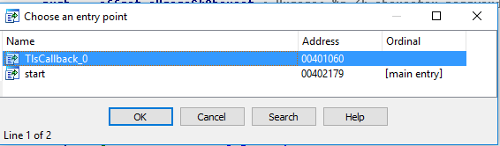Figure

10. Ctrl-E

##### Which anti-debugging technique is the program using to terminate immediately in the debugger and how can you avoid this check?

* 1. OLLYDBG window via FindWindowA
  2. OutputDebugString to detect for debugger
  3. BeingDebugged Flag via fs:[30h]+2

##### What is the command-line password you see in the debugger after you disable the anti- debugging technique?

refer to solution for question iii.

##### Does the password found in the debugger work on the command line?

refer to solution for question iii.

##### Which anti-debugging techniques account for the different passwords in the debugger and on the command line, and how can you protect against them?

* 1. OutputDebugString (nop out the callback function)
  2. BeingDebuggedFlag (change the structure to set debug flag back to 0)

## Analyze the malware in *Lab16-03.exe* using a debugger. This malware is similar to *Lab09-02.exe*, with certain modifications, including the introduction of anti-debugging techniques.

##### Which strings do you see when using static analysis on the binary?

these are the only strings of interest to us that we can observe statically.

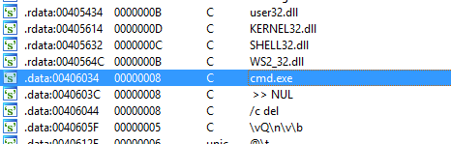

Figure 1. strings

##### What happens when you run this binary?

Nothing happen. It just terminates.

##### How must you rename the sample in order for it to run properly?

In ollydbg, we set breakpoint @0x401518 (strncmp) to see what the malware is comparing against. The executable name needs to be “**qgr.exe**“. However nothing happen when we attempt to run the malware via command line…

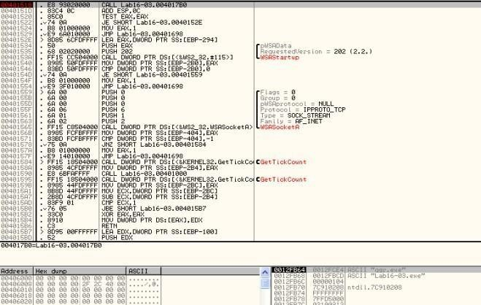

Figure 2. qgr.exe

Firing up IDA Pro we trace back the variable that was used to match against the current running executable filename.

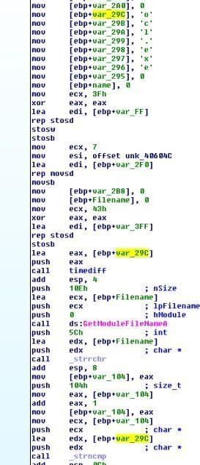 Figure 3. var_29C

Seems like the variable is initially set to ocl.exe. It is then passed to a function where [QueryPerformanceCounter](https://msdn.microsoft.com/en-us/library/windows/desktop/ms644904(v%3Dvs.85).aspx) was called twice… In between the 2 QueryPerformanceCounter is a Division by zero opcodes that is purposely set there to slow down the debugged process.

The time difference between the 2 QueryPerformanceCounter will determine if var_118 is 2 or 1 which will affect the return result of this subroutine. If we are using debugger the QueryPerformanceCounter difference might be above 1200 due to the triggering of the division by 0 error… if the time difference is above 1200, var_118 will be set to 2 and the filename should be qgr.exe else var_118 will be set to 1 and the filename should be peo.exe.

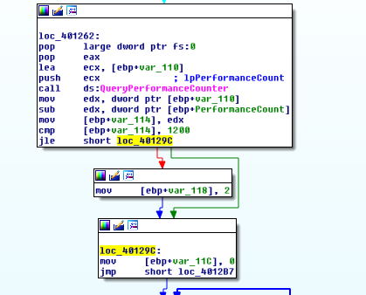Figure 4.

QueryPerformanceCounter

By manually making sure that var_118 is set to 1 and not 2, we get the following filename;

##### peo.exe.

Renaming the executable as **peo.exe** will do the trick in running the app properly.

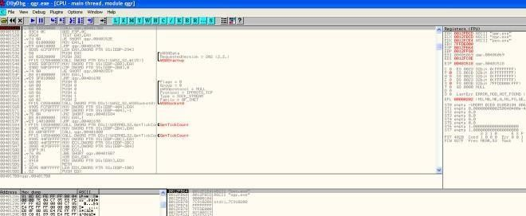

Figure 5. peo.exe

##### Which anti-debugging techniques does this malware employ?

The techniques used are all time based approach

* 1. QueryPerformanceCounter
  2. GetTickCount
  3. rdtsc (subroutine: @0x401300)

1. For each technique, what does the malware do if it determines it is running in a debugger?
   1. [QueryPerformanceCounter](https://msdn.microsoft.com/en-us/library/windows/desktop/ms644904(v%3Dvs.85).aspx) – determines what name should the executable be, in order to execute properly
   2. [GetTickCount](https://msdn.microsoft.com/en-us/library/windows/desktop/ms724408(v%3Dvs.85).aspx) – crashes the program by referencing a null pointer
   3. [rdtsc](https://msdn.microsoft.com/en-us/library/twchhe95.aspx) – call subroutine @0x004010E0; self delete

##### Why are the anti-debugging techniques successful in this malware?

The malware purposely triggers division by 0 error that will cause any attached debugger to break and for the analyst to rectify. This action itself is time consuming as compared to a program without debugger attached throwing exception and letting SEH handler to do the job. Therefore the malware codes are able to determine whether a debugger is being attached just via the time difference.

##### What domain name does this malware use?

adg.malwareanalysisbook.com

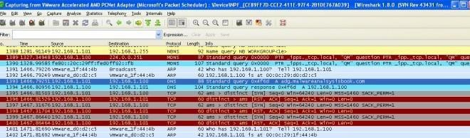

Figure 6. adg.malwareanalysisbook.com

##### Analyze the malware found in *Lab17-01.exe* inside VMware. This is the same malware as

***Lab07-01.exe*, with added anti-VMware techniques.**

##### What anti-VM techniques does this malware use?

The malware uses vulnerable instruction: **sidt,sldt and str**

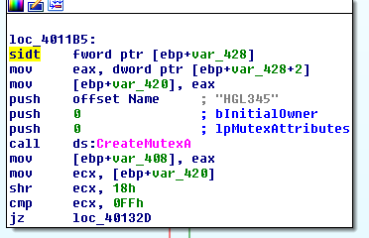

Figure 1. sidt instruction

The malware issues the sidt instruction as shown above, which stores the contents of IDTR into the memory location pointed to by var_428. The IDTR is 6 bytes, and the fifth byte offset contains the start of the base memory address. That fifth byte is compared to 0xFF, the VMware signature. We can see that var_428+2 is set to var_420. Later on in the opcodes we can observe that var_420 is shifted right by 3 bytes thus pointing it to the 5th byte.

##### If you have the commercial version of IDA Pro, run the IDA Python script from Listing 17-4 in Chapter 17 (provided here as findAntiVM.py). What does it find?

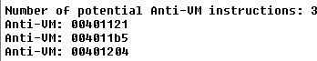Figure 2. 3 Anti-

VM instructions found 1. 00401121 – sldt

2. 004011b5 – sidt 3. 00401204 – str

##### What happens when each anti-VM technique succeeds?

* 1. 00401121 – sldt; service created but thread to openurl is not created the program terminates.
  2. 004011b5 – sidt; sub routine 0x401000 will be invoked, the program will be deleted
  3. 00401204 – str; sub routine 0x401000 will be invoked, the program will be deleted

##### Which of these anti-VM techniques work against your virtual machine?

None…

##### Why does each anti-VM technique work or fail?

It depends on the hardware and the vmware used.

##### How could you disable these anti-VM techniques and get the malware to run?

* 1. nop the instruction
  2. patch the jmp instruction

1. **Analyze the malware found in the file *Lab17-02.dll* inside VMware. After answering the first question in this lab, try to run the installation exports using *rundll32.exe* and monitor them with a tool like procmon. The following is an example command line for executing the DLL:**

**rundll32.exe Lab17-02.dll,InstallRT (or InstallSA/InstallSB)**

##### What are the exports for this DLL?

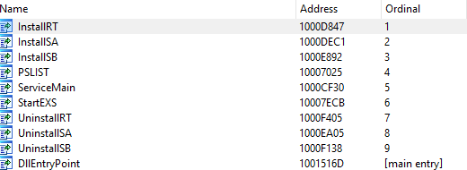

Figure 1. Exports

##### What happens after the attempted installation using rundll32.exe?

The dll gets deleted. A File xinstall.log was dropped. vmselfdelete.bat file was dropped,executed and subsequently deleted as well. From the log file created, it seems that the malware has detected that it is running in a VM thus deleting itself.

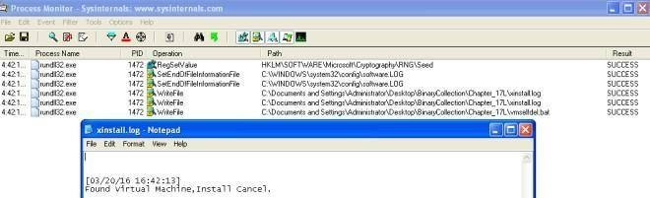

Figure 2. xinstall.log

##### Which files are created and what do they contain?

2 files are created; xinstall.log & vmselfdel.bat.

vmselfdel.bat can be traced to the subroutine @10005567 using IDA Pro. Needless to say, the purpose of the batch file is to delete the dll and itself from the system.

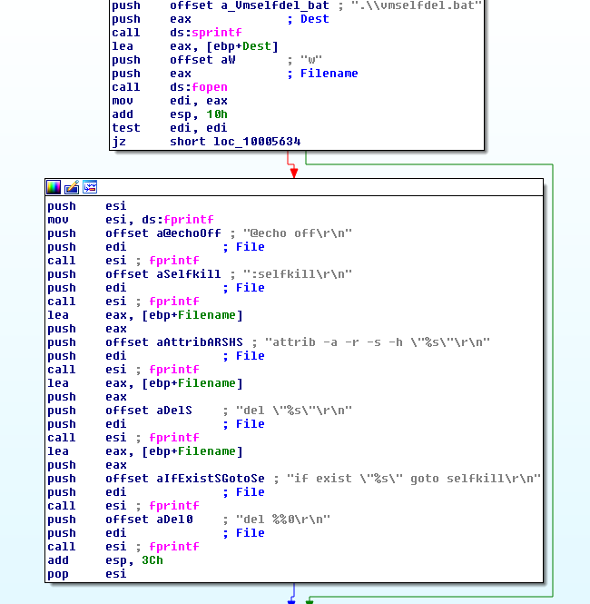

Figure 3. self delete

##### What method of anti-VM is in use?

querying I/O communication port.

VMware uses virtual I/O ports for communication between the virtual machine and the host operating system to support functionality like copy and paste between the two systems. The port can be queried and compared with a magic number to identify the use of VMware.

The success of this technique depends on the x86 **in** instruction, which copies data from the I/O port specified by the source operand to a memory location specified by the destination operand. VMware monitors the use of the in instruction and captures the I/O destined for the

ommunication channel port 0x5668 (VX). Therefore, the **second operand needs to be loaded with VX** in order to check for VMware, which happens only when the **EAX register is loaded with the magic number 0x564D5868 (VMXh)**. **ECX must be loaded with a value corresponding to the action you wish to perform on the port**. The value **0xA** means “**get VMware version type**” and **0x14** means “**get the memory size**.” Both can be used to detect VMware, but 0xA is more popular because it may determine the VMware version.

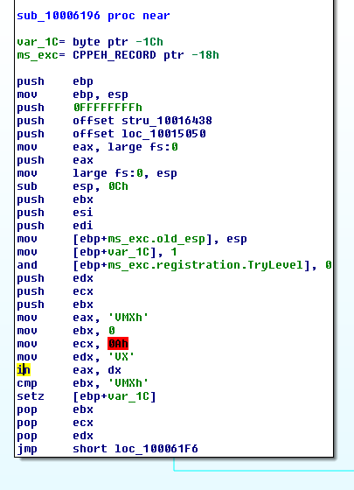

Figure 4. Querying I/O comm port

##### How could you force the malware to install during runtime?

* 1. Patch the jump condition (3 places need to patch since checkVM sub routine is xref 3 times)
  2. patch the in instruction in Figure 4 to nop

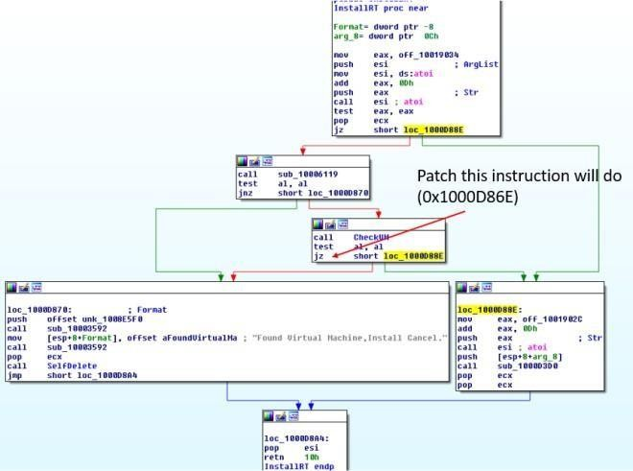

Figure 5. patching

##### How could you permanently disable the anti-VM technique?

Just patch the above and make the changes to the disk. Based on Figure 5, we could also patch the string @ offset 10019034 -> 10019248 from [This is DVM]5 to [This is DVM]0 to disable the check.

##### How does each installation export function work?

1. **InstallRT**

Inject dll into either iexplore.exe or a custom process name that is passed in as argument. In brief the subroutine @1000D847 will do the following

* 1. Get the dll filename via [GetModuleFileNameA](https://msdn.microsoft.com/en-us/library/windows/desktop/ms683197(v%3Dvs.85).aspx)
  2. Get System Directory path via [GetSystemDirectoryA](https://msdn.microsoft.com/en-us/library/windows/desktop/ms724373(v%3Dvs.85).aspx)
  3. Copy the current dll into system directory with the same file name
  4. Get the pid of a process; either iexplore.exe by default or a custom process name passed in as an argument
  5. Get higher privilege by changing token to SeDebugPrivilege
  6. Inject dll via CreateRemoteThread on the pid retrieved in 4.

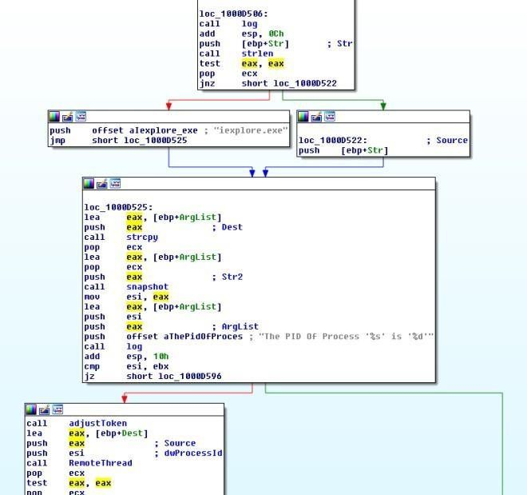

Figure 6. Install RT 2.**InstallSA** Install as a Service

In brief the subroutine @1000D847 will do the following

1. [RegOpenKeyExA](https://msdn.microsoft.com/en-us/library/windows/desktop/ms724897(v%3Dvs.85).aspx) – HKLM\SOFTWARE\Microsoft\Windows NT\CurrentVersion\Svchost
2. [RegQueryValueExA](https://msdn.microsoft.com/en-us/library/windows/desktop/ms724911(v%3Dvs.85).aspx) – netsvcs
3. loop through the data to find either Irmon or a custom string passed in as an argument
4. [CreateServiceA](https://msdn.microsoft.com/en-us/library/windows/desktop/ms682450(v%3Dvs.85).aspx) – with service name as Irmon or a custom string passed in as an argument
5. Add data to HKLM\SYSTEM\ControlSet001\Services\[Irmon | custom]\description
6. Creates a parameter key in HKLM\SYSTEM\CurrentControlSet\Services\[Irmon | custom]
7. Creates a Servicedll key in HKLM\SYSTEM\CurrentControlSet\Services\[Irmon | custom] with thepath of the dll as the value
8. Start the service
9. Creates a win.ini file in windows directory
10. Writes a Completed key to SoftWare\MicroSoft\Internet Connection Wizard\ if SoftWare\MicroSoft\Internet Connection Wizard\ does not exists

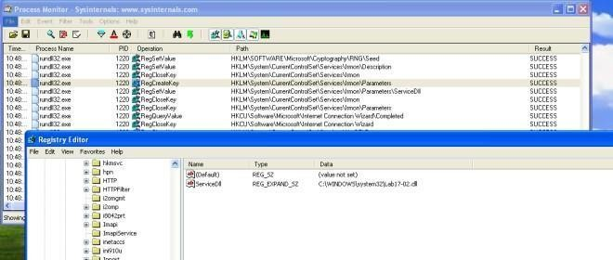

Figure 7. InstallSA

##### InstallSB

It first calls sub rountine 0x10005A0A to

* 1. Attain higher privileges via adjusting token to SeDebugPrivilige
  2. It then gets the WinLogon Pid
  3. It then get the windows version to determine which sfc dll name to use
  4. It then uses CreateRemoteThread to get Winlogon process to disable file protection via sfc

It then calls the subroutine @0x1000DF22 to

1. It first query service config of **NtmsSvc** service
2. If service **dwStartType** is > 2, it will then change the service to **SERVICE_AUTO_START**
3. If then checks if the service is **running or paused**. If it is running or in paused state, it will **stop**

the service.

1. It then queries HKLM\\SOFTWARE\Microsoft\Windows NT\CurrentVersion\Svchost\\Netsvcvalues
2. It then gets the PID of svchost and check if the malicious module is loaded
3. backup c:\\windows\\system32\\ntmssvc.dll to c:\\windows\\system32\\ntmssvc.dll.obak
4. copy current dll to c:\\windows\\system32\\ntmssvc.dll
5. If ntmssvc.dll isn’t loaded, the malware will then inject it into svchost
6. Starts the created service
7. Creates a win.ini file in windows directory
8. Writes a Completed key to “SoftWare\MicroSoft\Internet Connection Wizard\” if “SoftWare\MicroSoft\Internet Connection Wizard\” does not exists
9. **Analyze the malware *Lab17-03.exe* inside VMware.**

##### What happens when you run this malware in a virtual machine?

The malware terminates.

##### How could you get this malware to run and drop its keylogger?

we can patch the jump instructions at the following address 1. 0x004019A1

2. 0x004019C0

3. 0x00401A2F

4. 0x00401467

##### Which anti-VM techniques does this malware use? @00401A80: I/O communication port

**@004011C0: checking registry key SYSTEM\CurrentControlSet\Control\DeviceClasses\vmware**

##### @00401670: checking mac address

**@00401130: checking for vmware process name (hash of first 6 chars)**

##### What system changes could you make to permanently avoid the anti-VM techniques used by this malware?

* 1. Patch the binaries
  2. Change Mac Address
  3. Remove VMware tools

##### How could you patch the binary in OllyDbg to force the anti-VM techniques to permanently fail?

Change the following instruction to xor instead

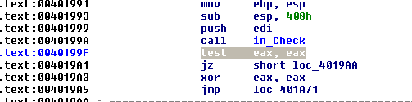

Figure 5. in instruction patch

Change the following instruction to xor instead

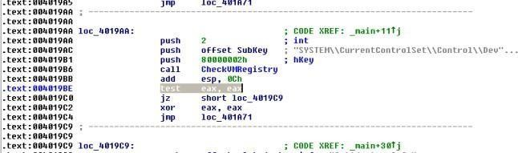

Figure 6. Registry checking patch Nop out the calling of this subroutine

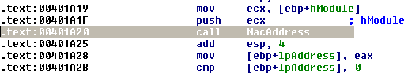

Figure vii. Mac Address patching

Change the hash to AAAAAAAAh to invalidate the search

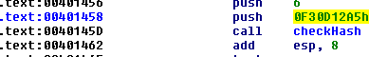

Figure 8. Process Name Hash patching